Oxfam in Vietnam vacancy (Re-advertisement)

PROGRAMME FINANCE OFFICER



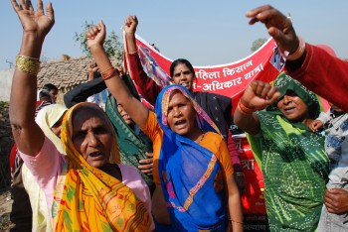
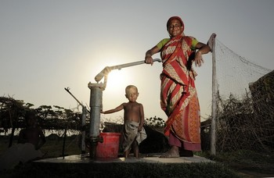

Oxfam is a global movement of people working together to end the injustice of poverty.

That means we tackle the inequality that keeps people poor. Together we save, protect and rebuild lives. When disaster strikes, we help people build better lives for themselves, and for others. We take on issues like land rights, climate change and discrimination against women. And we won’t stop until every person on the planet can enjoy life free from poverty.

Oxfam is a confederation of 21 organizations working together in more than 70 countries. We are part of a global movement for change, empowering people to create a future that is secure, just, and free from poverty.

Oxfam in Vietnam is working to seek transformative changes in policies, practices and beliefs in ways that will fundamentally improve the lives of poor and marginalized women and men and ensure that all citizens have the same opportunity to enjoy their rights. Oxfam in Vietnam current country strategy contributes to shaping the debate on extreme inequality in Vietnam and globally, our three program goals include promoting gender equality and women’s agency, social accountability and empowered citizens, and secured livelihoods and resilient communities.

All our work is led by three core values: Empowerment, Accountability, Inclusiveness. To read more about our values please click here

Oxfam is committed to preventing any type of unwanted behavior at work including sexual harassment, exploitation and abuse, lack of integrity and financial misconduct; and committed to promoting the welfare of children, young people and adults. Oxfam expects all staff and volunteers to share this commitment through our code of conduct. We place a high priority on ensuring that only those who share and demonstrate our values are recruited to work for us.

The Role
The Programme Financial Officer is responsible for the financial aspects of the management of country portfolios, the development, implementation and monitoring of the financial aspects of the assigned Special Projects, the management of the financial risks and opportunities on a country level, and to provide for the appraisal and analysis of the financial aspects of proposals and reports for back-donors.

Contract: | Fixed term, 2 years with possible extension (depending on performance)
Reporting to: | Senior Programme Finance Officer
Based in: | Hanoi with frequent travel

.
Key responsibilities:
- Analyse the financial aspects of funding applications, financial and operational reports and financial audits of Oxfam counterparts for the sake of a proper accountability and transparency; work with SPFO to ensure coherence and compliance across all major donor requirements;
- You assess, together with the Programme Managers/Programme Officers the organisational structure, capacity and management systems of counterparts as well as their external risks and communicate about these issues directly with the counterparts & propose appropriate monitoring and/or capacity-building;
- Closely monitor counterparts' financial management and implementation of activities and outcomes in collaboration with programme officer;
- Contribute to the further development of the capacity of programmes staff and partners in finance management and in preparing financial reports to ensure proper accountability and compliance to Oxfam grant management and/or back donors' requirements;
- Draws up the budget for (externally funded) project proposals on the basis of the intended project activities. When a project is approved: supports necessary system improvements, prepares the financial management reports in line with the standards of the back-donor(s), including a (first) analysis, and submits them to the project leader for his/her approval;
- Check and appraise the financial aspects of funding proposals of (intended) local partners, on internal and external risks and opportunities. You co-ordinate on findings with the project leader and you make proposal on the (manner of) financing;
- Contribute to financial management/policy (such as the quality of audits, opportunities for getting advice in the financial area and the quality of financial traffic);
- Ensure the archive system of project financial management is regularly updated for easily access and for audit purposes;
- Develop a network of financial consultants, auditors in Vietnam to support these tasks;
- Regularly visit counterparts and their projects in the field and other relevant organisations/people in Vietnam in order to properly implement and check the above mentioned duties in every six month;
- Have direct contacts with relevant units at HQ (project control, external funding, Quality & Control).

Skills, experience and knowledge

Essential
- A degree in finance management on a bachelor level;
- 5 years of relevant work experience in financial position including financial management, planning, administration and budgeting & auditing;
- Several years of working experience related to international development organisations;
- Experience in making independent financial analyses of development programmes, and you can evaluate these against the political and socio-economic context within which they are carried out;
- Experience and knowledge of relevant financial IT-systems;
- Excellent social skills and you are a team player;
- Excellent communications skills in English.

In addition, you need to
- Be a team player;
- Have good social and interpersonal skills;
- Be able to work across boundaries and enable cooperation among different groups/actors;
- Be able to work under pressure in response to changing needs.

Gross Annual Salary Range: VND360,869,588 – VND604,886,167

How to apply

Interested candidates can send your application including motivation letter and curriculum vitae via this LINK.

The closing date for application: 10th October 2021

We regret that only short-listed applicants will be contacted.

Those candidates who have already applied, do not need to apply again.

Oxfam is an equal opportunity employer

