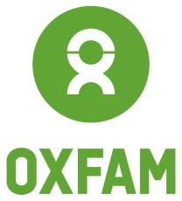

Oxfam in Vietnam vacancy

PROGRAMME INTERN FOR LIVELIHOOD AND RESILIENCE PROGRAMME

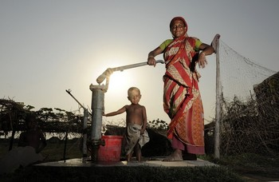
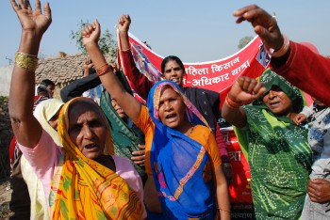
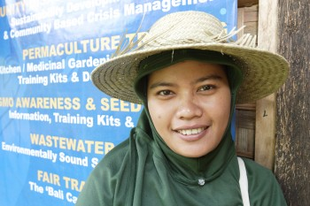
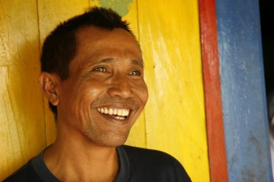

Oxfam is a global movement of people working together to end the injustice of poverty.

That means we tackle the inequality that keeps people poor. Together we save, protect and rebuild lives. When disaster strikes, we help people build better lives for themselves, and for others. We take on issues like land rights, climate change and discrimination against women. And we won’t stop until every person on the planet can enjoy life free from poverty.

Oxfam is a confederation of 20 organizations working together in more than 90 countries. We are part of a global movement for change, empowering people to create a future that is secure, just, and free from poverty.

Oxfam in Vietnam is working to seek transformative changes in policies, practices and beliefs in ways that will fundamentally improve the lives of poor and marginalized women and men and ensure that all citizens have the same opportunity to enjoy their rights. Oxfam in Vietnam current country strategy contributes to shaping the debate on extreme inequality in Vietnam and globally, our four-programme includes women rights’, building resilience to disaster, climate risks and emergency response, sustainable food and fair sharing of natural resources, and good governance.

All our work is led by three core values: Empowerment, Accountability, Inclusiveness. To read more about our values please click here

Oxfam is committed to preventing any type of unwanted behavior at work including sexual harassment, exploitation and abuse, lack of integrity and financial misconduct; and committed to promoting the welfare of children, young people and adults. Oxfam expects all staff and volunteers to share this commitment through our code of conduct. We place a high priority on ensuring that only those who share and demonstrate our values are recruited to work for us.

Oxfam offers an internship program for young Vietnamese graduates who are passionate about Oxfam's mission of working with others to overcome poverty, suffering and injustice. Selected intern will provide administrative support to the team, gain essential office skills, and take part in project activities as well as number of training opportunities. They will gain invaluable working experience that benefits their future employment. Internship contract lasts for 12 months. Oxfam wishes to promote diversity in our team: members of Vietnam's ethnic minorities, people with disabilities and members of other minority groups are particularly encouraged to apply.

Program Overview: Oxfam works with others to find lasting solutions to poverty and suffering. Through private sector engagement and market-based solutions, we are working to enhance the poor’s market access and women’s economic leadership, contributing to income increase and sustainable livelihoods as well as to mobilize resources and influence private sector for the fight against poverty and injustice.

Reference number: INTGoal3
Starting time: November 2021
Location: Hanoi, Vietnam with occasional travel to project areas
Report to: Project Managers
Allowance: VND3,000,000/month, plus lunch allowance and accident insurance.

KEY RESPONSIBILITIES

- Support documentation activities, namely, application of digital technology for creative reporting (biannually, annually or after workshops), documentation; interviewing; filming and photo-taking;
- Provide creative input to project activities;
- Communicate and support partners and other agencies in programme implementation;
- Organize workshops, seminars, training courses, etc;
- Contact project partners, consultants and other stakeholders in relevant activities;
- Support translation and interpretation when required (Vietnamese – English and vice versa);
- Be in charge of general administration (filing documents, managing the programme; library, booking, circulating mail, fax, photocopying, scanning);
- Search and provide data that serve as a basis for day-to-day implementation process and proposal writing;
- Join field trips when required;
- Others as appropriate.

TECHNICAL SKILLS, EXPERIENCE & KNOWLEDGE

- Vietnamese citizen, University degree
- Basic understanding of natural resources management (water resources, river basins, forest conservation and bio-diversity) and climate change;
- General knowledge of social-economic issues of rural areas, climate change issues and household economics;
- Good computer skills (MS Word, MS Excel, Ms. Outlook, PowerPoint);
- Good knowledge of digital application for creative reporting, documentation;
- Good command of English, including interpretation and translation from Vietnamese to English and vice-versa;
- Commitment and inspiration to work in development areas and poor community;
- Some knowledge of development work, but not essential.
- Good communication, presentation skills (especially in working with people from different backgrounds);
- Good teamwork skills (supporting others, delegation, influencing, negotiating);
- Ability to work independently as well as in the team;
- Respect for others.

LEARNING OPPORTUNITIES

- Taking part in relevant programme events (internal training, programme meetings, workshops, etc.);
- Taking part in monitoring and evaluation missions as appropriate;
- Induction to financial management system of Oxfam;
- Developing career development plan and review regularly with line-manager

HOW TO APPLY

Interested candidates can apply via this Link.

Closing date: 18 November 2021

We regret that only short-listed applicants will be contacted.

Oxfam is an equal opportunity employer.

