Oxfam in Vietnam vacancy

PROGRAMME ADMINISTRATIVE OFFICER



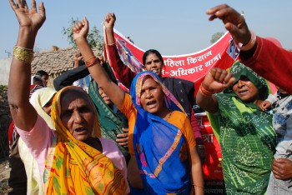
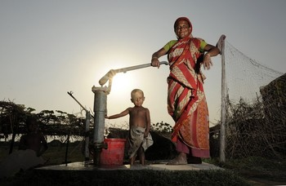

Oxfam is a global movement of people working together to end the injustice of poverty.

That means we tackle the inequality that keeps people poor. Together we save, protect and rebuild lives. When disaster strikes, we help people build better lives for themselves, and for others. We take on issues like land rights, climate change and discrimination against women. And we won’t stop until every person on the planet can enjoy life free from poverty.

Oxfam is a confederation of 21 organizations working together in more than 70 countries. We are part of a global movement for change, empowering people to create a future that is secure, just, and free from poverty.

Oxfam in Vietnam is working to seek transformative changes in policies, practices and beliefs in ways that will fundamentally improve the lives of poor and marginalized women and men and ensure that all citizens have the same opportunity to enjoy their rights. Oxfam in Vietnam current country strategy contributes to shaping the debate on extreme inequality in Vietnam and globally, our three program goals include promoting gender equality and women’s agency, social accountability and empowered citizens, and secured livelihoods and resilient communities.

All our work is led by three core values: Empowerment, Accountability, Inclusiveness. To read more about our values please click here

Oxfam is committed to preventing any type of unwanted behavior at work including sexual harassment, exploitation and abuse, lack of integrity and financial misconduct; and committed to promoting the welfare of children, young people and adults. Oxfam expects all staff and volunteers to share this commitment through our code of conduct. We place a high priority on ensuring that only those who share and demonstrate our values are recruited to work for us.

The Role:
The Programme Administrative Officer ensures the effective and efficient support of the administrative process of the assigned programmes.

Internal Job Grade: E1
Contract: Fixed term, 1 year with possible extension
Reporting to: Programme Manager
Location: Vietnam office in Hanoi

Key Responsibilities and Accountabilities
- Provide support as requested in preparation for program documentation and correspondence in the framework of the project cycle of Oxfam in Vietnam or requirements of the back donor;
- Arrange and monitor the (administrative) processes of the programs in line with ISO procedures and back donor requirements; to signal deviations within the different processes and remind the relevant staff members of this;
- Arrange the processes, registration and filing of the documentation and correspondence of the (core) processes, in line with applicable procedures and with the help of the automation systems;
- Prepare all relevant Oxfam meetings/workshops. If needed, to record action points and/or write the minutes, and to monitor their follow-up;
- Provide secretarial, administrative and organization support to assigned programs;
- Organize all duty arrangements (including hotel, transport and assisting with visas) of colleagues of the project and /or other visitors travelling to and from the field;
- Provide translation and interpretation supports to program activities.

Technical Skills, Experience & Knowledge
Essential
- Completed an education in secretarial, administrative or economic direction;
- Proven secretarial, administrative and organizational work experience;
- Excellent oral and written command of English and Vietnamese;
- Good computer skills and experience with SAP or other computerized information systems;
- A proactive attitude and you work systematically, you know to separate major and minor issues are accurate;
- Good interpersonal and communication skills and you are a team player;
- A flexible, customer-focused attitude.

Gross Annual Salary Range: VND 179,855,357 – VND 316,545,429

How to apply

Interested candidates can send your application including motivation letter and curriculum vitae via this LINK.

The closing date for application: 16 December 2021

We regret that only short-listed applicants will be contacted.

Oxfam is an equal opportunity employer

