Oxfam in Vietnam vacancy

POLICY ADVISOR DIGITAL RIGHTS AND SPACE


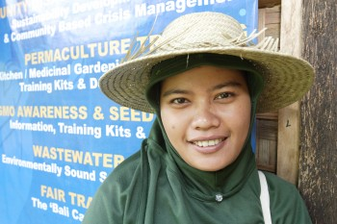
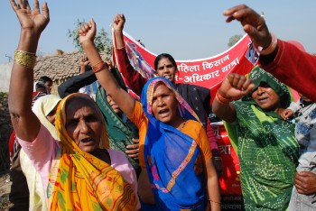
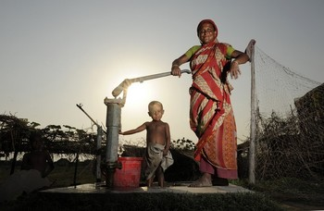

Oxfam is a global movement of people working together to end the injustice of poverty.

That means we tackle the inequality that keeps people poor. Together we save, protect and rebuild lives. When disaster strikes, we help people build better lives for themselves, and for others. We take on issues like land rights, climate change and discrimination against women. And we won’t stop until every person on the planet can enjoy life free from poverty.

Oxfam is a confederation of 21 organizations working together in more than 70 countries. We are part of a global movement for change, empowering people to create a future that is secure, just, and free from poverty.

Oxfam in Vietnam is working to seek transformative changes in policies, practices and beliefs in ways that will fundamentally improve the lives of poor and marginalized women and men and ensure that all citizens have the same opportunity to enjoy their rights. Oxfam in Vietnam current country strategy contributes to shaping the debate on extreme inequality in Vietnam and globally, our three program goals include promoting gender equality and women’s agency, social accountability and empowered citizens, and secured livelihoods and resilient communities.

All our work is led by three core values: Empowerment, Accountability, Inclusiveness. To read more about our values please click here

Oxfam is committed to preventing any type of unwanted behavior at work including sexual harassment, exploitation and abuse, lack of integrity and financial misconduct; and committed to promoting the welfare of children, young people and adults. Oxfam expects all staff and volunteers to share this commitment through our code of conduct. We place a high priority on ensuring that only those who share and demonstrate our values are recruited to work for us.

Job purpose
The main aim of this position is to shape the work on digital rights and -space in relation to Oxfam work on Civic Space, Oxfam’s Civic Space working group and OI working group on digital rights. The advisor will build and maintain a relevant network and undertake the necessary influencing activities connecting local to international level. The advisor will bring together knowledge, practice and instruments from within and outside Oxfam to support safe and smart use of digital space by activists, movements, projects, partners and country teams.

Contacts
- The policy advisor will work as part of and in collaboration with the Championing Civic Space team to support Civic (digital) space work as well as advise other units in Oxfam Novib and the Civic Space Working Group on digital rights and -space work (as far as time allows).
- The policy advisor will work on country/region/cluster specific issues.
- The policy advisor will be line managed by the CCS Unit Manager and matrix managed by senior manager of the hosting country office

Contract: | Fixed term, 1 year with possible extension
Reporting to:  Grade: | Unit Manager Championing Civic Space  C1 National
Based in: | Hanoi with frequent travel

Result Areas/ Key Deliverables:
- Mapped good practices, networks and allies to support digital rights and navigating digital space in and outside Oxfam and proposes way forward on digital rights for Oxfam Novib with limited resources;
- Contributed to international and national networking and advocacy on digital rights, relevant for Oxfam’s work on civic space;
- Supported partners and country teams in using most strategically and safely their digital space and rights;
- Digital rights/space issues, where relevant, well addressed in program/project development, where possible;
- Documented good and bad practices on digital rights & space (amongst others for awareness raising) in a selection of relevant Oxfam programmes;
- Developed guidelines for aligning the digital rights & digital space work with the civic space work as well as with other relevant support systems to offices and partners such as ICT support and digital campaigning.

Key responsibilities:
- Research and update knowledge and experiences about digital rights and -space in and outside Oxfam;
- Support partners and country teams in using most strategically and safely their digital space and rights;
- Contribute on digital rights/space issues as part of program/project development;
- Contribute to digital rights/space networks and advocacy debates;
- Document good and bad practices on digital rights & space;
- Contribute to awareness raising on digital rights and space; on what is possible/ necessary and what not in Oxfam Novib’s work;
- Advise Oxfam’s Civic Space group on digital rights and space;
- Developing guidelines for aligning the digital rights & digital space work with the civic space work; ICT work and digital campaigning work.

Skills, experience and knowledge
This policy advisor has
- A degree in a relevant field and academic working capacity, preferably related to digital civic space work;
- At least 5 years’ experience working on digital issues in relation to promoting civic space, human rights, democracy, social innovation in the global South and preferably in restricted environments;
- A strong personal motivation for protecting and strengthening online civil society and civic space;
- Embrace feminist principles in your work; the importance of equality in partnerships and able to reflect on your own perspective (‘positionality’) and that of others;
- Knowledge of digital civic space and rights;
- Experience in facilitating strategy and program/project development related to digital rights and civic space;
- Experience with capacity strengthening and facilitating mutual learning trajectories, preferably on digital civic space;
- Excellent analytical skills and demonstrable ability to think strategically and innovatively;
- The ability to be a proactive connector, team player, and excellent facilitator – online and offline;
- Experience in knowledge management and learning trajectories is an asset;
- A result oriented approach; and strong skills in planning and organizing;
- Good (online and offline) communication skills, including through social media; blogs, opinion articles;
- Excellent written & spoken English skills; French or other languages is desirable;
- The ability and interest to travel regularly;
- Understanding of and skills in influencing is an asset.
.
In addition, you need to
- Have good social and interpersonal skills;
- Be able to work across boundaries and enable cooperation among different groups/actors;
- Be able to work under pressure in response to changing needs.

Gross Annual Salary Range: VND684,660,222 – VND999,980,489

How to apply
Interested candidates can send your application including motivation letter and curriculum vitae via this LINK.

The closing date for application: 17 October 2021

We regret that only short-listed applicants will be contacted.

Oxfam is an equal opportunity employer

