Oxfam in Vietnam vacancy

PROGRAMME INTERN FOR GOVERNANCE TEAM¹


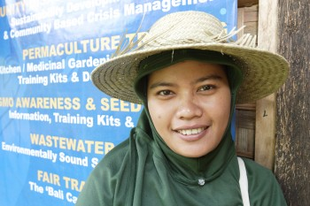
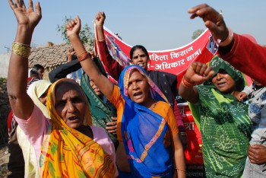
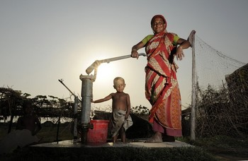

Oxfam is a global movement of people working together to end the injustice of poverty.

That means we tackle the inequality that keeps people poor. Together we save, protect and rebuild lives. When disaster strikes, we help people build better lives for themselves, and for others. We take on issues like land rights, climate change and discrimination against women. And we won’t stop until every person on the planet can enjoy life free from poverty.

Oxfam is a confederation of 21 organizations working together in more than 70 countries. We are part of a global movement for change, empowering people to create a future that is secure, just, and free from poverty.

Oxfam in Vietnam is working to seek transformative changes in policies, practices and beliefs in ways that will fundamentally improve the lives of poor and marginalized women and men and ensure that all citizens have the same opportunity to enjoy their rights. Oxfam in Vietnam current country strategy contributes to shaping the debate on extreme inequality in Vietnam and globally, our three program goals include promoting gender equality and women’s agency, social accountability and empowered citizens, and secured livelihoods and resilient communities.

All our work is led by three core values: Empowerment, Accountability, Inclusiveness. To read more about our values please click here

Oxfam is committed to preventing any type of unwanted behavior at work including sexual harassment, exploitation and abuse, lack of integrity and financial misconduct; and committed to promoting the welfare of children, young people and adults. Oxfam expects all staff and volunteers to share this commitment through our code of conduct. We place a high priority on ensuring that only those who share and demonstrate our values are recruited to work for us.

The Programme
Oxfam’s Good Governance programme is focused on ensuring that all citizens, in particular those who are marginalised in society, such as ethnic minorities and poor men and women, have increased access to information and feel confident about raising their voices. We work to ensure that citizens have greater opportunities to influence decisions that shape their lives and are able to hold the government accountable.
As part of the Governance and Civil Society programme, the objective of project EU JULE JIFF is to contribute to strengthen the rule of law in Vietnam through a more reliable, trusted and better accessed justice system. The specific objective is to increase access to justice for vulnerable groups, in particular women, children, ethnic minorities and poor people.

The Role
Oxfam in Vietnam is seeking a qualified Vietnamese candidate for the position of Programme Intern for Justice Initiatives Facilitation Fund of the EU Legal and Judicial Empowerment Programme in Viet Nam (EU JULE JIFF). The intern will work under line management of Oxfam’s Programme Admin Officer, in close collaboration with other members in the JIFF team. Selected intern will also provide administrative support to Governance team and take part in governance activities as well as number of training opportunities. He/she is expected to gain general knowledge, use common senses and specialized skills to the best of his/her ability to contribute to his/her own and Oxfam’s learning
Contract: Full-time, Fixed-term, 1-year contract
Reporting to: Programme Administrative Officer
Staff report to this post: N/A
Location: Vietnam office in Hanoi, with occasional travel

Key responsibilities:
Administrative support:
• Provide general administrative support including filing, sending and circulating mail, fax; photocopying, travel booking, helping to prepare float accounts;
• Provide interpretation and translation of letters and project documents;
• Attend meetings, take notes and prepare meeting minutes;
• Provide logistical support in the organization of trainings, workshops, and field trips;
• Support the organisation and implementation of project activities in the field;
• Support for preparing training manual, IEC materials, and other publications;
• Join field trips when required;
• Perform others support tasks to JIFF team, as required.
Communication and learning:
• Together with Program Administrative Officer, contact programme partners, consultants and other stakeholders in relevant activities;
• Participate in some learning sessions organized for Oxfam staff.
Other supports to JIFF’s team:
• Support in organising trainings, workshops on capacity building for grantee
• Support in collecting and storing information for project Monitoring and Evaluation
• Provide knowledge for partners in legal aid and justice activities

Skills, experience and knowledge
• University graduate; graduate with background in law, public administration or social development is a plus;
• Very good spoken and written English and Vietnamese;
• Good computer skills (MS Word, MS Excel, Ms Outlook, PowerPoint);
• Good communication skills;
• Ability to work independently as well as in the team;
• Strong motivation for learning about development work;
• Willingness to travel, if required.

Benefits: monthly allowance of VND3,000,000, plus lunch allowance and accident insurance covered for the employment period.

How to apply
Interested candidates can send your application including motivation letter and curriculum vitae via this LINK

The closing date for application: 10th October 2021

We regret that only short-listed applicants will be contacted.

Oxfam is an equal opportunity employer

