

Financial Flows for Climate Adaptation and Resilience in Zimbabwe

By

N Dube
&
VN Jakarasi

Executive summary
Climate Change presents a significant threat to the environment, human life, food security and economic development. Africa will be the most affected continent due to poverty and low adaptive capacity and Zimbabwe has not been spared by the impacts of climate change as studies have shown that Zimbabwe is now experiencing more hot and less cold days than in the past and rainfall has become erratic in space and time. This study increases understanding of adaptation financing in Zimbabwe. Climate finance generally refers to finance for activities aiming to mitigate or adapt to the impacts of climate change. However, it is sometimes conflated with the related and overlapping concepts of development and green finance.

The immediate user of the outputs of this study will be Oxfam and its partners as they contribute towards shaping their national climate justice advocacy. The study will also help to identify adaptation climate finance that can be amplified through the global climate finance demands ensuring an engendered and green economy. Specifically, the study will:

- Assess climate finance flows in Zimbabwe as Oxfam’s contribution on climate finance data and evidence for advocacy on Climate Justice.
- Provide evidence on the current situation and offer options for improvements based on evidence.
- Contribute to the broader agenda of climate justice effort of the government and other development practitioners used for organisational learning, capacity building, accountability, and advocacy.

The findings from this study will serve as a baseline of climate finance flows for Zimbabwe; help to improve the understanding of volume, sources, thematic uses, and sectoral allocation of these climate finance flows; and identify entry points, financing gaps, and opportunities for new investments. The evidence will be used by Oxfam partners and target groups to influence national financial flows and access to climate finance by communities and sectors at the frontline of the climate crisis. Regarding the Zimbabwean adaptation finance situation, the study endeavours to:

- Provide an exhaustive list of adaptation climate finance flows available to Zimbabwe (international, national, and local) available and how they work.
- Provide an analysis of gaps related to access to adaptation climate finance by different actors including CSOs, NGOs, government, and other stakeholders.
- Assess socio-economic and financial implications (past and projected) of climate in Zimbabwe through the development of climate expenditure analyses and modelling.
- Provide an analysis on how to improve the access to climate finance for vulnerable and marginalized populations in Zimbabwe.
- An analysis of barriers that exclude local communities at the frontline of the climate crisis from accessing climate finance / making the access more difficult.
- Provide recommendations based on analysis of gaps and opportunities to help the national government, sub-national governments, local communities, CSOs and marginalized groups to better access climate finance, and to influence national and likely international financial mechanisms and flows for them to be better suited for inclusion of local communities and marginalized groups.

Adequate climate financing for adaptation is important for Africa due to its vulnerability to climate change and the need to build resilience in various sectors for sustainable socio-economic development.

Methods
This study uses the Rio Markers in the Organisation for Economic Cooperation and Development (OECD)’s Creditor Reporting System (CRS) which require donors to indicate if an aid project contributes ‘principally’ or ‘significantly’ to climate change mitigation or adaptation. However, the Rio Markers are rife with inconsistencies and over-reporting on adaptation aid due to unclear definitions and political motivation in the coding done by donor institutions. To deal with the challenges of definitional ambiguity when utilising the Rio Makers, an action research design was followed. The OECD database was used and all finances that flowed into Zimbabwe under the climate adaptation tag were catalogued. These were then filtered with a focus on those flows that were considered principally or significantly linked to adaptation. National policies were used to contextualise the meaning of climate change adaptation in Zimbabwe together with the constituents of an adaptation project.

Findings
Between 2002 and 2022, it is estimated that bilateral adaptation financing flowing into Zimbabwe totaled USD2,579,625,924 while flows from multilateral climate funds were estimated at USD471,724,737. The total financing is therefore estimated at USD3,051,350,661 over 20 years or USD152,567,533 annually in adaptation finance flowing to Zimbabwe and the per capita adaptation financing received by Zimbabweans annually is about USD10 less 20% which goes to administrative and specialist fees resulting in an estimated annual per capita adaptation finance disbarment of USD8. The AfDB estimated the per capita adaptation cost in Africa at USD17. This means that at the current level of adaptation financing realised, Zimbabweans are experiencing an adaptation financing gap of over 53%. Thus, to adequately deal with resilience building in Zimbabwean communities, adaptation financing must increase by at least 53% annually.

Although adaptation financing continues to play second fiddle to mitigation financing in the global climate agenda and is an issue prioritised more by the global south who are owed a climate debt and suffer more from the negative aspects of climate change, CSOs and NGOs have played a major part in advocating for the climate debt, adaptation finance and fairer financing. This means they can still do more to ensure adaptation financing reaches those that need it most today. The adaptation finance flows that come into Zimbabwe from bilateral and multilateral platforms also given an extensive debate on the suitability of different sources of adaptation finance flows with a focus on the major donor countries and funds; the areas most funded and local channels through which funds flow. For stakeholders in the adaptation finance space, it is paramount to have a balanced perspective of bilateral and multilateral climate finance platforms. Adaptation financing and climate financing in general should ideally flow through multi-lateral climate funds rather than bilateral lines as this allows the global south to have more power in the negotiation processes. While it is easier for CSOs and NGOs to access funding through bilateral channels, this is not ideal for the long-term climate justice agenda which seeks to give more control of climate financing to the global south.

There is also need for clarity on the types of financing used i.e., more grant financing is required instead of the business-as-usual loans and other market financial instruments. This would bring back advocacy dimensions of global taxation spaces such as the aviation industry. From the same vein, the study noted with concern that climate finance is moving towards market financing which may be used to weaken the global south solidarity in the negotiation processes. Finally, climate funds are heavily duplicated, and this creates confusion that makes it difficult to adequately account for climate funds. The list of adaptation finance funds provided has endeavoured to be as exhaustive as possible but should still be considered as a minimum baseline value given that the data sources may have omitted critical donations that were not captured in the databases consulted. The adaptation finance flows analysed showed that Zimbabwean CSOs and small NGOs are more likely to get bilateral support from the USA, Japan, Germany and Ireland than any other donor countries. The assumption is that the more the projects, the more the spread and the chance of small CSOs and NGOs receiving adaptation finance flows.

The study also considered the broader space of climate justice with a focus on the climate debt and how things have evolved as attempts have been made to claim compensation for the global climate debt. The socio-economic and financial implications (past and projected) of climate in Zimbabwe through exposing current gaps and giving projected adaptation requirement has also been undertaken and ultimately showed that diversification of adaptation finance options is necessary and possibly including the private sector.

Recommendations
- CSOs and NGOs in Zimbabwe should join global advocacy on “burden sharing mechanism” that includes an international levy on international aviation and maritime transport to fund adaptation in vulnerable countries. This would improve the replenishing of multilateral climate funds and allow for more financing where the global south has more of a say.
- As a transitionary measure, developed countries could consider setting up dedicated national funds in whose primary purpose is mobilizing finances which are then channeled towards projects concepts developed by the global south. This would improve the relevance of bilateral finance to the developing world though it be technically duplication of the multilateral funds at country level which on its own is not ideal but a functional step forward in adaptation finance. The EU institutions could technically represent a step towards this.
- CSOs and NGOs in Zimbabwe must advocate for better use of the strengthening mechanisms in the multilateral funds —e.g., the project preparatory facility of GCF— than to remain in the business-as-usual bilateral space that has is characterized by unfair relations and tends to relegate the climate debt owed to the backdrop.
- It is critical for the Zimbabwean CSOs and NGOs to locate their advocacy position in the long-standing debate on control versus abuse of funds. The recommended position is the midpoint where there is a healthy level of trust in the governance systems and a fair level of autonomy in the use of aid that is not attached to multiple conditionalities. This midpoint should be ideally the space that is created by CSOs, NGOs and other non-state actors through advocacy for more transparent use of adaptation finance and less conditionalities in the use and access to aid by Zimbabwean stakeholders.
- CSOs and NGOs in Zimbabwe should always be on the lookout for possibilities donor control and abuse of adaptation financing. When evidence exists for their presence, they must fully challenge them as CSOs and NGOs to ensure that the beneficial aspects of bilateral aid being used as a swift focused mechanism of delivering climate finance are not lost.
- CSOs and NGOs in Zimbabwe must start developing methodologies and procedures for private sector entrance into the adaptation finance space.
- There is need to consider the development of a contextualised climate-verse dictionary that would explain critical issues from the science of climate change, its management, key institutions and issues of climate finance. Such a dictionary was said to be more effective if it was accompanied by climate-verse training of development workers preferably from more than just government. This would allow development practitioners to better explain climate change related issues to communities who were said to see most adaptation initiatives as extensions of development projects and at most disaster response activities.
- Related to the dictionary would be a simplified climate finance guide to allow for targeted information for specific groups together with answers to commonly asked questions with possible references where more information could be sought.
- Deliberate action is required to separate the climate-verse from the general environmental management space all the way to the grassroots so that communities are aware of adaptation initiatives.
- Areas of further research emerging from this project include an assessment on the utilisation of the adaptation finance, the disaggregation of adaptation financing by gender and baseline on the understanding of adaptation finance by the private sector together with the adaptation finance flows associated with the public sector.

Acknowledgements
To be added by Oxfam

Table of Contents
Executive summary i
Acknowledgements v
List of figures vii
List of tables vii
List of acronyms viii
1. Introduction: The financing of climate change management 1
1.1. Climate change in the Zimbabwean space 2
1.2. What is climate finance? 3
1.3. A snapshot of adaptation financing in Africa 5
1.4. Goals and objectives 5
1.5. Data Sources and Methodology 6
1.6. Structure of the report 7
2. The progression of adaptation finance and the role of CSOs and NGOs 8
2.1. Multilateral climate funds 12
2.2. Section conclusions 13
3. Adaptation financing in Zimbabwe 14
3.1. Does the money reach the grassroots? 15
Building Climate Resilience of Vulnerable Agricultural Livelihoods in Southern Zimbabwe 15
3.2. How much adaptation finance has been received? 16
3.3. Who are the major donors? 20
3.4. What issues are covered by bilateral adaptation finance flows? 23
3.5. The national adaptation plan and the financing gap 25
3.6. Section conclusions 25
4. Access to multilateral climate funds by Zimbabwean CSOs and NGOs 27
4.1. Perspectives from the ground 27
4.2. Summary of perceptions 28
5. Overall conclusions and recommendations 30
5.1. Recommendations 31
References 33

List of figures

Figure 1. 1: Climate and Development Finance Landscape (OECD, 2015) 3
Figure 1. 2: The global climate financing architecture 4
Figure 1. 3: African adaptation finance deficit 5

Figure 2. 1: The progression of Adaptation under the UNFCCC 11

Figure 3. 1: SADC Total Climate Finance Flows 2013-2017 (Routil, n.d) 14
Figure 3. 2: Bilateral adaptation financing in Zimbabwe 2002-2022 17
Figure 3. 3: Multilateral climate funds —in USD Millions— flowing to Zimbabwe 2002-2022 17
Figure 3. 4: Multilateral climate finance flows—in USD Millions— into Zimbabwe 2002-2022 (Number of projects) 18
Figure 3. 5: Prominent bilateral donors for adaptation finance 2002-2022 20
Figure 3. 6: Donor country adaptation financing disaggregated by years 21
Figure 3. 7: Number of adaptation finance projects by donor country by year 21
Figure 3. 8: Recipients of adaptation financing in Zimbabwe 22
Figure 3. 9: Aspects financed by bilateral donors 23

List of tables
Table 1. 1: Social vulnerability and climate risk in Zimbabwe 3

Table 2. 1: Global Multi-lateral climate funds 11

Table 3. 1: Adaptation costs for Zimbabwe up to 2030 25

Table 4. 1: Issues on accessing multilateral climate finance funds in Zimbabwe 28
Table 4. 2: CSO Barriers to accessing adaptation finance by Lorimer et al. (2018) 29

List of acronyms

AF | Adaptation fund
AOSIS | Alliance of Small Island States
CAN | Climate Action Network
CDM | Clean Development Mechanism
CER | Certified Emission Reduction
CFU | Climate Funds Update
CIFs | Climate Investment Funds
COP | Conference of Parties
CSO | Civil Society Organisation
CTF | Clean Technology Fund
EMA | Environmental Management Agency
EU | European Union
GCF | Green Climate Fund
GEF | Global Environmental Facility
IMF | International Monetary Fund
IPCC | Inter-governmental Panel for Climate Change
L&D | Loss and Damage
LDC | Least Developed Countries
LDCF | Least Developed Countries Fund
LEDS | Low Emissions Development Strategy
MAC | Marginal Abatement Cost
MCFs | Multilateral Climate Funds
MDBs | Multilateral Development Banks
NAP | National Adaptation Plan
NDC | Nationally determined contributions
NGO | Non-Governmental Organisation
ODA | Development Assistance
OECD | Organisation for Economic Development and Cooperation
SCCF | Special Climate Change Fund
SCF | Strategic Climate Fund
UK | United Kingdom
UN | United Nations
UNDP | United Nations Development Programme
UNFCCC | United Nations Framework Convention for Climate Change
USA | United States of America
WASH | Water Sanitation and Hygiene
WFP | World Food Programme

Introduction: The financing of climate change management

The management of climate change centres on climate change mitigation —actions that reduce the emission of greenhouse gases or carbon sequestrations —actions that remove excess CO2 in the atmosphere — adaptation —actions that allow human and ecological systems to cope with a changing climate — and weather engineering —actions that manipulate weather systems. Although climate change is a global crisis, its effects are not felt evenly around the world. The worst effects of the climate crisis – for example extreme heat, flooding and crop failures – are disproportionately felt by countries and communities in the Global South. A core tenet of international climate policy, since the creation of the United Nations Framework Convention on Climate Change (UNFCCC) in 1992, has been that the developed world, which is largely responsible for greenhouse gas emissions, will assist the developing world in developing sustainably through promoting mitigation actions and adapting to climate change. Article 2, paragraph B of the Paris agreement focuses on increasing the ability to adapt to the adverse impacts of climate change and foster climate resilience and low greenhouse gas emissions development, in a manner that does not threaten food production.

Climate Change presents a significant threat to the environment, human life, food security and economic development. The International Governmental Panel on Climate Change Sixth Assessment Report (IPCC, 2022) indicates that Africa will be the most affected continent due to poverty and low adaptive capacity. The anthropogenic effects have been contributing to the changing of the earth’s climate. Global temperatures have increased, and the rainfall has become increasingly erratic and uncertain. The impacts of climate change include increased frequency of droughts and floods, high temperatures and other disasters. Globally, sectors such as agriculture, water, health, disaster-risk reduction, infrastructural development, transport, ecosystems and settlements are highly vulnerable to these impacts. Increasingly climate change has contributed to loss and damage where some of the impacts are irreversible.

The cost of adapting to climate change in the developing world over the next few decades has been estimated at up to or over $100 billion / year (Parry 2009, World Bank 2010), although there are questions about the reliability of such estimates (Fankhauser 2010). United Nations Environment Programme also indicated that this could range between $140-$300 billion per year in 2030 and can reach $280-$500 billion in 2050. According to Zimbabwe’s NDC, US$5.4Billion is required for adaptation up to 2030 but according to the National Adaptation Plan, US$10, 6 billion is required up to 2030. Adaptation finance needs both regionally and nationally fall short of what is required and there is an increased call to double adaptation financing and prioritise it to the level that mitigation has been considered. Only 3% of private sector financing is channelled to adaptation, leaving a great need to explore how more private sector financing can be unlocked as fund managers are managing over US$100 trillion, which part of it can be channelled to adaptation initiatives.

To support adaptation actions, Cancun in 2010, the developed country parties to the UNFCCC agreed to mobilize climate financing of US $100 billion/year by the year 2020 to assist the developing world in responding to climate change, including both adaptation and mitigation. To not jeopardize other development efforts, the targeted $100 billion/year in climate aid was expected by the UNFCCC to be ‘new’ and ‘additional’ to development aid (Donner, Kandlikar and Webber, 2016). This and the general global debate on climate finance has been met with different responses from both the developed and developing countries in their quest to tackle the climate crisis through actions and responsiveness towards a net zero-emission ambition by the year 2050.

Climate change in the Zimbabwean space
Zimbabwe has not been spared by the impacts of climate change as studies have shown that Zimbabwe is now experiencing more hot and less cold days than in the past and rainfall has become erratic in space and time (Manatsa, 2020; Dube et al., 2018; Mubaya and Mafongoya, 2017; Unganai et al., 2013). There is also an increased frequency and intensity of droughts and floods, affecting water availability and quality, agriculture production and food security among others. Recent climate change observations and projections for Zimbabwe provide ample evidence that key sectors such as Water, Health, Energy, Agriculture and Infrastructure are already being affected, with serious consequences for social and economic development (Chirisa et al., 2021). Cyclone Idai was a clear demonstration that the country has limited capacity to deal with the impacts of extreme weather events rooted in climate change. See case of Cyclone Idai in Zimbabwe below.

Zimbabwe Cyclone Idai  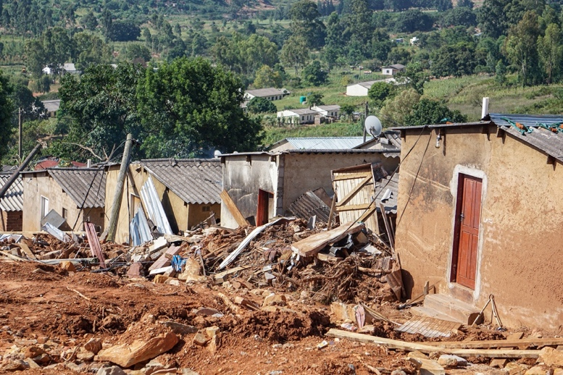  Damage caused by cyclone Idai in Manicaland province, Zimbabwe. | Cyclone Idai struck Zimbabwe in March 2019, causing extensive damage estimated at between US$622 million and US$1Billion. Over 50,000 households were destroyed, directly affecting 270,000 people, including 60,000 who were displaced. The World Bank Group provided an initial first response amount for relief efforts with $250,000 in humanitarian aid. This climate disaster bill was partly footed by development partners but ultimately the government of Zimbabwe has and is still dealing with the responsibility of paying for the costs of the climate disaster. Financing such a cost will ultimately increase the national debt burden as the government turns to the financial markets to borrow in order to deal with the climate change related challenges.

The droughts and floods depicted above are already affecting the availability, accessibility, quality and quantity of the country’s water resources are expected to continue. Vulnerability to climate change is higher in the rural spaces of Zimbabwe where the majority is dependent on rainfed agriculture (Chirisa et al., 2021). The intermittent rainfall has resulted in reduced crop yields, low livestock productivity, poor pastures all leading to increased vulnerability of rural communities through reduction of food security, livelihood options and loss of income generating capacity (Chari and Ngcamu, 2022; Murombo, 2020; Kupika et al., 2019).

Dzwimbo et al, (2022) explained that vector and water borne diseases are increasing mortality and morbidity among vulnerable groups and climate change is expected to exacerbate existing gender inequalities in livelihoods and adaptive capacity. Women and children are among the vulnerable groups, and the more vulnerable they become, the less likely they can employ the robust response strategies and the less likely they are to escape poverty and cope with the impacts of climate change (Mukurazhizha and Matanga, 2023). According to the Zimbabwe Vulnerability Assessment Committee report of 2021, the global acute nutrition rate of children between 6–59 months reached 5.7%, which was the highest recorded in 15 years. Dube (2023) summarised the major climate risks associated with Zimbabwe as shown in Table 1.1.

Table 1. 1: Social vulnerability and climate risk in Zimbabwe
Key Sources of Vulnerability |  | Climate Risks
- Rising temperatures  - Uncertain rainfall patterns  - Increase in rainfall extreme events in both intensity and frequency of floods and droughts  - Shortening of growing season  - Increase in landslides |  | - Water scarcity  - Food and nutrition insecurity  - Negative health impacts for humans and livestock  - Intensified Landslides and erosion  - Increase in human-wildlife conflict  - Deterioration in biodiversity  - Increase in infrastructure damage & settlement damage
Identified Climate Change Impacts
- Increase in climate related disasters
- Declining agricultural productivity
- Food insecurity
- Land and ecosystem degradation
- Shifts in intra-seasonal rainfall characteristics

What is climate finance?
Climate finance generally refers to finance for activities aiming to mitigate or adapt to the impacts of climate change. However, it is sometimes conflated with the related and overlapping concepts of development and green finance. Climate finance primarily flows in the following streams (see Figure 1.1):
- Domestic public – Government income from taxes and budget, strengthened tax administration, improved quality expenditures, risks management e.g., Government of Zimbabwe Taxes including carbon tax, green bonds, Banks, such as the Infrastructure Development Bank of Zimbabwe (IDBZ) Climate Finance Facility and National Climate Change Fund (being developed)
- International public – Aid, grants and concessional finance, multilateral and bilateral (GCF, GEF, AF). Developmental partners such as the United Nations Development Programme (UNDP), Oxfam, ActionAid, EU, SIDA, etc
- Domestic private – National private sector for instance corporations and SMEs; individuals, corporates, institutional investors (pension and insurance funds such as NSSA and Old Mutual).
- International private – Foreign Direct Investment (FDI), remittances, private philanthropy, financial market-based financing (carbon markets) and private sector-like investment return focused sovereign wealth fund (World Bank, IMF).
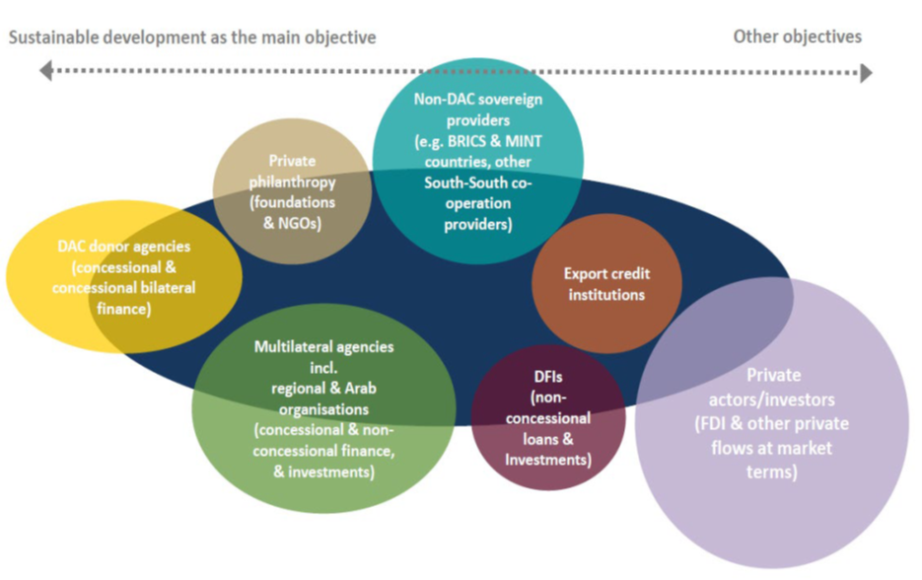
Figure 1. 1: Climate and Development Finance Landscape (OECD, 2015)

Almost all these flows are encapsulated in Bilateral (country to country) and multi-lateral climate and non-climate financing mechanisms. Multilateral non-climate finance sources mainly are Multilateral Development Banks (MDBs) while the five major Multilateral climate funds connected to the institutional framework of the United Nations Framework Convention for Climate Change (UNFCCC), are the Least Developed Countries Fund (LDCF), Special Climate Change Fund (SCCF), Adaptation Fund (AF), Global Environmental Facility (GEF), and Green Climate Fund (GCF) (see Figure 1.2 with key multilateral funds circled in red).

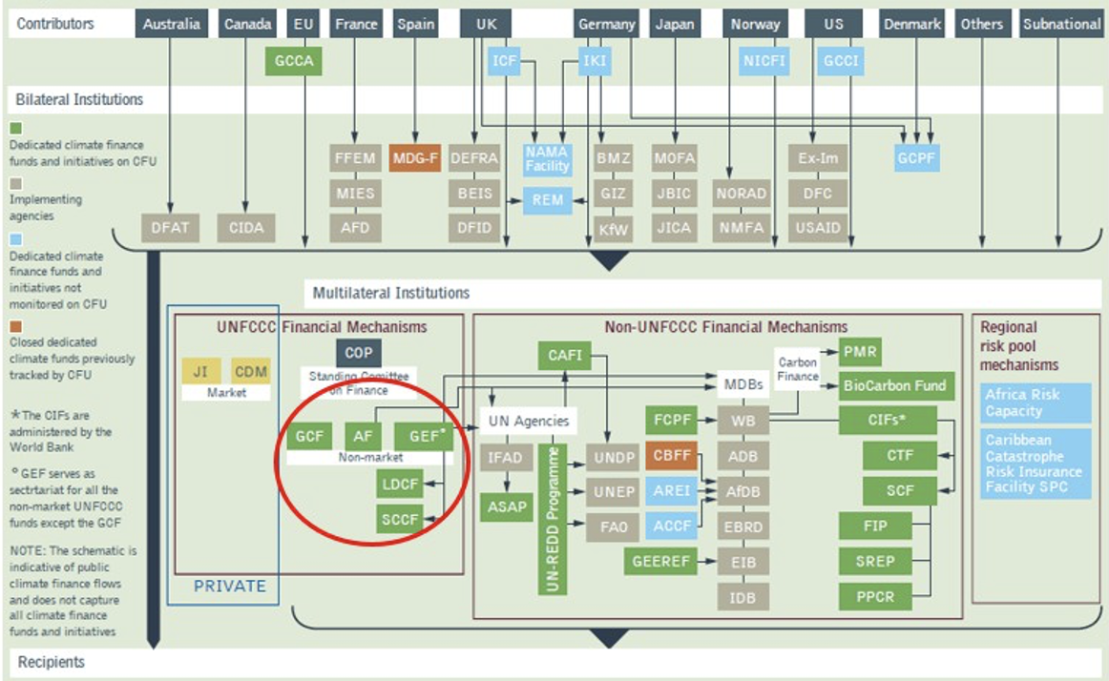
Figure 1. 2: The global climate financing architecture

The UNFCCC also includes the Climate Investment Funds (CIFs) comprising of the Clean Technology Fund (CTF) and the Strategic Climate Fund (SCF) (Doshi and Garschagen, 2020). The CIFs include a “sunset clause” which calls for the funds to close once a new climate finance architecture, mostly around the Green Climate Fund, is effective. As they fall outside the UNFCCC governance framework, they are supposed “not to prejudice the on-going UNFCCC deliberations regarding the future of the climate change regime, including its financial architecture” (SCF, 2011).

Regarding adaptation focused climate finance, Khan et al. (2020) noted numerous struggles that climate managers had to deal with when raising and using climate finance for adaptation. These struggles have involved conflicts related to several key questions:

- How much finance should be provided to support climate adaptation?
- Who should provide adaptation finance?
- Through which channels should adaptation finance be delivered to developing countries?
- How should it be allocated? Should some countries be prioritized?
- Which, and on what basis? Does adaptation finance represent a form of compensation from “polluting” countries to “victims” of climate change?

Such questions on the norms and rules that guide adaptation finance are at the core of climate justice which is a critical issue in the climate finance discourse.

A snapshot of adaptation financing in Africa
According to (GCA, 2023) Current adaptation finance flows in Africa are insufficient to meet the growing adaptation needs on the continent. As such, Africa faces a serious and urgent shortfall in funding for climate adaptation, even as the costs of delayed action rise. Figure 3 shows a cumulative analysis of the Nationally Determined Contributions (NDCs) of 51 African countries showed a need for an estimated US$579 billion (or approximately US$52.7 billion annually) in funding for adaptation through 2030 while tracked adaptation financing in 2019 and 2030 was at US$11.4 billion (GCA, 2023).
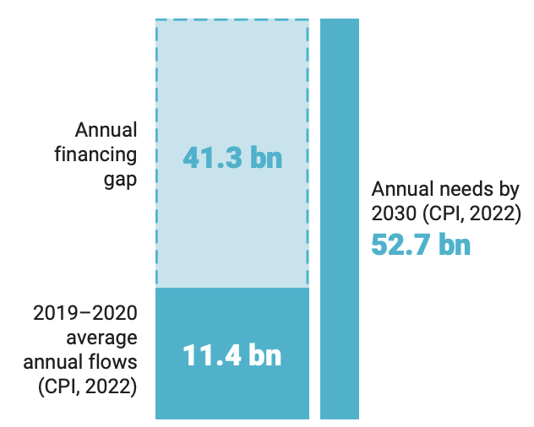
Figure 1. 3: African adaptation finance deficit

GCA (2023) also noted that adaptation finance was approximately 39% of total tracked climate finance to Africa in 2019– 2020. Further, the share of adaptation finance as a percentage of total climate finance was higher in Africa than any other region for 2019–2020. Across Africa, multilateral development finance institutions (DFIs) were the most significant source of adaptation finance flows (53%, US$6 billion), followed by governments (23%, US$2.6 billion) and bilateral DFIs (16%, US$1.8 billion).

More than half (53%) of the adaptation finance commitments to Africa in 2019–2020 were loans. A high share of financing from multilateral DFIs was committed in the form of commercial-rate loans (41%) and concessional loans (32%), whereas bilateral DFIs primarily committed concessional loans (82%). By contrast, more than 90% of adaptation finance committed from governments was in the form of grants, with less than 6% in the form of loans. The share of grants and loans varies across regions and the income profile of countries. Low-income countries primarily attracted grant commitments for adaptation financing, whereas lower-middle-income countries largely saw commitments of loans at market rate (58%) (GCA, 2023)

Goals and objectives
This study increases understanding of adaptation financing in Zimbabwe. The immediate user of the outputs of this study will be Oxfam and its partners as they contribute towards shaping their national climate justice advocacy. The study will also help to identify adaptation climate finance that can be amplified through the global climate finance demands ensuring an engendered and green economy. Specifically, the study will:

- Assess climate finance flows in Zimbabwe as Oxfam’s contribution on climate finance data and evidence for advocacy on Climate Justice.
- Provide evidence on the current situation and offer options for improvements based on evidence.
- Contribute to the broader agenda of climate justice effort of the government and other development practitioners used for organisational learning, capacity building, accountability, and advocacy.

The findings from this study will serve as a baseline of climate finance flows for Zimbabwe; help to improve the understanding of volume, sources, thematic uses, and sectoral allocation of these climate finance flows; and identify entry points, financing gaps, and opportunities for new investments. The evidence will be used by Oxfam partners and target groups to influence national financial flows and access to climate finance by communities and sectors at the frontline of the climate crisis. Regarding the Zimbabwean adaptation finance situation, the study endeavours to:

- Provide an exhaustive list of adaptation climate finance flows available to Zimbabwe (international, national, and local) available and how they work.
- Provide an analysis of gaps related to access to adaptation climate finance by different actors including CSOs, NGOs, government, and other stakeholders.
- Assess socio-economic and financial implications (past and projected) of climate in Zimbabwe through the development of climate expenditure analyses and modelling.
- Provide an analysis on how to improve the access to climate finance for vulnerable and marginalized populations in Zimbabwe.
- An analysis of barriers that exclude local communities at the frontline of the climate crisis from accessing climate finance / making the access more difficult.
- Provide recommendations based on analysis of gaps and opportunities to help the national government, sub-national governments, local communities, CSOs and marginalized groups to better access climate finance, and to influence national and likely international financial mechanisms and flows for them to be better suited for inclusion of local communities and marginalized groups.

Adequate climate financing for adaptation is important for Africa due to its vulnerability to climate change and the need to build resilience in various sectors for sustainable socio-economic development. Global multilateral climate funds play a significant role in providing adaptation financing from African countries. The Green Climate Fund is one of the key funds established to support adaptation efforts, also complemented by the Adaptation Fund. The Africa Development Bank has also played a significant role in providing through the Africa Climate Change Fund in providing finance for adaptation and resilience-building initiatives in the continent. Bilateral initiatives led by multilateral development banks, donor countries and international organisations have also played a critical role in supporting adaptation actions in Africa. Whilst adaptation is deemed to be largely social with a low return on investment, the private sector is increasingly coming on board. Zimbabwe’s adaptation financing has not been unique from the Africa’s financing landscape as the GCF, GEF, AF, donor countries, international organisations and the private have also shaped adaptation financing in Zimbabwe.

Data Sources and Methodology
This study uses the Rio Markers in the Organisation for Economic Cooperation and Development (OECD)’s Creditor Reporting System (CRS) which require donors to indicate if an aid project contributes ‘principally’ or ‘significantly’ to climate change mitigation or adaptation. However, the Rio Markers are rife with inconsistencies and over-reporting on adaptation aid due to unclear definitions and political motivation in the coding done by donor institutions. Despite these challenges, it remains the most comprehensive database to estimate adaptation flows into a country (Bigger and Millington, 2020); Adaptation Watch, 2015).

To deal with the challenges of definitional ambiguity when utilising the Rio Makers, an action research design was followed. The OECD database was used and all finances that flowed into Zimbabwe under the climate adaptation tag were catalogued. These were then filtered with a focus on those flows that were considered principally or significantly linked to adaptation. National policies were used to contextualise the meaning of climate change adaptation in Zimbabwe together with the constituents of an adaptation project.

After the filtering, key stakeholders —communities, climate change managers at national level, civil society organisations (CSOs), policy makers, academics, and community leaders— were gathered in a series of consultative workshops where the filtered adaptation finances were presented and further assessed for their alignment with the national constituents of adaptation in line with key national documents such as the National Adaptation Plan (NAP) and the National Climate policy. Virtually consultations were done to improve the methodology and to validate the OECD data that was used for this study.

The final flows to the related projects on the OECD database were then recorded and used as the key baseline data for adaptation flows to Zimbabwe. Adaptation flows that were considered spanned the years 2002 to 2022 which coincided with the critical climate change summits in Rio de Janeiro, Brazil. Databases containing information on adaptation flows from multilateral climate funds were added to the overall climate finance flows into Zimbabwe over the same period with additional information shared by the Climate Change Management Department in the Ministry of Environment, Climate and Wildlife.

After the capturing, filtering and internal stakeholder assessment of the flows, the same stakeholders were asked to give independent perspectives on the understanding, access to and utilisaiton of adaptation finance in Zimbabwe. These perspectives have been used to paint a more nuanced picture of the relationship between adaptation finance flows and the grassroots recipients.

Structure of the report
This report is structured into four sections. Section 1 is the introduction and provides the background to the study, objectives of the research and the research methodology. Section 2 covers the progress of adaptation finance globally and regionally, a summary on how adaptation financing has evolved since the formation of the UNFCCC and the role of different stakeholders in adaptation financing. This is followed by Section 3 which highlights the adaptation requirements in Zimbabwe now and into the future thereafter, an accounting for the actual amounts of adaptation finance that have flowed into Zimbabwe focusing on how much has flowed in to the country, from which sources, targeting what projects and facilitated by who. Issues regarding the general understanding of climate change management issues are then considered from the perspective of civil society organisations (CSOs) and local non-governmental organisations (NGOs). The report then comes to its logical conclusions giving recommendations centred on advocacy issues for climate justice in the adaptation finance space in Section 4.

The progression of adaptation finance and the role of CSOs and NGOs

Having been drafted in 1991 and 1992, the Convention (UNFCCC) focused mostly on mitigation as the ultimate solution to climate change (Khan 2014). In the initial years, adaptation was overlooked in part because of the apprehension that it might lead Parties to underemphasize mitigation (Ciplet et al. 2015). Also, adaptation was viewed as a national issue whose addressing resulted in national benefits unlike mitigation which had global benefits. Moreover, while AOSIS raised the issue of compensation for climate impacts suffered, compensatory justice was largely neglected by the COP, and relegated to a decision on the provision of insurance (see Article 4.8). This was, in part, because the climate regime has often narrowly reflected market-based solutions of both economic growth and climate change within the framework of neoliberal, market economics (Ciplet and Roberts 2017). This placed adaptation on the back burner in terms of the developed countries taking responsibility for climate change.

The concepts of carbon debt, climate debt, and ecological debt were introduced into international climate politics in the late 1990s by NGOs such as Acción Ecológica and Christian Aid (Roberts and Parks 2006; Simms et al. 1999). The specific networks that pushed for gains in this area were broad-based, loosely tied, and often involved developing country State and non-State actors in the Global South and North working in tandem. The crux of the climate debt advocates for that the Global North owes the Global South a climate debt due to its disproportionate use of carbon space without payment (Martinez-Alier 2002), this debt is argued to be far greater than the Third World financial debt to the global north. Khan (2020) explained that the climate debt concept evolved to have two main components. First, because wealthy countries have utilized most of the atmospheric space for storing carbon emissions, developing countries should be paid an “emissions debt” to account for their fair share of atmospheric space. Second, wealthy countries owe an “adaptation debt” which represents compensation owed to enable developing countries to adapt and respond to climate impacts that are not of their own making and to develop more sustainably.

Around the same time, States in the Global South began expressing and demanding that the climate debt be recognised and serviced by the global north. The message was galvanized in the statement released by the Heads of State and Government at the Group of 77 (G77) and China’s South Summit in Havana in 2000. In subsequent years, the least developed countries (LDCs), Alliance of Small Island States (AOSIS), G77 and China, and a coalition of more than 30 Western NGOs, policy institutes, and think tanks began to aggressively push for remuneration of the ecological and climate debts (Roberts and Parks 2009), in addition there was a major call for wealthy States to take the lead on cutting emissions.

With the publication of the Third and Fourth Assessment Reports of the Intergovernmental Panel on Climate Change (IPCC) in 2001 and 2007, respectively, climate change issues began to be seen as development issues that required the mainstreaming of adaptation. On the other hand, mitigation was not being taken seriously by the developed countries. As a result, COP7 adopted the Marrakesh Accords in 2001, which, among other things, contained the first substantial package on adaptation. There, three Funds were established—the Least Developed Countries Fund (LDCF), the Special Climate Change Fund (SCCF) under the Convention and the Adaptation Fund under its 1997 Kyoto Protocol. In terms of adaptation finance, post Marakesh witnessed the laying out of infrastructure and the operationalization of the newly established Funds under the UNFCCC regime.

Despite the spirited efforts, adaptation was still not widely viewed as a core issue in the global development negotiations. It was not until COP13 in Bali in 2007 that developing countries made adaptation a core demand at the negotiations. Arguing that adaptation in the UNFCCC documents and discussions was “piecemeal,” Tuvalu, on behalf of the LDCs and AOSIS, introduced the so-called International Blueprint on Adaptation (Government of Tuvalu, 2007). Despite crucial elements being watered down, this document would largely set the agenda on adaptation politics for the next five years. In addition to calling for predictable and adequate funding and a coordinated international response to adaptation, the blueprint introduced a novel demand for a “burden sharing mechanism.” This included a proposal for an international levy on international aviation and maritime transport to fund adaptation in vulnerable countries.

The Climate Action Network (CAN) International, Climate Justice Now, a new climate justice network, and other civil society networks such as the Pan African Climate Justice Network, representing 63 NGOs from across Africa, attended COP15 in Copenhagen in record numbers in 2009. Many of these groups had adopted a justice message at the negotiations, focused on realizing a legally binding and enforceable treaty, and for wealthy countries to pay their climate debt, including the establishment of a Fund under the COP to administer such finance. Civil society groups in both CAN International and the newly formed Climate Justice Now! network made calls during this period for innovative public finance mechanisms to fund adaptation. CAN International, while focusing most of its attention on mitigation, called for adaptation to have equal footing with mitigation in the Convention (CAN International 2007). Many of the more radical groups demanded a “solidarity fund” or a “reparations fund” to administer climate debt to countries of the South. The Copenhagen negotiations, dubbed by critics as “Brokenhagen,” were a turning point in global climate politics. Expectations were high for a new agreement on climate action and support that finally addressed the legacy of climate injustices (Kahn, 2020).

Even after almost two decades, there were wide differences among groups of countries in the negotiations about how adaptation finance should be mobilized (Ciplet et al. 2015). There was a yawning gap in the amount of adaptation funds available to developing nations, compared with any assessment of adaptation needs. The Copenhagen Accord and the 2010 Cancun Agreements promised developing countries US$30 billion in short-term “fast-start finance” for the period 2010 to 2012 and a “scaling up” to US$100 billion per year by 2020. The proportion of the funding that would be in the form of pure grants, partial grants, or purely market rate loans was however not made clear. The Copenhagen Accord states that, “This funding will come from a wide variety of sources, public and private, bilateral, and multilateral, including alternative sources of finance.” Despite repeated complaints about this mixing of two very different types of finance, during this period, there was no improved clarity. The 2015 Paris Agreement avoids mentioning specifics, indicating that funds will be mobilized “from a wide variety of sources, instruments, and channels, noting the significant role of public funds” (Article 9.3). And unlike the Convention, the Copenhagen Accord and the Cancun Agreements, the Paris Agreement also does not mention “alternative/innovative” sources of finance, such as funds that could be generated through a tax on international financial transactions or international air travel.

Khan (2020) argued that in this murky space, contributor nations were protecting their right to channel climate finance through their own bilateral agencies (and not just through the multilateral climate Funds established under the UNFCCC) and to provide loans and export credits, instead of grants-based assistance. For instance, while the United States (USA) allocated no money to the UNFCCC or the Green Climate Fund (GCF) in 2018, for example, it channelled a larger amount of its climate finance support through its State Department, its Agency for International Development, and its Treasury (Thwaites, 2018; United States Government, 2018). This preference for prioritizing bilateral transfers is in no way surprising—the Paris Agreement avoids directly referencing some of the key principles of climate finance relating to funds mobilization, administration, governance, disbursement, and implementation (Schalatek and Bird 2015).

Channelling finance through the multilateral climate funds allows for more control of what the funds will be used for by developing countries who are free to craft their own programmes without numerous conditions that often characterise the bilateral funding channels (De Sépibus, 2014). However, since the creation of the multi-lateral climate funds developing countries have constantly expressed the fear that the new fund would remain an empty shell. For instance, De Sépibus (2014) noted that overall pledges for climate funds in 2013 were 71% lower than in 2012. Also, official development assistance (ODA), which contributed to 80% of adaptation finance is, in most cases, channelled through bilateral aid institutions. Finally, core funding for International Development Organisations (IDO), where donors’ contributions are pooled and disbursed according to the priorities set at the level of the multilateral governing bodies, is stagnating whereas ‘multi-bi-financing’, which allows ‘like-minded’ donors to earmark voluntary contributions, has witnessed a massive increase.

The Global Environment Facility (GEF), since its inception in 1993, began to fund adaptation projects. But developing countries were sceptical of the Facility because it is donor-controlled, based at the World Bank in Washington, D.C., and requires that all spending result in global public goods benefits, including in the case of adaptation projects (Khan 2014; Khan and Roberts 2013). Gradually, this policy was relaxed, and the Facility began accommodating a broader approach to adaptation funding. Nonetheless, developed countries preferred that the GEF oversee the Funds. Since major donors have near veto power at the World Bank, where the Facility is based. Developing countries objected to the GEF having administrative power over UN Funds. Further controversy was added by the GEF’s earlier Resource Allocation Framework, which was based on two criteria—global benefits from projects and country performance (GEF 2010). The criterion of “global benefits” is seen by the LDCs as a way of diverting most of the GEF resources to mitigation, while leaving almost nothing for adaptation. Despite developing country opposition, the LDCF and SCCF continue to be administered by the GEF (Khan, 2020).

Another issue that has been heavily criticized is the growing focus on private finance in institutions such as the GCF in lieu of public funds and governance forms that reflected business as usual, rather than the “transformative” approach outlined in the Fund’s mission statement. Civil society groups such as Jubilee South and Oxfam also critiqued the ways in which climate finance was further indebting LDCs and causing increased dependency when primarily provided as loans as opposed to grants.

Also, a challenge is the persistent issue of double or even triple counting of the same money provided through the UNFCCC and non-UNFCCC delivery channels which has not been resolved. The developed countries have been allowed to report on their own about how they count “new and additional” climate finance. This subjective fixing of accounting methodologies by finance providers hardly allows any comparability. An additional prick is the extreme fragmentation of climate finance delivery with the total number of public and private channels currently ranging from 99 to over 500, including over 22 multilateral climate finance Funds (NDC Partnership 2018; OECD 2015). There are too many overlaps involving huge transaction costs, which generate frustrations both for contributors who are duplicating efforts and recipients who have mountains of tedious paperwork to file to access these Funds (Robinson and Dornan, 2017; Robinson and Gilfillan, 2017). Figure 2.1 summarises the progression of adaptation finance issues within the UNFCCC while Table 2.1 shows the key global multi-lateral climate funds.

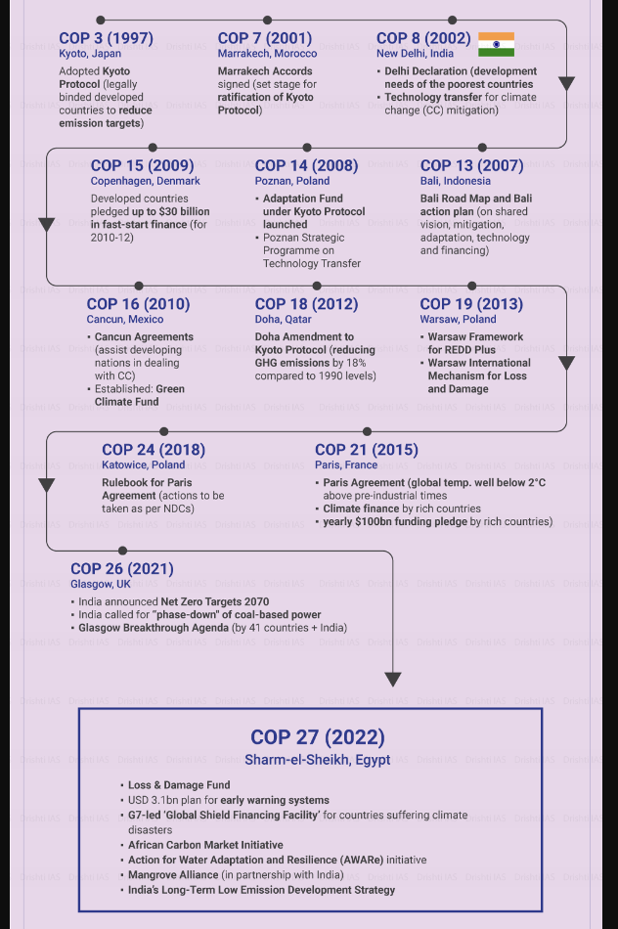
Figure 2. 1: The progression of Adaptation under the UNFCCC

Table 2. 1: Global Multi-lateral climate funds
 | LEAST DEVELOPED COUNTRIES FUND (LDCF) | SPECIAL CLIMATE CHANGE FUND (SCCF) | ADAPTATION FUND (AF) | GREEN CLIMATE FUND (GCF)
Year established | 2001/2002 | 2001/2004 | 2001/2008 | 2010/2015
Objective | Adaptation only | Adaptation and technology transfer | Adaptation only | Adaptation and mitigation, with a target 50–50-split in allocation
Overall funding | USD 1.3 billion, of which USD 1.2 billion have been allocated | USD 366 million, of which USD 285 million have been allocated | USD 755 million, of which over USD 720 million have been allocated | USD 7.2 billion mobilized (2015–2019), of which 5.6 billion have been allocated
Current status/ Horizon | Both funds are part of the Global Environment Facility’s (GEF) 2018–2022 Programming Strategy on adaptation to climate change |  | Adopted a Medium-Term Strategy (2018–2022) with an annual resource mobilization target of USD 100 million | First replenishment phase mobilized USD 9.8 billion for the term 2020–2023
Eligible countries | Least Developed Country (LDC) Parties to UNFCCC and countries which have completed their National Adaptation Programmes of Action (NAPAs) | Non–Annex I Parties to the UNFCCC, prioritizing most vulnerable countries in Africa, Asia, and Small Island Developing States (SIDS) | Developing country Parties to the Kyoto Protocol, prioritizing those which are particularly vulnerable to climate change | All developing country Parties to the UNFCCC which are Party to the Paris Agreement, prioritizing LDCs, SIDS and African states
Access Modality | Through an Implementing Agency of the Global Environment Facility (GEF) | Through an Implementing Agency of the Global Environment Facility (GEF) | Multilateral, Regional and National | Multilateral, Regional and National
Governance | GEF | GEF | AF Board | GCF Board
Trustee | World Bank | World Bank | World Bank | World Bank

Multilateral climate funds
Multilateral climate funds are increasing in importance and beginning to rival bilateral climate finance flows (Doshi and Garschagen, 2020). They aim to support resource poor and highly vulnerable countries following the principle of common but differentiated responsibility within the UNFCCC and the Paris Agreement (UNFCCC, 2015). Respective redistribution mechanisms from richer to poorer countries should constitute a cornerstone of the architecture of international adaptation finance (Brown et al., 2013). In the logic and legal terminology of the Paris Agreement, it is the “developing country Parties, especially those that are particularly vulnerable to the adverse effects of climate change and have significant capacity constraints” which qualify for such support and should be prioritized (UNFCCC, 2015 Article 9, Paragraph 4).

Countries therefore compete for multilateral funding, following the assumption that countries most in need and with the best concept for adaptation will succeed (GCF, 2013). The assessment criteria for this selection process are constantly under development for some funds, with a mixture of effectiveness, efficiency, justice, and sustainability being considered (Amerasinghe et al., 2017; Fankhauser and Burton, 2011).

Despite the obvious positives, the rise of competitive fund-based mechanisms also brings about a set of considerable requirements for applying countries and their administrations. These span conceptual, methodological, technical, financial and language aspects of proposal-writing as well as project management and implementation. Also, given that vulnerability is often driven by fundamental development deficits, many of the most vulnerable countries are also those being the least ready to attract, administer and use climate finance since they are often suffering from poor governance, weak institutions, and a lack of financial and human capacities in their administrations. Moser et al. (2019) argued that in the hopes to generate new sources of funding, there has been a nearly exclusive focus on finance mechanisms with little focus first on establishing the precise nature of local finance challenges. Across the body of literature, there is a growing concern with social equity and justice in adaptation finance however, those most vulnerable often do not always have the capacity to receive or utilize the financing they desperately need (Webber 2013, Barrett 2014).

Furthermore, despite the steady growth of climate financing platforms and systems and even after the Paris Climate Agreement, there is no clear agreement on what classifies climate aid, on the expected baseline trajectory of development aid, or on what separates climate projects from development projects.

Tracking this finance is particularly problematic for climate change adaptation, as there is no clear definition of what separates adaptation aid from standard development aid. Tracking climate finance transfers is a particular challenge for climate change adaptation. Accounting of adaptation finance depends heavily on assumptions about what counts as adaptation, which some argue is more difficult than mitigation to clearly separate from other development efforts (Buchner et al. 2011) and reflects a long-standing debate about whether adaptation can be distinct from development (Pickering et al. 2015). For instance, an aid-funded project to replace asphalt roads with more durable concrete roads in a country that happens to be threatened by recurrent flash flooding may/may not be seen as an ‘adaptation’ project by some donors or by the recipients. The labelling is complicated further by political incentives; development institutions, for example, are competing to demonstrate their capacity to implement climate change adaptation to secure donor funds and to grow in the climate finance market (Webber 2013).

The scenario described above begs answers to critical questions around the flow processes of adaptation finance and the final recipients of the finance particularly in developing countries like Zimbabwe. Adaptation climate finance availability or lack thereof is tied to the resulting extreme climate change adaptation capacity. There is, therefore, no solution to climate injustice that does not also address the problems with the adaptation climate finance knowledge, literacy and accessibility by vulnerable communities and populations. Although often overlooked in local discussions around climate policy, adaptation finance flow is beginning to earn recognition as both a driver of climate injustice and a key part of the solution. Without a transparent and independent system to track and measure adaptation funding, climate finance accounting practices could skew funding amounts and practices towards adaptation at the expense of other development needs by influencing the priorities of governments and aid institutions as well as the selection and design of individual aid projects (Michaelowa and Michaelowa, 2011).

Section conclusions
The key issues that this section has shown are that CSOs and NGOs have played a major part in advocating for the climate debt, adaptation finance and fairer financing. This means they can still do more to ensure adaptation financing reaches those that need it most today. Also, adaptation financing continues to play second fiddle to mitigation financing in the global climate agenda and it is an issue prioritised more by the global south who are owed a climate debt and suffer more from the negative impacts of climate change. Furthermore, Adaptation financing and climate financing in general should ideally flow through multi-lateral climate funds rather than bilateral lines as this allows the global south to have more power in the negotiation processes. There is also need for clarity on the types of financing used i.e., more grant financing is required instead of the business-as-usual loans and other market financial instruments. This would bring back advocacy dimensions of global taxation spaces such as the aviation industry. From the same vein, climate finance is moving towards market financing which may be used to weaken the global south solidarity in the negotiation processes. Finally, climate funds are heavily duplicated, and this creates confusion that makes it difficult to adequately account for climate funds. The section that follows assesses the state of adaptation finance in Zimbabwe.

Adaptation financing in Zimbabwe

This section presents findings on adaptation finance flows for Zimbabwe. The volume of funds received and main sources are presented.

Lorimer et al. (2018) considered 48 civil society led projects implemented between 2013 and 2018 related to climate change adaptation. Of these, only eight projects were identified as receiving specifically climate-streamed funding, and all were led by international NGOs, with local implementing partners. A total of around USD50million of climate finance, most of this originating from the Zimbabwe Resilience Building Fund (ZRBF) was committed to international NGO-led climate adaptation projects between 2013 and 2018. In the ZRBF, funding from three key bilateral donors: Sweden, the United Kingdom and the European Union (EU) has been pooled while local CSOs are often sub-grantees for climate funding, and non-climate-streamed funding which remains an important source of funding for CSOs’ adaptation projects in Zimbabwe (Lorimer et al., 2018).

While international NGOs have accessed significant climate funding either individually or as lead agents of consortiums, local NGOs have struggled to access climate finance directly. Local CSOs in Zimbabwe are often prevented from accessing climate funds directly due to the large size of available grants, donor partner preferences and the absence of an enhanced direct access mechanism. Bilateral funding in general has been limited in Zimbabwe due to sanctions, and various bilateral donors do not make their climate-streamed funding available in Zimbabwe.

Figure 3.1 shows the adaptation flows into Zimbabwe between 2013 and 2017. from a regional background. Evidently, despite higher levels of social vulnerability rooted in low economic growth, Zimbabwe has received less adaptation financing in comparison to SADC countries with larger economies. This points to the need to increase efforts in securing global adaptation finance for Zimbabwe amongst the relevant stakeholders.
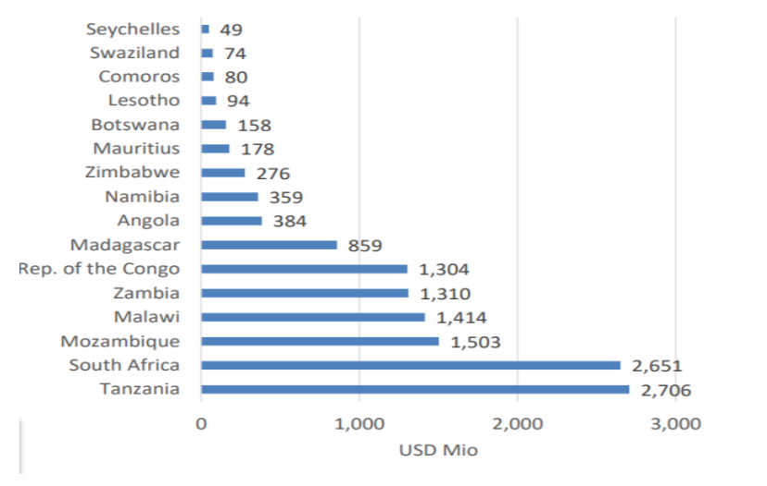
Figure 3. 1: SADC Total Climate Finance Flows 2013-2017 (Routil, n.d)

Zimbabwe currently accesses adaptation financing through the Adaptation Fund (AF) and Green Climate Fund (GCF), whose direct access entities are the Environmental Management Agency (EMA) and the Infrastructure Development Bank of Zimbabwe (IDBZ) respectively.

Does the money reach the grassroots?
The case studies below show adaptation finance flowing through various channels into Zimbabwe together with the size of the fund and various points the funding goes through before it reaches the intended beneficiaries.

UNDP-GCF —  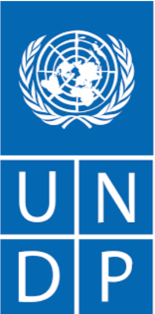 | Building Climate Resilience of Vulnerable Agricultural Livelihoods in Southern Zimbabwe  USD26.6million; 7 years; 2,300,000 small holder farmers benefiting— | This GCF-financed project supports the Government of Zimbabwe in strengthening the resilience of agricultural livelihoods of vulnerable communities, particularly women, in southern Zimbabwe to increasing climate risks and impacts. The project supports vulnerable people, especially smallholder farmers and women to access sufficient, reliable sources of water to enhance the climate resilience of agricultural production, adopt climate-resilient agricultural practices and cropping systems, and access and utilize climate information to more effectively manage climate risk in rain-fed and irrigated agricultural production. The project will benefit an estimated 2.3 million people across Manicaland, Masvingo and Matabeleland South provinces.

UNESCO-Adaptation Fund  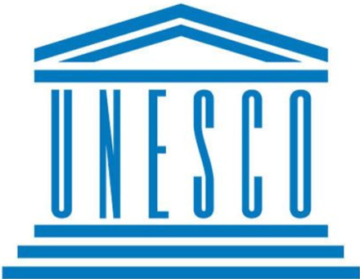 | Strengthening Local Communities’ Adaptive Capacity and Resilience to Climate Change through Sustainable Groundwater Utilisation in Zimbabwe. —USD5,000,000; 4 years; project execution cost 437,789; UNESCO Management Fee 370,370—. 2000 households (approximately 100,000 individuals benefiting) | To address several climate related challenges, this Project aims to increase local communities’ adaptive capacity and resilience to climate change through sustainable groundwater utilisation for food security and other productive uses in rural areas of Zimbabwe. To achieve this, an array of actions are required starting at national to local levels and involving institutional reforms and modelling, characterisation and quantification of the groundwater resources, knowledge generation and capacity development, and awareness raising through piloting and demonstration.

Zimbabwe resilience Building Fund 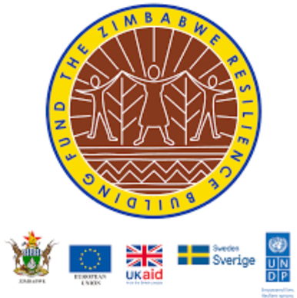 | Multi-Sector Project; 5 Years; USD75Million  Fund Manager: UNDP Funding Sources: The EU, Embassy of Sweden and DfID National Implementing Partner: Ministry of Lands, Agriculture and Rural Resettlement (MLARR)  830,000 beneficiaries in 18 rural districts of Zimbabwe | ZRBF focused on three overall sets of components namely:  Component 1: Evidence base and capacity building: This component entailed creating a body of evidence to improve the policy environment and stimulate informed service provision to enhance household and community resilience.  Component 2: Increasing adaptive, absorptive, and transformative capacities: Interventions were designed to support long-term household and community resilience in the face of climate shocks and trends.  Component 3: A crisis modifier: This was designed to respond to humanitarian shocks in support of the resilience interventions at community level in an appropriate, predictable, coordinated manner.
The case studies show an average benefit of adaptation financing in Zimbabwe are targeted at vulnerable household beneficiaries in line with the climate justice mantra. In the UNDP-GCF example, for every USD1 spent on adaptation, about USD12 over 7 years is realised in benefits. In the case of UNESCO, for every USD1 spent on adaptation, about USD50 over 4 years is realised in benefits. Regarding the ZRBF, for every USD1 spent on adaptation, about USD90 over 5 years is realised in benefits

Nonetheless, in both cases, the actual financing reaching the communities is however lessoned by the administrative costs and the other related costs —over 10%— that the funding channels have to deal with. Therefore, the more the administrative processes —e.g., in the case of multiple partners on one adaptation finance source—, the less money to the beneficiaries. Using the minimum estimate of 10% of the financing going towards administrative issues and adding another matching 10% for related issues then it should follow that at a minimum, 20%+ of the adaptation financing received does not reach the grassroots in cash or related resources where the actual resilience building projects are implemented.

How much adaptation finance has been received?
Between 2002 and 2022, it is estimated that the country received bilateral adaptation financing amounting to USD2,579,625,924. Adaptation Financial flows rose sharply after 2008 at the height of the Zimbabwean economic crisis peaking in 2010 before falling in 2014 and gradually rising again towards 2022 (see Figure 3.2). A total of 7973 projects were supported by donor governments through bilateral channels between 2002 and 2022, of which 2684 were adaptation related. Flows from multi-lateral climate finance (including Government co-finance) channels during the same period were estimated at USD471,724,737 (Figure 3.3). Co-financing through government assistance and initiatives has been a constant over time and has been significantly higher than external financing from the multi-lateral climate finance funds. External financing significantly increases post 2014 and will hopefully continue to increase (see Figure 3.4).

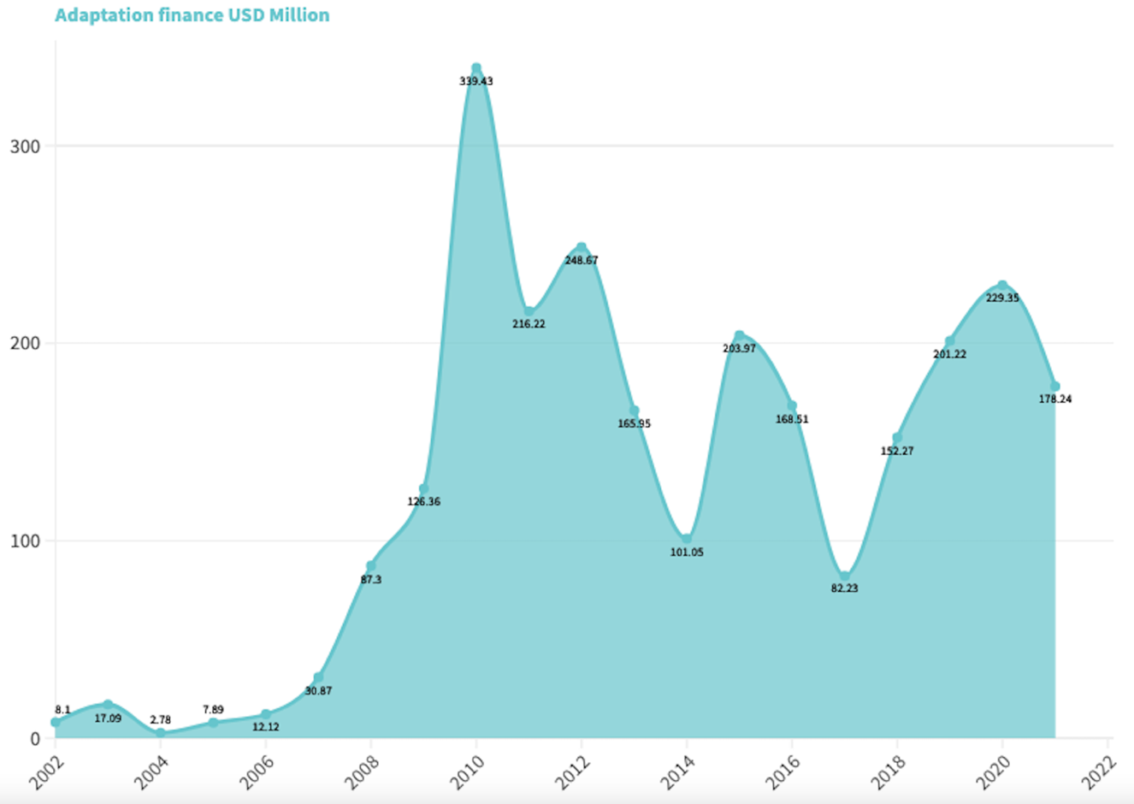
Figure 3. 2: Bilateral adaptation financing in Zimbabwe 2002-2022

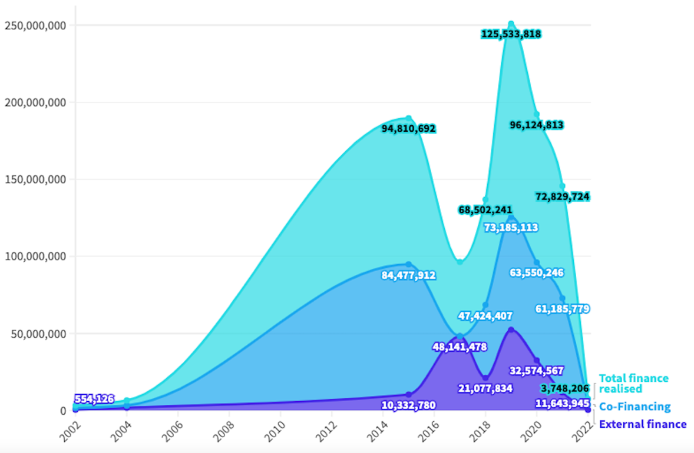
Figure 3. 3: Multilateral climate funds —in USD Millions— flowing to Zimbabwe 2002-2022

The above translates to a total of USD3,051,350,661 over 20 years or USD152,567,533 annually in adaptation finance flowing to Zimbabwe. Using the latest population statistics, the per capita adaptation financing received by Zimbabweans annually is about USD10 less 20% which goes to administrative and specialist fees resulting in an estimated annual per capita adaptation finance disbarment of USD8. According to the African Development Bank, a wide number of estimates of the costs of adaptation in Africa have been made, using a variety of approaches. This generates considerable uncertainty with the full range of estimates spanning USD2 billion to USD60 billion per annum. However, most recent studies, especially those that attempt to address Africa’s existing adaptation deficit (see below) converge on a range between USD20-30 (average USD25) billion over the next 10-20 years. Using the estimated African population, this translates to a minimum continental per capita adaptation cost of USD17. This means that at the current level of adaptation financing realised, Zimbabweans are experiencing an adaptation financing gap of over 53%. Thus, to adequately deal with resilience building in Zimbabwean communities, adaptation financing must increase by at least 53% annually.

Bilateral financing accounts for 85% of the adaptation finance that has flowed into Zimbabwe in the past 20 years. This did not change even after the establishment of the multi-lateral adaptation funds such as the GCF. The Global Environmental Facility (GEF) managed projects have been the largest multilateral climate finance streams between 2002 and 2022 (Figure 4.4). Post 2014 the GCF has also started to make notable impact in the adaptation financing space. Other funds including the Adaptation Fund (AF), and climate investment funds still need to be harnessed better so that they flow into the Zimbabwean adaptation space.
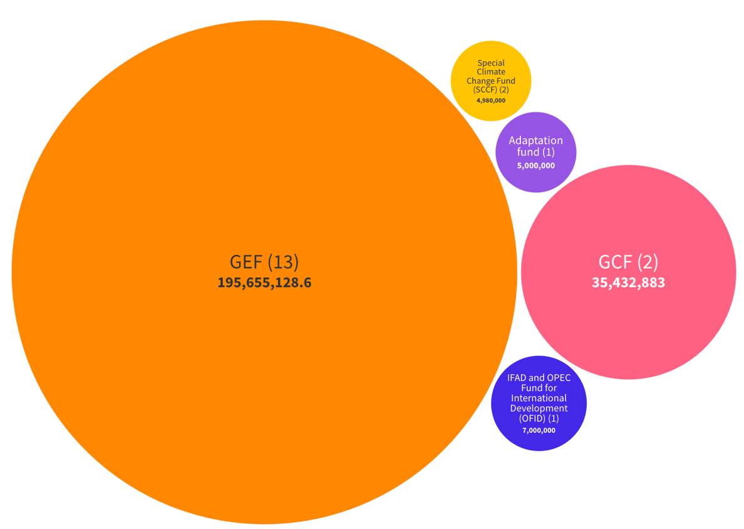
Figure 3. 4: Multilateral climate finance flows—in USD Millions— into Zimbabwe 2002-2022 (Number of projects)

The preference for bilateral channels by donors has been shown to be rooted in the need for control of what gets financed and where the project will be implemented. This weakens the climate management thrust of Zimbabwe and the global south in general. Control to execute urgent national goals is lost when the immediate interests of the donor country do not coincide with those of the government of Zimbabwe. This loss of control reduces the negotiating power of project implementers who often follow the donors programme with limited resistance.

From an alternative perspective, advocates of bilateral channels ‘i.e., power remaining with the donor’ argue that in most recipient countries, the institutional framework is not strong enough to absorb and effectively use adaptation finance (De Sépibus, 2014). While this argument may hold water, it ignores the mechanisms such as the GCF project preparatory facility and other institutional strengthening support mechanisms within the multilateral climate funds aimed at addressing the challenge.

A 2016 Overseas Development Institute (ODI) report found strong evidence that bilateral channels are more politicized than multilateral, that aid recipients prefer multilateral to bilateral channels, and that aid dispersed via multilateral channels is often less fragmented than via bilateral channels. The ODI report further cites moderate evidence that multilateral channels are more selective than bilateral ones and that multilateral channels are better suppliers of global public goods. However, the report finds weak evidence for the claim that multilateral channels are more efficient than bilateral channels, citing evidence of lower administrative costs for bilateral aid. The ODI report suggests that donors use bilateral channels to achieve goals of control, accountability, and visibility around aid, and use multilateral channels when striving to pool resources and advance a common global cause.
Civil society has often expressed the criticism that aid is a neo-colonial tool by developed countries as they impose prohibitive policy conditionalities on developing countries while donors tie their commercial, political, and military interests to the aid they provide. This is often viewed as one of the causes of poverty, hunger, disease, and backwardness in developing countries including Africa and Zimbabwe in particular (Chikowore, 2010).

Bilateral adaptation finance channels are likely to come with perceived benefits for the recipient country —e.g., Zimbabwe— given the notable climate change challenges in the country. These benefits are however not tailor made by Zimbabwe given that the donor countries have more leverage in developing the overall project goals. On the other hand, the donor country also has a list of benefits that it derives from undertaking the initiative resulting in a perceived win-win scenario.

The win-win scenario goes against the fundamental climate debt ideology because ideally, we should see the developed world compensating the developing world for the climate related losses meaning that preferably there should be one winner i.e., the developing world.

While bilateral adaptation finance is not a bad channel, it should be reformed in such a way that more leverage in developing climate adaptation programmes is with the developing countries. This could come through dedicated national funds in the developed countries whose primary purpose is mobilizing finances which are then channeled towards project concepts developed by the global south. This would improve the relevance of bilateral finance to the developing world though it could be technically duplication of the multilateral funds at country level which on its own is not ideal but a functional step forward in adaptation finance.

Evidently, it seems progressive to advocate for better use of the strengthening mechanisms in the multilateral funds —e.g., the project preparatory facility of GCF— than to remain in the business-as-usual bilateral space that is characterized by unfair relations and tends to relegate the climate debt owed to the background.

Who are the major donors?
The USA with over USD1Billion— followed by western Europe, east Asia (predominantly Japan) and Australia are the major sources of bilateral adaptation finance for Zimbabwe (Figure 3.5). Notable funds have also been realized from Unified EU institutions. Interestingly, the EU institutions could technically represent a step towards the previously proposed unified EU adaptation fund that supports recipient country-initiated concepts.

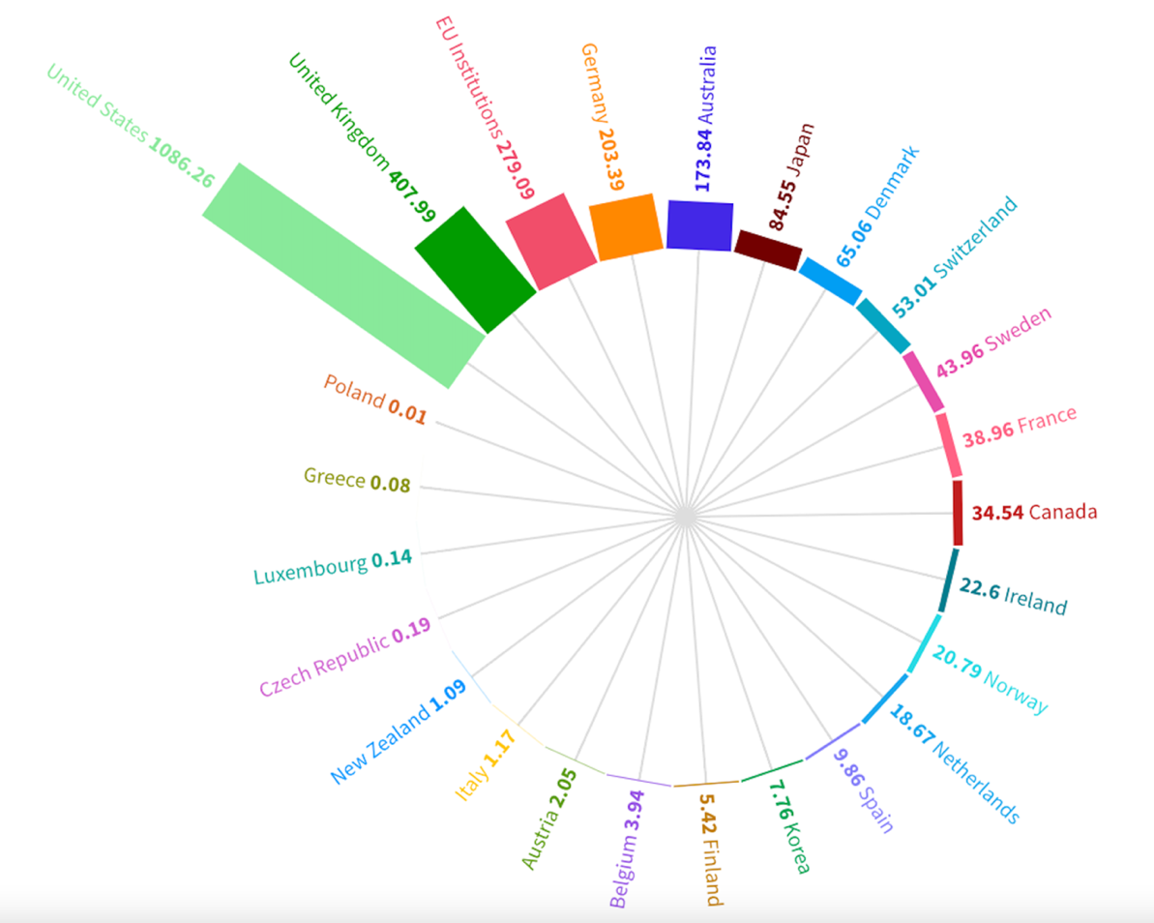
Figure 3. 5: Prominent bilateral donors for adaptation finance 2002-2022

Donor financing significantly rises post 2008, with US adaptation financing make a notable presence post 2008 and thereafter (see Figure 3.5). The United Kingdom, Australia, Japan, and Germany are also notable donor countries in the Zimbabwean adaptation financing space and their contributions also increase post 2008.

The bilateral adaptation finance data (see Figure 3.6) also showed that countries such as the United Kingdom with notable financial contributions tended to make these in large sums for a few projects thereby limiting the possibility of participation by many players. Figure 3.7 shows that the USA by far has the highest reach in the Zimbabwean climate adaptation space through multiple adaptation-based projects which are likely to be in more parts of the country. This means CSOs and small NGOs are more likely to get bilateral support from the USA, Japan, Germany, and Ireland than any other donor countries. The assumption is that the more the projects, the more the spread and the chance of small CSOs and NGOs receiving adaptation finance flows. In this regard, USA, Japan, Germany, and Ireland have the most individual projects that receive adaptation financing on an annual basis.

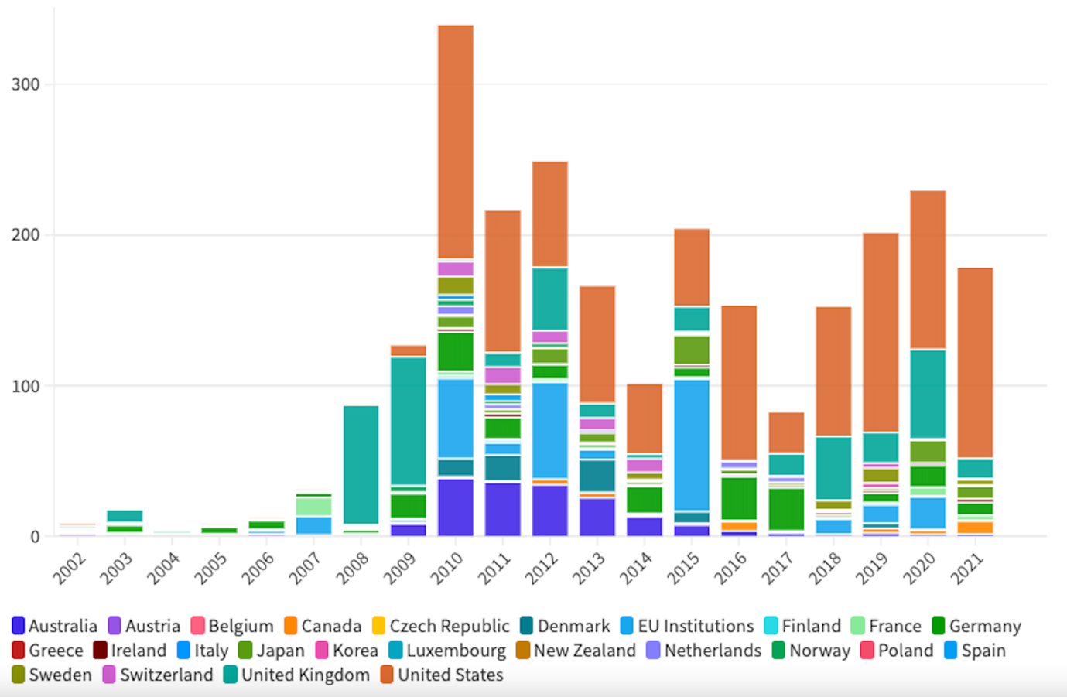
Figure 3. 6: Donor country adaptation financing disaggregated by years

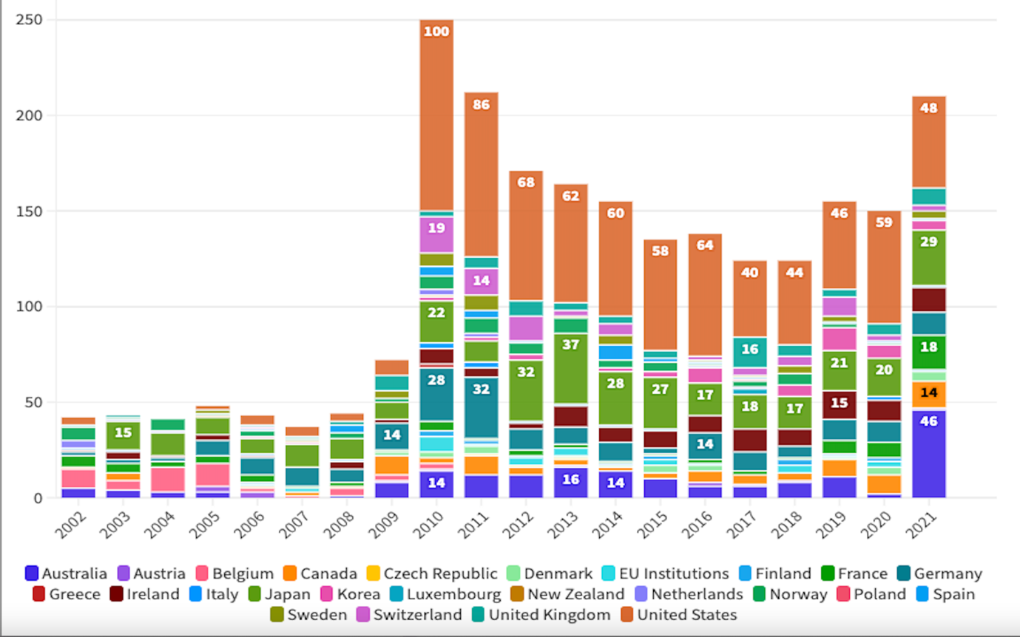
Figure 3. 7: Number of adaptation finance projects by donor country by year

The two key arguments —control of the recipient vs abuse of the adaptation finance— above have been the bone of contention in the Zimbabwe adaptation financing and foreign aid space in general. The argument follows the logical pattern that if one aligns with the control dimension, they will see a positive correlation between donation size and the need to control other aspects of the country. The alternative is if one is aligned to the abuse of aid argument, they will see a positive correlation between the size of aid and the level of mistrust for the government systems.

Returning to the importance of the identity of the bilateral donor discussion. The year 2008 was arguably the ceiling of the Zimbabwean economic crisis which was characterized by serious commodity shortages and the demise of the local Zimbabwean dollar. It is after the same year that bilateral adaptation finance flows begin to rise from major donor countries such as the USA. The answer to why this happened depends on the side of the two key arguments one subscribes to.

The issue of control versus abuse of funds may also come to light when considering the major recipients of the adaptation financing within Zimbabwe. Figure 3.8 shows that most of the bilateral adaption finance from donor countries into Zimbabwe flows through NGOs from the specific donor country followed by through the Government of Zimbabwe. These are followed by flows through UN agencies and other multilateral financial institutions that also channel significant quantities of adaptation finances into Zimbabwe. Smaller amounts also reach local NGOs and CSOs while certain organisations such as OXFAM and World Vision have also directly channeled bilateral adaptation finance funds.

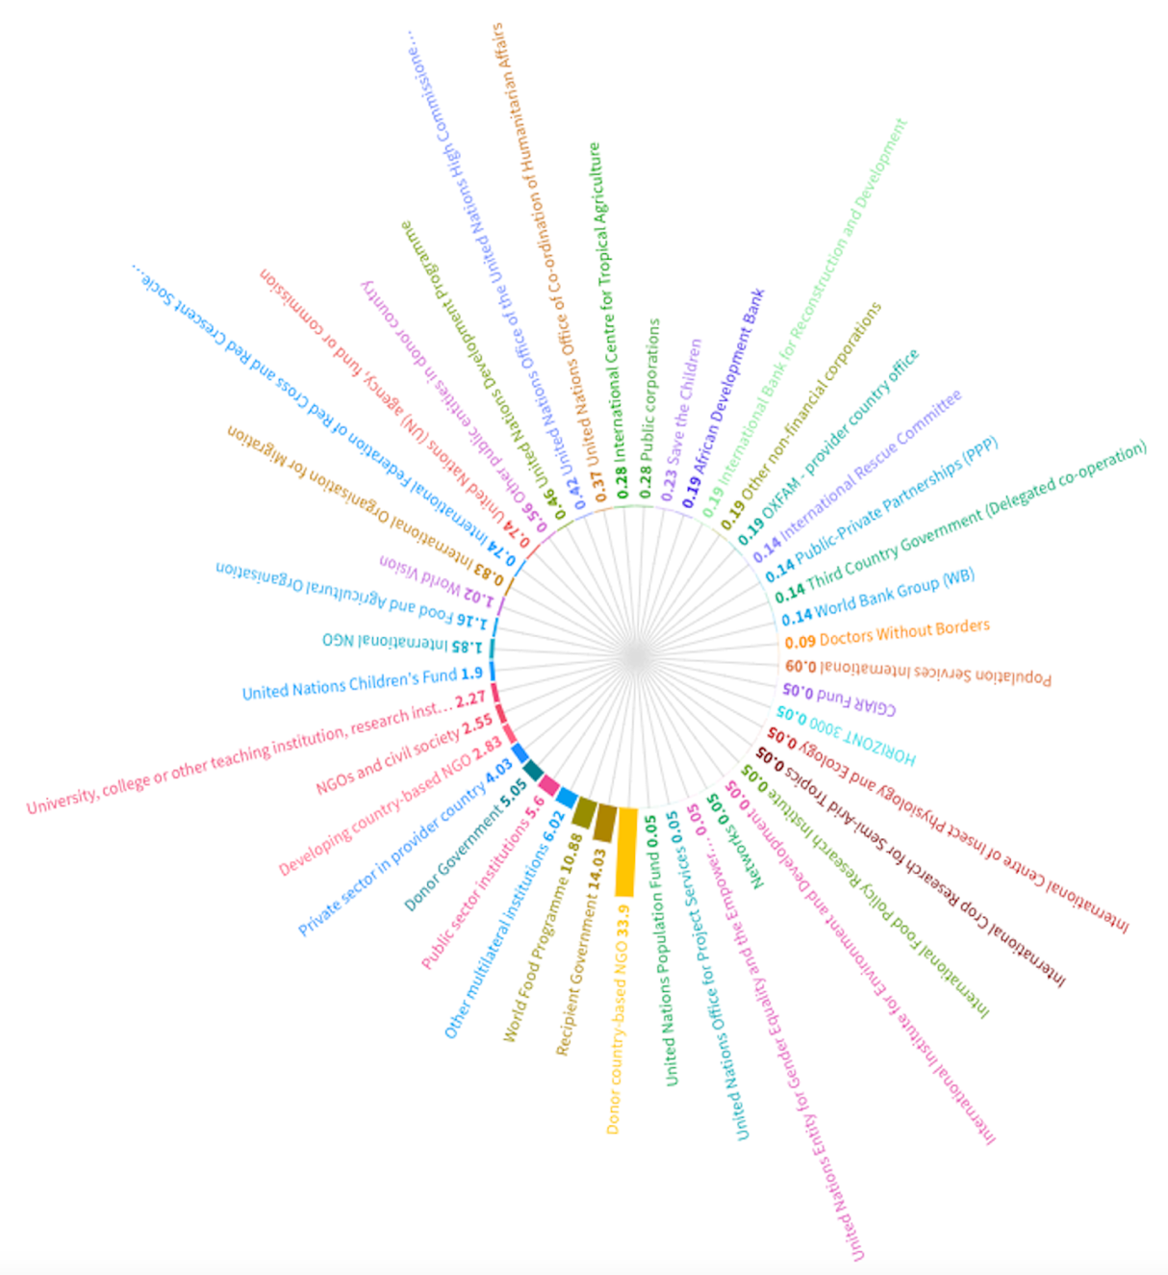
Figure 3. 8: Recipients of adaptation financing in Zimbabwe

The presence of notable adaptation finance flows through NGOs from the donor country and the Government of Zimbabwe shows that while it is possible that the donor countries may be furthering their interest in Zimbabwe, there is also notable trust in the abilities of government to channel and effectively utilise the adaptation finance flows.

Given the above arguments and the supporting data, it is critical for the Zimbabwean CSOs and NGOs to locate their advocacy position in the long standing debate on control versus abuse of funds. The logical conclusion of this report is that given the data on Figure 3.7, there should surely be a midpoint where there is a healthy level of trust in the governance systems and a fair level of autonomy in the use of aid that is not attached to multiple conditionalities. This midpoint should be ideally the space that is created by CSOs, NGOs and other non-state actors through advocacy for more transparent use of adaptation finance and less conditionalities in the use and access to aid by Zimbabwean stakeholders.

What issues are covered by bilateral adaptation finance flows?
In Zimbabwe, climate finance from bilateral donor countries has been mostly financing emergency response to climate related disasters such as droughts and floods. Related to emergency response, is funding for food assistance while other major areas that have seen significant adaptation finance flows are agriculture, water sanitation and hygiene (WASH), reconstruction and rehabilitation (see Figure 3.9).

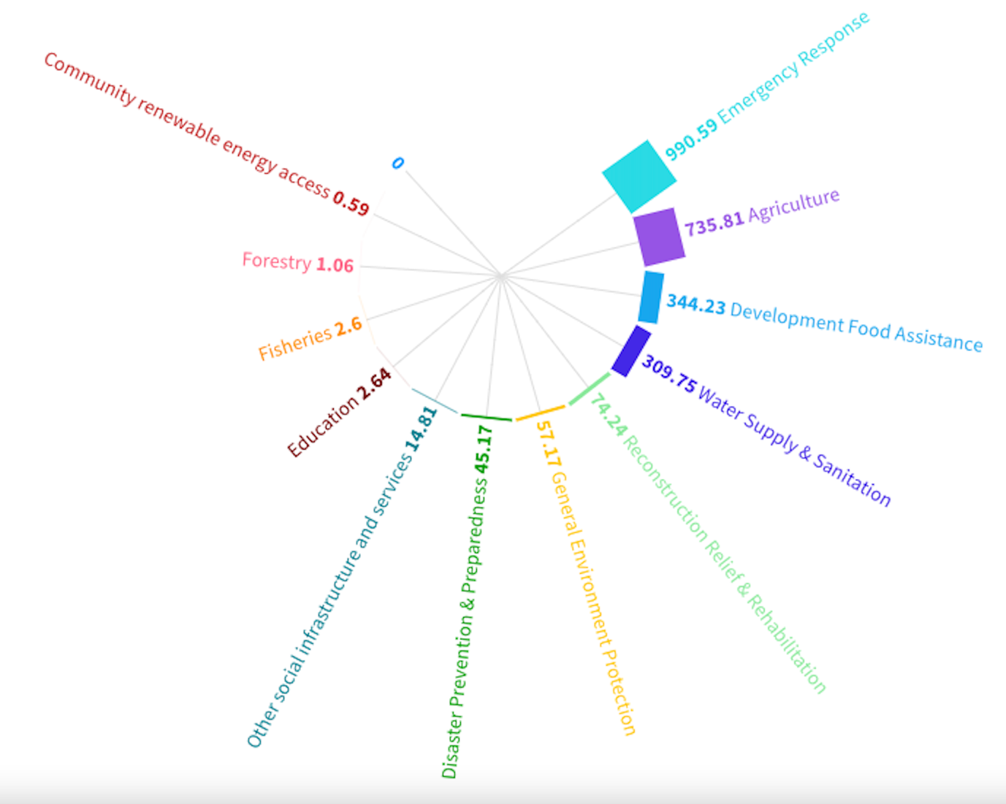
Figure 3. 9: Aspects financed by bilateral donors

The fact that most of the financing focused on emergency response brings in interesting dimensions to the arguments around adaptation finance supported by bilateral donors in Zimbabwe. If most of the financing is given to alleviate challenges caused by climate related and other disasters that increase vulnerability then surely this buttresses the perspective that bilateral adaptation finances allow for swift action that is focused and can be well accounted for given the strong involvement of the donor country in the overall utilisation of the adaptation finance. It however shows that adaptation financing in Zimbabwe is more reactive than proactive i.e., there is more disaster response than preparedness.

Bilateral adaptation financing therefore is very effective and preferred during emergency periods as it reaches the beneficiaries much faster than adaptation financing that would come from multi-lateral climate funds whose access during such events would be a tedious near impossible exercise. As such during climate related emergencies such as cyclone Idai, bilateral adaptation financing is seen less as a tool for control of the socio-economic environment of Zimbabwe and more as humanitarian assistance. Consider the two case studies below on emergency adaptation financing by largest bilateral adaptation finance donor —the USA— and an emerging alternative bilateral donor —China—.

USA | CHINA
For the past four decades, the United States has consistently supported Zimbabwe when the country faces emergency needs, such as Cyclone Idai and the ongoing COVID-19 global pandemic. The U.S. committed over US$19 million to help Zimbabwe respond to the COVID-19 pandemic. This amount includes $10 million to ensure that 100,000 people in eight urban areas have access to adequate food supplies between August 2020 and January 2021. In addition, previous U.S. investments in the health care system totalling over a billion dollars laid the foundation for Zimbabwe’s efforts to combat COVID-19. U.S. health assistance concentrates on the prevention and treatment of the diseases that are the three leading causes of death in Zimbabwe—HIV/AIDS, tuberculosis, and malaria—to help Zimbabweans live longer and healthier lives.  Through PEPFAR, the U.S. provided US$163 million in 2020, and has committed over US$230 million in 2021, to support Zimbabwe’s efforts to achieve HIV epidemic control and more than a million people living with HIV in Zimbabwe with care and treatment. With Zimbabwe facing one of its worst food security crises in a decade due to the combined effects of failed economic and agricultural policies, corruption, consecutive poor agricultural seasons, the aftermath of Cyclone Idai, and now, the COVID-19 pandemic, the United States will provide over $62 million to support food distributions during the upcoming 2020/21 lean season and $5 million to meet the additional needs of drought-affected communities. This adds to last year’s lean season, where USAID provided more than $86 million to reach more than 1.8 million food insecure Zimbabweans in 22 rural districts throughout the country. The United States remains the largest bilateral donor of emergency humanitarian assistance in Zimbabwe. In 2020, total U.S. assistance exceeded $337 million. This includes $197.5 in health, $79.8 million in emergency assistance, $11.4 million in economic growth, $26.5 in resilience building, and $21.9 in other programs. | This is just part of China’s aid provided to Zimbabwe this year. Right after the Cyclone Idai, China swiftly provided to Zimbabwe 80,000 USD in cash for emergency humanitarian assistance. The food aid provided through bilateral channels just for this year--the donation of 10165 tons of rice, and the free aid of drilling of 500 boreholes are being implemented. In the past few years, China has completed another 500 boreholes in Zimbabwe as free aid. Another important aid through bilateral channels provided by China not long ago is that at the coordinators’ meeting of FOCAC at the end of June this year, China decided to provide a new grant to Zimbabwe to help the country complete post-cyclone reconstruction and other important projects.  China has never attached any political conditions to the assistance to Africa. This is our basic principle. Unfortunately, many countries don’t do this. More accurately, they don't want to.  We believe all these assistances will help alleviate the difficulties encountered by the Zimbabwean people. Zimbabwean people are now in time of need, a circumstance substantially caused by illegal sanctions which have been in place for nearly 20 years. Some countries claim that the so-called targeted sanctions did not have a major negative impact on Zimbabwean economy and its people’s livelihood. But such an argument is untenable as sanctions disrupt financial transactions between Zimbabwe and outside world and disable Zimbabwe from accessing lines of credit from International financial Institutions, which is essentially needed for the development of a country.

In both the cases above, bilateral adaptation finance is used to swiftly deal with climate induced disasters or disasters that reduced household adaptive capacity to deal with climate change. However, the two case studies bring in a new twist to adaptation financing in general. The question is are crises that require emergency adaptation financing natural disasters or man-made. This question brings back the challenge of bilateral adaptation finance being used as a tool for control again.

In the first case study, the USA indicates commendable assistance given to Zimbabwe for emergencies such as cyclone Idai and the COVID-19 pandemic and goes further to explain how it is assisting in dealing with a decade-long food security crisis. China on the other hand also gives notable adaptation financing in the form of humanitarian assistance but goes further to interrogate the question of the rationale for the crisis and Zimbabwe’s dwindling resilience to climate related disasters.

The national adaptation plan and the financing gap
The study has shown the adaptation financing that has been flowing into Zimbabwe over a 20 year period. It is prudent to compare these historical flows with current adaptation financing requirements and those forecast in the future.

As we project Zimbabwean adaptation finance requirement into the future, preliminary adaptation assessments by the NAP show that the cost of climate change adaptation in 2030 for Zimbabwe could be cumulatively over USD10 Billion (see Table 3.1). The preliminary NAP results also forecast an adaptation financing gap of USD1 Billion a year meaning that what is currently being mobilised from bilateral and multilateral sources is not enough. There is evident need for diversification of adaptation finance options beyond the traditional bilateral and multilateral sources.

Table 3. 1: Adaptation costs for Zimbabwe up to 2030
Quantifiable adaptation option | 2020 | 2030
Quantifiable adaptation option | 2,531,080,068 | US$10,653,999,790
Agriculture | 2,426,571,685 | US$10,123,736,233
Expert services | 6,205,000 | US$36,017,791
Infrastructure | 23,740,179 | US$69,903,906
Water | 15,321,934 | US$58,826,030
Research | 4,250,000 | US$49,786,200
Early warning systems | 48,772,000 | US$185,831,235
Tourism | 6,091,971 | US$129,397,040
Health | 127,299 | US$501,354
Source: Preliminary NAP (2023)

Despite the numerous debates in literature around the role of the private sector in climate finance, it may be necessary for CSOs and NGOs in Zimbabwe to start developing methodologies and procedures for private sector entrance into the adaptation finance space.

The adaptation finance space is normally associated with non-profit development initiatives which often discourage private sector participation. However, in the pursuit of more adaptation finance flows, it becomes necessary to develop private sector centred financing instruments that allow for win-win scenarios in resilience building and profit.

Examples of such arrangements have been noted in the Zimbabwean horticulture sector where offtake arrangements between smallholder farmers and large scale commercial farmers allowed for the development of hub and spoke models that effectively attracted private sector financing that saw the resilience of small holder farmers rise due to improved agricultural systems while at the same time the providers of the finance realised returns on their investment.

Section conclusions
This section has shown that Zimbabwean CSOs and small NGOs are more likely to get bilateral support from the USA, Japan, Germany and Ireland than any other donor countries. The assumption is that the more the projects, the more the spread and the chance of small CSOs and NGOs receiving adaptation finance flows. Clearly it is paramount to have a balanced perspective of bilateral and multilateral climate finance platforms because bilateral adaptation financing is remarkably effective and preferred during emergency periods as it reaches the beneficiaries much faster than adaptation financing that would come from multi-lateral climate funds.

The section showed the necessity of considering dedicated national funds in the developed countries whose primary purpose is mobilizing finances which are then channelled towards projects concepts developed by the global south. This would likely improve the relevance of bilateral finance to the developing world. Also, there is emphasis on the need to advocate for better use of the strengthening mechanisms in the multilateral funds —e.g., the project preparatory facility of GCF— than to remain in the business-as-usual bilateral space that has is characterized by unfair relations and tends to relegate the climate debt owed to the backdrop.

From an advocacy perspective, there should be a midpoint where there is a healthy level of trust in the governance systems and a fair level of autonomy in the use of aid that is not attached to multiple conditionalities. This midpoint should be ideally the space that is created by CSOs, NGOs and other non-state actors through advocacy for more transparent use of adaptation finance and less conditionalities in the use and access to aid by Zimbabwean stakeholders. Also, CSO and NGOs in Zimbabwe must always be on the lookout for the challenges of control and abuse of finances and when evidence exists for their presence to fully challenge them as CSOs and NGOs to ensure that the beneficial aspects of bilateral adaptation being used as a swift focused mechanism of delivering climate finance are not lost. Finally, CSOs and NGOs in Zimbabwe must start developing methodologies and procedures for private sector entrance into the adaptation finance space.

The section that follows gives a perspective on how those —local NGOs and CSOs— on the frontline understand and are dealing with issues related to adaptation financing in Zimbabwe.

Access to multilateral climate funds by Zimbabwean CSOs and NGOs

This section considers the perspectives of CSOs and NGOs involved in the climate management space with an aim of understanding the key barriers to accessing adaptation finance particularly from the multilateral climate funds. Through key informant interviews, a workshop and a mini online assessment perspectives were gathered from representatives of civil society organisations (CSOs), faith based organisations (FBOs), non-governmental organisations (NGOs) and Government departments.

Perspectives from the ground
Most of the respondents indicated that the subject of climate finance was esoteric and they were more familiar with issues of climate change in general. This was especially the case with CSOs, FBOs and NGOs and less in the larger development agencies. It is not only adaptation finance understanding that is lacking but rather the fundamental basics from definition of terms to the science of climate change, the institutions at play and the issues related to finance.

In the CSO and NGO space, KIs argued that it was not common to find someone with specialised knowledge around climate issues but rather contemporary popularity of the subject often forced particular officers who lead the portfolio to do their own research to better understand the space. This often resulted in serious gaps when the few individuals who showed interest left the organisation. The general feeling was that climate change management and related issues of climate finance was a closed space dominated by the government, larger international NGOs, the UN and a select few experts who rarely share the knowledge with the average development worker. As such, many questions such as how to access climate funds, who to approach on climate issues, the groups covered remain un-answered resulting in minimum participation in the space by CSOs, FBOs and small NGOs. As such, KIs argued that if their constituency knew how to access the funds they would definitely make an effort towards access.

KIs argued that the climate management terms were confusing and the difference between mitigation and adaptation was not very clear to most, worse of other more esoteric terms such as additionalities and the climate rationale. Mitigation was explained to be used differently in development work in comparison to what one KI called the climate-verse. Most KIs explained that they were always shocked by new terms and financing platforms when they met climate change management and especially climate finance experts. They argued that in most organisations these platforms are unknown and often come to them through bilateral grants initiated by donor countries which push them to find out more about issues of climate change management and to a lesser extent climate finance. Government KIs concurred that capacity was still very low amongst CSOs and NGOs when it comes to issues of climate finance in general and adaptation finance. The government KIs explained that they often received capacity building requests and when resources permitted they organised training sessions where they explained key issues in the climate-verse.

In this regard, KIs suggested the development of a contextualised climate-verse dictionary that would explain critical issues from the science of climate change, its management, key institutions and issues of climate finance. Such a dictionary was said to be more effective if it was accompanied by climate-verse training of development workers preferably from more than just government. This would allow development practitioners to better explain climate change related issues to communities who were said to see most adaptation initiatives as extensions of development projects and at most disaster response activities. Government KIs also agreed that a capacity building literature was required though they advised guidebook that simplified climate finance guide alongside and dictionary. This was thought to allow for targeted information for specific groups together with answers to commonly asked questions with possible references where more information could be sought. KIs argued that the climate verse has so may dimensions and so many interventions and actions have been going on at a very fast pace resulting in most potential stakeholders being left behind.

Furthermore, KIs highlighted that at grassroots level, it was very difficult to separate the climate-verse from the general environmental protection space which has been dogged by negatives such as hostile political economy issues and limited benefits from interventions. From a similar perspective, Government KIs also revealed that at grassroots levels, communities are not usually interested in the sources of finance but rather the objectives achieved by a particular intervention and how they benefit. As such, like in the case of the NGO KIs government representatives agree that most aid looks the same to communities and what is key is what they get from the aid rather than who provided it and through which channel. As such, there was a need to separate the climate-verse from the general environmental management space all the way to the grassroots.

From the same vein Lorimer et al. (2018) argued that many Zimbabwean CSOs do not make a clear distinction between money they can obtain for their adaptation work and ‘climate-streamed’ grant funding. CSOs often lack awareness of potential climate change donors and donor funding themes. In addition to internet searches, CSOs are highly reliant on their networks to provide them with information on donor calls for proposals, while some calls for proposals are advertised in local newspapers. Often local CSOs are contracted as minor partners in larger international consortia.

KIs from the CSOs explained that the turnaround time for adaptation finance discourages NGO and CSO workers who usually have short contracts and limited time to deliver high impact projects. This was said to give climate finance a reputation as place for the organisations that have higher levels of job security such as the Government, the UN Agencies and the large NGOs and iNGOs. The KIs from CSOs further argued that the long turnaround time pushed them to focus on ready-made calls for applications that were usually from bilateral partners.

Summary of perceptions
Following Moser (2019), the key stakeholder perspectives were grouped into four key archetypes rooted in the major themes discussed by the stakeholders. These were the understanding of climate change management issues in general; the process accessing climate finance from multilateral climate funds; time taken to access finance from multilateral funds and the amount of knowledge that exists about the multi-lateral climate finance mechanisms. The archetypes were considered in accordance with the key categories in which they belonged which were summarised as economic, structural, and human resource based. The perspectives of the key stakeholders are summarised in Table 4.1.

Table 4. 1: Issues on accessing multilateral climate finance funds in Zimbabwe
 | Limited understanding of the climate space | Navigating the funding application process | Time component | Limited Knowledge of climate finance platforms
Economic |  | Limited resources to support project development process | Limited short run financial incentive | Lack of resources to participate in critical meetings like COP
Structural | Limited simple reference information | Complex proposal development processes | Short contracts | Limited access to accredited entities or equivalents
Human resources |  | Lack of proposal development champions |  | Lack of climate finance champions
Political |  |  | Limited interest from communities | Multiple processes that require state intervention and participation
Scientific information | Complex jargon and terminology |  |  | Limited internal capacity in CSOs and small NGOs
RESULT | Leave it for those who know it or just follow others | Avoid developing such proposals | Focus on quick turnaround calls by bilateral donors | Hear of them by chance

Similar perspectives are noted by Lorimer et al. (2018) who noted that CSOs in Zimbabwe complained that donors such as USAID and the EU do not accept any unsolicited proposals and prefer to first develop their own strategies and issue calls for proposals for specific work to be done. CSO respondents felt that this strict approach to determining what donors would fund represented a top-down approach and limited community participation and innovation. By contrast donors such as the Embassy of Sweden, the GEF Small Grants Programme (SGP), DanChurchAid (DCA) and Brot für die Welt were highlighted by CSO respondents for their more flexible approach. Sweden, for example, does not have specific templates that must be used or specific calls for proposals, and the Swedish Embassy may be approached at any time. Various civil society organisations indicated that they appreciated this more open and flexible approach, which provided CSOs with an opportunity to engage in dialogue with donors to discuss with what they felt was best to focus on and why. Rather than being based on preconceived ideas, this approach allowed project developers to be more responsive to community needs and the situation on the ground, which could provide better results in project implementation. Similar to the results from this study, Lorimer et al. (2018) summarised the barriers shown in Table 4.2.

Table 4. 2: CSO Barriers to accessing adaptation finance by Lorimer et al. (2018)
Barrier type | Barrier
Donor requirements | Donor sector and location preferences may not be well known, and may limit CSOs from responding to local emerging needs.
Donor requirements | Donors that only offer large grant sizes are not accessible to many local CSOs, and a range of grant sizes is needed.
Donor requirements | Donor preference for partnering with international NGOs, including as lead agents for consortia.
Donor requirements | Consortium funding may limit the access of sub-grantees to core funding.
Donor requirements | Overly complex and rigid donor application and reporting templates.
Donor requirements | Significant donor fund handling and co-financing requirements.
CSO Capacity Needs | Lack of CSO awareness of climate adaptation donors and their funding themes.
CSO Capacity Needs | Lack of local CSO visibility to climate funders.
CSO Capacity Needs | Many local CSOs lack the ability to write funding proposals that are of a high enough standard, are adequately justified in terms of climate change and are innovative.
CSO Capacity Needs | CSO climate networks lack funding support and international linkages
Policy and Structural Barriers | Limited bilateral and private climate funding in Zimbabwe due to political instability.
Policy and Structural Barriers | Direct access to major climate funds has been hampered by slow national accreditation.
Policy and Structural Barriers | Lack of local co-ordination on funding information and access.

Overall conclusions and recommendations
Between 2002 and 2022, it is estimated that bilateral adaptation financing flowing into Zimbabwe totaled USD2,579,625,924 while flows from multilateral climate funds were estimated at USD471,724,737.

The total financing is therefore estimated at USD3,051,350,661 over 20 years or USD152,567,533 annually in adaptation finance flowing to Zimbabwe and the per capita adaptation financing received by Zimbabweans annually is about USD10 less 20% which goes to administrative and specialist fees resulting in an estimated annual per capita adaptation finance disbarment of USD8. The AfDB estimated the per capita adaptation cost in Africa at USD17. This means that at the current level of adaptation financing realised, Zimbabweans are experiencing an adaptation financing gap of over 53%. Thus, to adequately deal with resilience building in Zimbabwean communities, adaptation financing must increase by at least 53% annually.

Although adaptation financing continues to play second fiddle to mitigation financing in the global climate agenda and is an issue prioritised more by the global south who are owed a climate debt and suffer more from the negative aspects of climate change, CSOs and NGOs have played a major part in advocating for the climate debt, adaptation finance and fairer financing. This means they can still do more to ensure adaptation financing reaches those that need it most today.

This study has shown the adaptation finance flows that come into Zimbabwe from bilateral and multilateral platforms also given an extensive debate on the suitability of different sources of adaptation finance flows with a focus on the major donor countries and funds; the areas most funded and local channels through which funds flow. For stakeholders in the adaptation finance space, it is paramount to have a balanced perspective of bilateral and multilateral climate finance platforms.

Adaptation financing and climate financing in general should ideally flow through multi-lateral climate funds rather than bilateral lines as this allows the global south to have more power in the negotiation processes. While it is easier for CSOs and NGOs to access funding through bilateral channels, this is not ideal for the long-term climate justice agenda which seeks to give more control of climate financing to the global south.

There is also need for clarity on the types of financing used i.e., more grant financing is required instead of the business-as-usual loans and other market financial instruments. This would bring back advocacy dimensions of global taxation spaces such as the aviation industry. From the same vein, the study noted with concern that climate finance is moving towards market financing which may be used to weaken the global south solidarity in the negotiation processes. Finally climate funds are heavily duplicated, and this creates confusion that makes it difficult to adequately account for climate funds.

The list of adaptation finance funds provided has endeavoured to be as exhaustive as possible but should still be considered as a minimum baseline value given that the data sources may have omitted critical donations that were not captured in the databases consulted. The adaptation finance flows analysed showed that Zimbabwean CSOs and small NGOs are more likely to get bilateral support from the USA, Japan, Germany and Ireland than any other donor countries. The assumption is that the more the projects, the more the spread and the chance of small CSOs and NGOs receiving adaptation finance flows.

The study has also considered the broader space of climate justice with a focus on the climate debt and how things have evolved as attempts have been made to claim compensation for the global climate debt. The socio-economic and financial implications (past and projected) of climate in Zimbabwe through exposing current gaps and giving projected adaptation requirement has also been undertaken and ultimately showed that diversification of adaptation finance options is necessary and possibly including the private sector.

Points of advocacy for local CSOs and NGOs have also been highlighted in this study and these are further strengthened by the future recommendations in this section. Such pointers shed light on how to improve the access to climate finance for vulnerable and marginalized populations in Zimbabwe. Related to advocacy, an analysis of barriers that exclude local communities at the frontline of the climate crisis from accessing climate finance has also been given in accordance with perspectives given by CSOs that represent the frontline communities.

The aspects highlighted in this study allow it to serve as a comprehensive baseline and advocacy tool that Oxfam partners and target groups can use to improve influencing national financial flows and access to climate finance by communities and sectors at the frontline of the climate crisis for effective and lasting locally led climate responses.

Recommendations
- CSOs and NGOs in Zimbabwe should join global advocacy on “burden sharing mechanism” that includes an international levy on international aviation and maritime transport to fund adaptation in vulnerable countries. This would improve the replenishing of multilateral climate funds and allow for more financing where the global south has more of a say.
- As a transitionary measure, developed countries could consider setting up dedicated national funds in whose primary purpose is mobilizing finances which are then channeled towards projects concepts developed by the global south. This would improve the relevance of bilateral finance to the developing world though it be technically duplication of the multilateral funds at country level which on its own is not ideal but a functional step forward in adaptation finance. The EU institutions could technically represent a step towards this.
- CSOs and NGOs in Zimbabwe must advocate for better use of the strengthening mechanisms in the multilateral funds —e.g., the project preparatory facility of GCF— than to remain in the business-as-usual bilateral space that has is characterized by unfair relations and tends to relegate the climate debt owed to the backdrop.
- It is critical for the Zimbabwean CSOs and NGOs to locate their advocacy position in the long-standing debate on control versus abuse of funds. The recommended position is the midpoint where there is a healthy level of trust in the governance systems and a fair level of autonomy in the use of aid that is not attached to multiple conditionalities. This midpoint should be ideally the space that is created by CSOs, NGOs and other non-state actors through advocacy for more transparent use of adaptation finance and less conditionalities in the use and access to aid by Zimbabwean stakeholders.
- CSOs and NGOs in Zimbabwe should always be on the lookout for possibilities donor control and abuse of adaptation financing. When evidence exists for their presence, they must fully challenge them as CSOs and NGOs to ensure that the beneficial aspects of bilateral aid being used as a swift focused mechanism of delivering climate finance are not lost.
- CSOs and NGOs in Zimbabwe must start developing methodologies and procedures for private sector entrance into the adaptation finance space.
- There is need to consider the development of a contextualised climate-verse dictionary that would explain critical issues from the science of climate change, its management, key institutions and issues of climate finance. Such a dictionary was said to be more effective if it was accompanied by climate-verse training of development workers preferably from more than just government. This would allow development practitioners to better explain climate change related issues to communities who were said to see most adaptation initiatives as extensions of development projects and at most disaster response activities.
- Related to the dictionary would be a simplified climate finance guide to allow for targeted information for specific groups together with answers to commonly asked questions with possible references where more information could be sought.
- Deliberate action is required to separate the climate-verse from the general environmental management space all the way to the grassroots so that communities are aware of adaptation initiatives.
- Areas of further research emerging from this project include an assessment on the utilisation of the adaptation finance, the disaggregation of adaptation financing by gender and baseline on the understanding of adaptation finance by the private sector together with the adaptation finance flows associated with the public sector.

References
Adaptation Watch 2015 Toward Mutual Accountability: The 2015 Adaptation Finance Transparency Gap Report (http:// adaptationwatch.org)
Amerasinghe, N.M., Thwaites, J., Larsen, G. and Ballesteros, A., 2017. Future of the funds: exploring the architecture of multilateral climate finance.
Barrett, S. 2014. Subnational climate justice? Adaptation finance distribution and climate vulnerability. World Development 58:130-142.
Bigger, P. and Millington, N. (2020) ‘Getting soaked? Climate crisis, adaptation finance, and racialized austerity’, Environment and Planning E: Nature and Space, 3(3), pp. 601–623. Available at: https://doi.org/10.1177/2514848619876539.
Biscaye, P.E., Reynolds, T.W. and Anderson, C.L. (2017) ‘Relative Effectiveness of Bilateral and Multilateral Aid on Development Outcomes’, Review of Development Economics, 21(4), pp. 1425–1447. Available at: https://doi.org/10.1111/rode.12303.
Buchner B, Stadelmann M, Wilkinson J, et al. (2014) The global landscape of climate finance 2014. http:// climatepolicyinitiative.org/wp-content/uploads/2014/11/The-Global-Landscape-of-Climate-Finance2014.pdf.
CAN International, 2007. Climate negotiations: NGO Newsletter. ECO, 7th edn. Climate Action Network, Bali, p4
Chari, F. and Ngcamu, B.S. (2022) ‘Climate Change-Related Hazards and Livestock Industry Performance in (Peri-)Urban Areas: A Case of the City of Masvingo, Zimbabwe’.
Chikowore, G. (2010) ‘Contradictions in Development Aid: The Case of Zimbabwe’.
Chirisa, I. et al. (2021) ‘Interrogating Climate Adaptation Financing in Zimbabwe: Proposed Direction’, Sustainability, 13(12), p. 6517. Available at: https://doi.org/10.3390/su13126517.
Ciplet, D. and Roberts, J.T., 2017. Climate change and the transition to neoliberal environmental governance. Global Environmental Change, 46, pp.148-156.
Ciplet, D., Roberts, J.T. and Khan, M.R., 2015. Power in a warming world: The new global politics of climate change and the remaking of environmental inequality. Mit Press.
Climate Change Management Department (CCMD), 2023. Climate Change Adaptation in Zimbabwe. https://climdat.cloud/NAP_Consultancy_Vulnerability%20Assesment%20Report%20_Complete%20draft_020321.pdf
De Sépibus, J. (2014) ‘The Green Climate Fund: how attractive is it to donor countries?’ Available at: https://doi.org/10.7892/BORIS.90360.
Donner, S., Kandlikar, M. and Webber, S. (2016) ‘Measuring and tracking the flow of climate change adaptation aid to the developing world’, Environmental Research Letters, 11(5), pp. 1–9.
Doshi, D. and Garschagen, M. (2020) ‘Understanding Adaptation Finance Allocation: Which Factors Enable or Constrain Vulnerable Countries to Access Funding?’, Sustainability, 12(10), p. 4308. Available at: https://doi.org/10.3390/su12104308.
Dube, N. et al. (2018) ‘Impact of climate change on sustainability in semi-arid, rural Africa: Lessons from rural Zimbabwe’, Cogent Social Sciences, p. 23.
Dube, N., 2023. Forty years of climate risk research in Zimbabwe–1980–2021. Development Southern Africa, pp.1-35.
Dzvimbo, M.A., Ncube, C.T., Zhanda, K. and Mutanana, N., 2022. Climate Change and Poverty: Coping Strategies Adopted by Female-Headed Households in Zimbabwe. In Handbook of Climate Change Across the Food Supply Chain (pp. 369-379). Cham: Springer International Publishing.
Fankhauser, S. and Burton, I., 2011. Spending adaptation money wisely. Climate Policy, 11(3), pp.1037-1049.
Fankhauser, S., 2010. The costs of adaptation. Wiley interdisciplinary reviews: climate change, 1(1), pp.23-30.
Ford, J.D., Maillet, M., Pouliot, V., Meredith, T. and Cavanaugh, A., 2016. Adaptation and indigenous peoples in the United Nations Framework Convention on climate change: Post-print version.
GEF (2010) System for transparent allocation of resources (STAR). https://www.thegef.org/publications/systemtransparent-allocation-resources-star.
Government of Tuvalu (2007) International blueprint on adaptation. https://unfccc.int/resource/docs/2007/cop13/ eng/misc02.pdf.
Inuit Circumpolar Council (2009) Report of the indigenous peoples’ global summit on climate changeinuit circumpolar council. http://webcache.googleusercontent.com/search?q=cache:Jyq51wjRNiQJ:www.un.org/ ga/president/63/letters/globalsummitoncc.pdf+&cd=1&hl=en&ct=clnk&gl=us.
Junghans, L. and Harmeling, S., 2012. Different tales from different countries. A first Assessment of the OECD «Adaptation Marker», Briefing Paper, Germanwatch, Bonn.
Khan, M. et al. (2020) ‘Twenty-five years of adaptation finance through a climate justice lens’, Climatic Change, 161(2), pp. 251–269. Available at: https://doi.org/10.1007/s10584-019-02563-x.
Khan, M. R., 2014. Toward a binding climate change adaptation regime. Routledge, London
Khan, M.R. and Roberts, J.T., 2013. Towards a binding adaptation regime: three levers and two instruments. In Successful Adaptation to Climate Change (pp. 132-148). Routledge.
Kupika, O.L. et al. (2019) ‘Local Ecological Knowledge on Climate Change and Ecosystem-Based Adaptation Strategies Promote Resilience in the Middle Zambezi Biosphere Reserve, Zimbabwe’, Scientifica, 2019, pp. 1–15. Available at: https://doi.org/10.1155/2019/3069254.
Lorimer, E. et al. (2018) Opportunities For Accessing International Climate Adaptation Finance For Civil Society Organizations In Zimbabwe. Harare: Brot fur die welt.
Manatsa, D. (2020) ‘New Agroecological Map of Zimbababwe’.
Martinez-Alier, J., 2003. The Environmentalism of the poor: a study of ecological conflicts and valuation. Edward Elgar Publishing.
Michaelowa, A. and Michaelowa, K., 2011. Coding error or statistical embellishment? The political economy of reporting climate aid. World Development, 39(11), pp.2010-2020.
Moser, S.C. et al. (2019) ‘Adaptation finance archetypes: local governments&#8217; persistent challenges of funding adaptation to climate change and ways to overcome them’, Ecology and Society, 24(2), p. art28. Available at: https://doi.org/10.5751/ES-10980-240228.
Moyo, D., 2009. Dead aid: Why aid is not working and how there is a better way for Africa. Macmillan.
Moyo, S., 1995. The Impact of Foreign Aid on Zimbabwe's Agricultural Policy. Africa Development/Afrique et Développement, pp.23-50.
Mubaya, C.P. and Mafongoya, P. (2017) ‘Local-level climate change adaptation decision-making and livelihoods in semi-arid areas in Zimbabwe’, Environment, Development and Sustainability, 19(6), pp. 2377–2403. Available at: https://doi.org/10.1007/s10668-016-9861-0.
Mukurazhizha, R.M. and Matanga, S.Y., 2023. The role of women in managing the environmental crisis: A case study of Cyclone Idai in Chipinge, Zimbabwe. HTS Theological Studies, 79(3), pp.1-7.
Murombo, T. (2020) ‘Climate Change in Zimbabwe: Towards a Low Carbon Energy Industry’, in Climate Change Law in Zimbabwe: Concepts and Insights. Harare: The Konrad Adenauer Foundation, pp. 205–242.
NDC Partnership (2018) Climate funds update. http://ndcpartnership.org/content/climate-funds-update.
OECD (2015) Climate fund inventory: a report to the G20 climate finance study group. https://bit.ly/2TLayaY.
Parry, M., Arnell, N., Berry, P., Dodman, D., Fankhauser, S., Hope, C., Kovats, S., Nicholls, R., Satterthwaite, D., Tiffin, R. and Wheeler, T., 2009. Adaptation to climate change: assessing the costs. Environment, 51(6), pp.29-36.
Pickering, K., Plummer, R., Shaw, T. and Pickering, G., 2015. Assessing the adaptive capacity of the Ontario wine industry for climate change adaptation. International Journal of Wine Research, pp.13-27.
Raman M and Lin LL., 2009. Sign-on letter calling for repayment of climate debt. http:// www.ourworldisnotforsale.org/en/action/sign-letter-calling-repayment-climate-debt/.
Robinson, S.A. and Dornan, M., 2017. International financing for climate change adaptation in small island developing states. Regional Environmental Change, 17, pp.1103-1115.
Schalatek L, Bird N. 2015. The principles and criteria of public climate finance: a normative framework. https:// bit.ly/2HDDHyo.
Third World Network (2009) Bonn news updates and climate briefings (June 2009). https://www.twn.my/title2/ books/bonn.news.climate.briefings4.htm
Thwaites J (2018) US 2018 budget and climate finance: it’s bad, but not as bad as you might think. https:// www.wri.org/blog/2018/03/us-2018-budget-and-climate-finance-its-bad-not-bad-you-might-think. Cited January 20, 2019.
Tinarwo, J. and Babu, S.C. (2023) ‘Chinese and Indian economic relations and development assistance to Zimbabwe: Rationale, controversies and significance’, Journal of International Development, 35(4), pp. 655–667. Available at: https://doi.org/10.1002/jid.3704.
UNFCCC. FCCC/CP/2015, “Adoption of the Paris Agreement”. In Proceedings of the Conference of the Parties 21st Session, Paris, France, 30 November–11 December 2015.
Unganai, L.S. et al. (2013) ‘Tailoring seasonal climate forecasts for climate risk management in rainfed farming systems of south’, p. 15.
United States Government (2018) Consolidated appropriations Act, 2018. https://www.govinfo.gov/content/pkg/ CPRT-115HPRT29374/pdf/CPRT-115HPRT29374.pdf.
Webber, S. 2013. Performative vulnerability: climate change adaptation policies and financing in Kiribati. Environment and Planning A: Economy and Space 45(11):2717-2733.
World Bank 2010 Economics of Adaptation to Climate Change: Synthesis Report (Washington: International Bank for Reconstruction and Development/The World Bank)
Zimbabwe Vulnerability Assessment Committe. Zimbabwe Vulnerability Assessment Committee (ZimVAC) 2016 Rural Livelihoods Assessment, Food and Nutrition Council; Zimbabwe Vulnerability Assessment Committee: Harare, Zimbabwe, 2016.

IPCC, 2022. Climate Change 2022: Impacts, Adaptation and Vulnerability.
UNEP, 2021. The Adaptation Gap Report 2021. The Gathering Storm
Government of Zimbabwe, 2021. Zimbabwe’s National Determined Contribution.
They Survived Cyclone Idai. Then Came the Coronavirus (globalpressjournal.com)
Green Climate Fund approves US$26.6 million grant on ‘Building Climate Resilience of Vulnerable Agricultural Livelihoods in Southern Zimbabwe’ | United Nations Development Programme (undp.org)
Strengthening Local Communities’ Adaptive Capacity and Resilience to Climate Change through Sustainable Groundwater Utilisation in Zimbabwe - Adaptation Fund (adaptation-fund.org)
UNDP-ZWE-Pubs-ZRBF-Sustainability-Report-2023.pdf
The Zimbabwean population in 2022 was estimated at 15,178,957 individuals https://www.zimstat.co.zw/census/
https://www.afdb.org/fileadmin/uploads/afdb/Documents/Project-and-Operations/Cost%20of%20Adaptation%20in%20Africa.pdf
The African population is estimated at 1,475, 000,000 individuals https://www.worldometers.info/world-population/africa-population/
Donors’ Dilemma: Bilateral versus Multilateral Aid Channels | Evans School of Public Policy and Governance (uw.edu)
U.S. Government Assistance to Zimbabwe tops $3.5 billion since 1980 - U.S. Embassy in Zimbabwe (usembassy.gov)
What Zimbabwe needs is assistance, not interference By ambassador Guo Shaochun (china-embassy.gov.cn)
In development work problems such as poverty are mitigated using action but, in the climate-verse, we are told this is adaptation not mitigation. It’s very confusing for the average development worker (KI, TDH).
Issues of natural resources access have been a challenge particular in the case of forest products where communities have argued that their lives and livelihoods seem to be less valued than that of wildlife and other forms of biodiversity.

