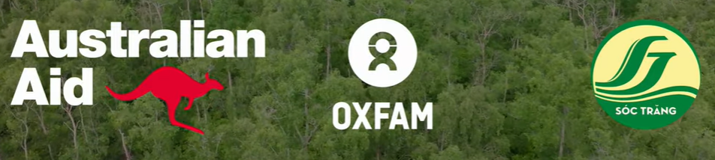

STORY TELLING – DOCUMENTATION REPORT
Strengthening Climate Resilience in the Mekong
Subregion (SCR) Project in Soc Trang province, Vietnam

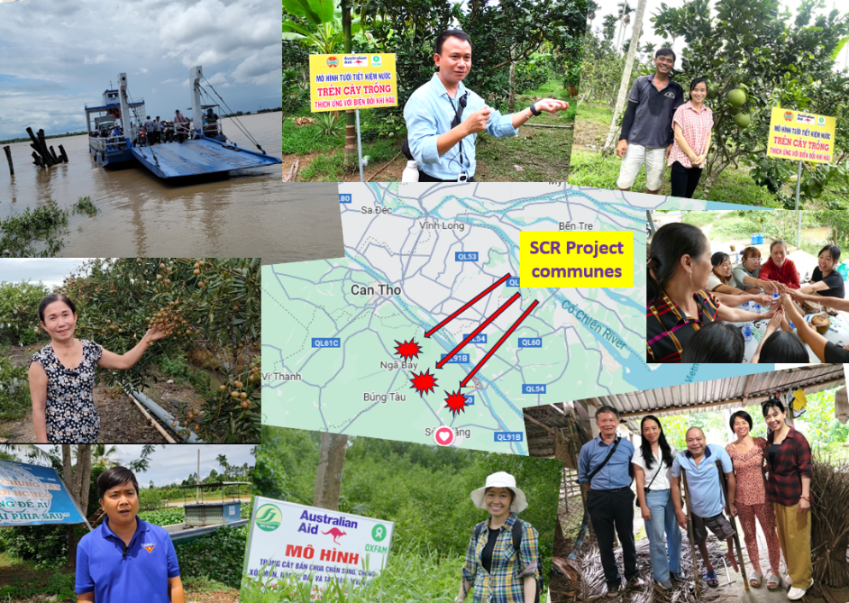

Prepared by
Hoang Thi Ngoc Ha & Nguyen Van Gia
DRR and CCA Specialists
in collaboration with Oxfam’s project team

July 2025

Acknowledgements
The Story telling and documentation team would like to express our sincere gratitude to Stichting Oxfam Novib in Vietnam (Oxfam in Vietnam) for entrusting us with the opportunity to conduct the Story telling and documentation of the project "Strengthening Climate Resilience in the Mekong Subregion (SCR) Project in Soc Trang province, Vietnam." We are especially thankful to the Project Manager and Oxfam team for their guidance and support throughout the process.
The development of this storytelling and documentation is strongly based on household visits, group discussions and in-depth interviews with beneficiaries, project holders, project partners and representatives of communities. Much learning has taken place throughout the process of developing and conducting the storytelling and documentation
We would also like to thank the local authorities and implementation partners in Soc Trang province, including the Department of Agriculture and Environment, Soc Trang Project Team Management, Soc Trang Division of Water Resources Management, the Farmer’s Association, Women’s Union commune Red Cross Chapters and the, local authorities of Phong Nam commune, Ke Sach districts, Song Phung commune, Long Phu District and An Thạnh Dong commune, Cu Lao Dung district, Soc Trang province whose cooperation and logistical support, providing key interesting life stories. Special appreciation goes to the community members, women and men, who generously shared their time, experiences, and insights during interviews and focus group discussions—providing a human voice behind the project’s outcomes.
Our appreciation is also extended to Mekong Water Governance Program. The dedication and professionalism demonstrated by all involved have significantly contributed to the depth and quality of this storytelling and documentation.
We hope that the Stories presented in this story collection will serve as a useful input for Oxfam and its partners in designing future advocacy for Climate Resilience and Disaster Risk Reduction interventions that are even more inclusive, gender sensitive and impactful.

The Storytelling and Documentation Team:
Hoang Thi Ngoc Ha, Communication – Monitoring & Evaluation specialist
Nguyen Van Gia, Disaster Risk Reduction and Climate Change Adaptation Specialist, team leader

Content
Acknowledgements 2
List of Participants 3
List of Stories 3
1.1 Background and Context of the Project 5
1.2 Implementation Partner 5
1.3 Location 6
Part II. Overview of the Story telling and documentation 6
2.1 Methodologies 6
2.1.1 Development of framework and story collection tools 6
2.1.2 Field survey 7
2.2 Limitation 7
Part III: Results of the survey and documentation 7
Outcome 1: Inclusive and Climate-Informed Governance & Planning 7
Outcome 2: Climate-Smart Livelihoods & Resource Mobilization 10
Outcome 3: Inclusive and Climate-Informed Governance & Planning 12
STORY TELLING – DOCUMENTATION REPORT 14
Story 1: "Nature-based solutions have always been available, but we must act now!” 14
Story 2: Climate-resilient development planning based on local capacity building 16
Story 3: “I never imagined my garden would be this lush” 18
Story 4: “The earlier and more accurate the information, the better protected the community is” 20
Story 5: When the lives of the disadvantaged improve, their communities will also be stronger ! 21
Story 6: A green solution for climate-smart livelihoods 24
Story 7: Strengthening community-based early warning of climate-related information 25
Story 8: Shifting Perception & Action-Mindset of local officials is the core issue 26
Annex 28

List of Participants
Table 1. List of KII and FGD participants 28
Table 2. List of participants to the in-depth interview in Soc Trang city 29
Table 3. List of participants in An Thanh Dong 29
Table 4. List of participants in Phong Nam commune, Ke Sach district 31
Table 5 List of participants in Song Phung commune, Ke Sach district 32
Table 6: Summary of Survey Participants by Stakeholder Group and Gender 33

List of Stories
Figure 1 Project site: 2 of 3 communes’ sites are Islands 6
Figure 2 Story: “Nature-based solutions” 8
Figure 6: Story 3: “I never imagined my garden would be this lush” 8
Figure 7: Story 5: “When the lives of the disadvantaged improve 9
Figure 5: Story 8: Shifting Perception & Action-Mindset 10
Figure 3: Story 2: Climate-resilient development planning 11
Figure 4 Story: “Better protection from earlier warning information 11
Figure 9: Story 8: “Shifting Perception & Action-Mindset of local officials is the core issue” 12
Figure 8: Story 7: “When the lives of the disadvantaged improve 13

Part I. An overview of the SCR project

Background and Context of the Project
The Strengthening Climate Resilience in the Mekong Subregion (SCR) project is an AUD 4.5 million initiative funded by the Australian Department of Foreign Affairs and Trade (DFAT), implemented from March 2022 to November 2025. In alignment with Mekong government countries' efforts in addressing climate vulnerability and building community resilience, the project aims to strengthen the capacity of riverine communities and local governments across Cambodia, Lao PDR, Thailand, and Vietnam. Therefore, they can better manage climate and disaster risks. By facilitating inclusive and locally driven Disaster Risk Management (DRM) and Climate Change Adaptation (CCA) planning, SCR seeks to reduce vulnerabilities while promoting collaboration across stakeholders. Oxfam leads the implementation in partnership with civil society organisations, local authorities, academic institutions, and regional bodies, emphasizing inclusivity through Gender Equality, Disability, and Social Inclusion (GEDSI) principles.
The strategy of the project aims to bring a positive impact in three domains of change - strengthened capacity of the riverine communities and local authorities on inclusive climate and disaster risk management and improved hydro-meteorological data sharing for early warning. By the end of the project, it aims to achieve the following three outcomes:
- Target riverine communities are implementing inclusive Disaster Risk Management and Climate Change Adaptation (DRM/CCA) plans
- Local authorities are supporting communities to manage disaster and climate related hazards
- Improved hydro-meteorological data is used by riverine communities and Disaster Risk Management (DRM) authorities.

Oxfam in Vietnam manages the project and it is coordinated by Soc Trang DARD (currently coordinated by the Department of Agriculture and Environment) and implemented by Soc Trang Division of Water Resources Management, Provincial Farmer and Women Unions through Project Team Management, which was set up by Soc Trang People’s Committee. This project aims to improve the capacity of the riverine communities and local government authorities to minimize the impact of disasters and climate risks by working together to develop locally appropriate and socially inclusive climate change adaptation and disaster risk management plans in three communes namely: An Thanh Dong commune in Cu Lao Dung district, Phong Nam commune in Ke Sach district and Song Phung commune in Long Phu district, at Soc Trang province.

Implementation Partner
  - Soc Trang Provincial Committee for Natural Disaster Prevention and Control, Search and Rescue (PCNDPC) - including Water Resources Division
  - Soc Trang provincial Farmers’ Union; provincial Women's Unions
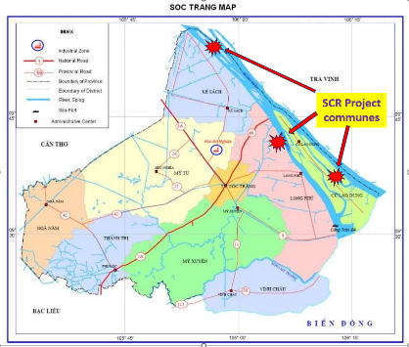

Location
Vietnam - Mekong and tributary riverine communities in Soc Trang Province in the Mekong Delta
  - Phong Nam Commune - population 5,080, Ke Sach district
  - An Thanh Dong Commune - population 9,159, Cu Lao Dung district
  - Song Phung Commune - population 7,077, Long Phu district

Figure 1 Project site: 2 of 3 communes’ sites are Islands

Part II. Overview of the Story telling and documentation

Methodologies
The consultancy team applied the following data collection methods, using a gender-sensitive, inclusive, and participatory approach:
- Qualitative method: (1) Document review, (2) Key Informant Interviews (KIIs) (3) Focus Group Discussions (FGDs) and (4) Field observation and taking photos, video clips
- Following the Oxfam guidelines and learning examples from countries in the region.

Development of framework and story collection tools

Key Informant Interviews (KIIs)
To gather information for the Story development, the consultancy team applied a primary qualitative tool: Key Informant Interviews (KIIs) with key stakeholders. The set of interview questionnaires was designed, discussed with the Oxfam team, with an open-ended and flexible structure allowing for adjustments based on the actual context and the specific person involved, considering gender sensitivity. The set of questions was sent to the partner in the province on week before the practical field assessment was carried out.

Focus Group Discussions (FGDs)
Participatory FGDs are designed to explore the perspectives and experiences of experts and both direct and indirect beneficiaries of the Project interventions. The set of discussion guides was designed to be open-ended and flexible, allowing for gender-responsive solutions tailored to the actual context and the specific groups of respondents involved.

Field survey
The evaluation was conducted in three project communes in Soc Trang Province: An Thanh Dong (Cu Lao Dung District), Phong Nam (Ke Sach District), and Song Phung (Long Phu District) and the DARD provincial office in Soc Trang city.

Data Collection for story development:
In total, the consultancy team conducted 17 key informant interviews and six focus group discussions involving 85 participants, including 43 males and 42 Females.
- In-depth interviews: Approximately six community representatives and commune/district officials were interviewed in each commune.
- Expert consultations: Three key experts were consulted using a semi-structured format.
- Focus group discussions: Two group discussions were held in each commune (one with men, one with women), each with about six participants.

Documenting Success Stories:
Through these discussions and interviews, the consultants identified 4–5 representative beneficiary cases per site to develop into learning stories, capturing key lessons learned and best practices. A total of eight stories were documented, supported by both the evaluation and story documentation consultants. All information was verified, and participants provided informed consent by signing Oxfam’s template before their interviews.

Limitation
The consultancy team identified the following limitations that may have affected the final evaluation:
- The survey was conducted during a critical period of administrative restructuring in Vietnam. Field visits and the arrangement of meetings, including focus group discussions and key informant interviews, took place amidst significant changes to the country’s administrative system. This situation affected both the timing and the psychological readiness of project stakeholders at the provincial, district, and commune levels.
- Two of the three project sites were located on the Mekong River, isolated islands, making travel by boat-ferry difficult and risky late in the day, particularly during the rainy days that the evaluation team experienced.

Part III: Results of the survey and documentation

Outcome 1: Inclusive and Climate-Informed Governance & Planning

Story 1: “Nature-based solutions have always been available, but we must act now!”
- Location: An Thanh Dong, Soc Trang
- Key Idea: Community leadership in piloting and promoting mangrove planting to reduce riverbank erosion.
- Highlight: Local authorities (e.g., Mr. Mung) lead by example in adopting green solutions. Mangrove trees are seen as cost-effective, sustainable “bio-walls.”
 | 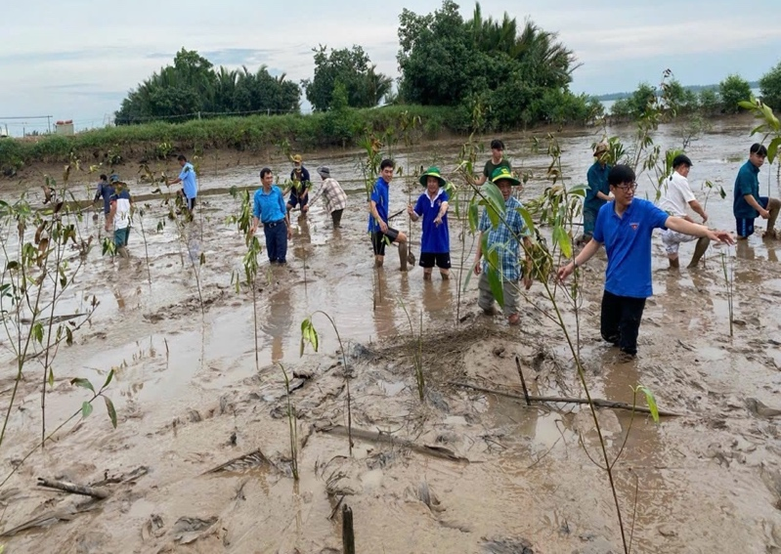
Photo: Mr. Nguyen Van Mung (white shirt), Vice Chairman of An Thanh Dong Commune People's Committee, with the team to promote forest sanitation (2024) | Photo: Tree planting movement to preserve soil and prevent riverbank erosion in An Thanh Dong commune (Photo source: SCR project, 2024)
Figure 2 Story: “Nature-based solutions”

Story 3: “I never imagined my garden would be this lush”
(or: “Green Garden for Peaceful Heart”)
- Location: Song Phung
- Key Idea: Smart irrigation empowers single, older women to sustain livelihoods.
- Highlight: Ms. Thuy, a widow, sees increased productivity and health with reduced labor, thanks to automatic misting systems.
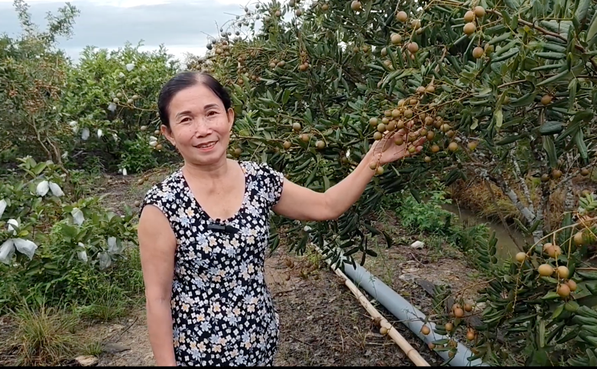 | 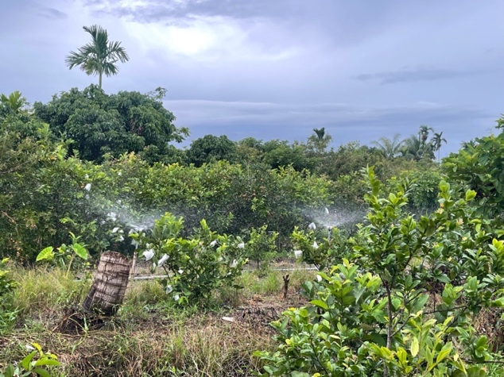
Photo: Mrs. Thuy happily shows off her garden, which is regularly watered by an automatic irrigation system that she never dared to dream of before.
Figure 6: Story 3: “I never imagined my garden would be this lush”

Story 5: “When the lives of the disadvantaged improve, their communities will also be stronger!”
- Location: Phong Nam
- Key Idea: Inclusive support for People with Disability improves household resilience and dignity.
- Highlight: Automatic irrigation gives mobility-limited farmers “technological legs,” improving livelihoods and health.
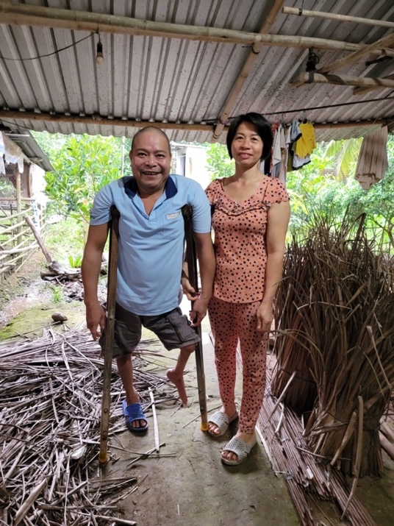  Mr. Dinh Quang Chuc (51 years old) |  | 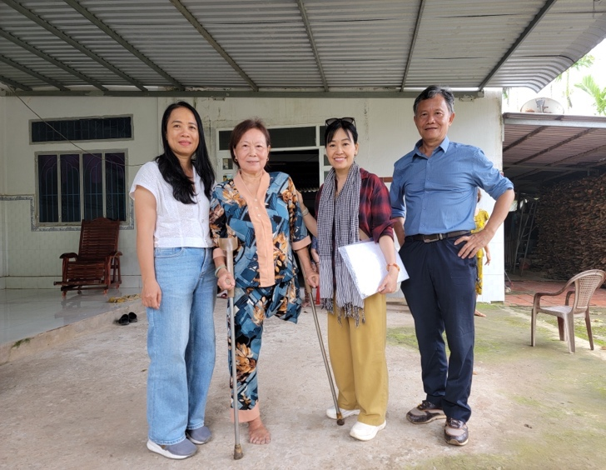  Mrs. Tran Thi Ung (60 years old)
 | Photo: Households with People with Disability are supported to improve their livelihoods in Phong Nam commune, Ke Sach district, Soc Trang province (from July 2025, Can Tho city).
Figure 7: Story 5: “When the lives of the disadvantaged improve

Story 6: A green solution for climate-smart livelihoods
- Location: An Thanh Dong
- Key Idea: Integration of technology and youth return to agriculture improves climate resilience.
- Highlight: An older man's grapefruit garden becomes productive under the care of his returned granddaughter and husband using smart irrigation.
Remarks: Lessons & Recommendations Cross-cutting Lessons & Reflections:
- Leadership matters: Active engagement of local leaders boosts community trust and participation.
- Technology + tradition: Smart tech like automatic irrigation systems or mobile apps complements local experience.
- Inclusion is key: Women, older people, and People with Disability need tailored interventions to truly build climate resilience.
- Mindset shift is essential: Sustainability depends not only on interventions but on how deeply local officials internalize DRR/CCA principles.
- Story 8: Shifting Perception & Action-Mindset of local officials is the core issue
- Location: Provincial level (Irrigation Sub-Department)
- Key Idea: Local officials’ mindset shift toward community-based, nature-based adaptation is central to sustainability.
- Highlight: Emphasizes long-term adaptation through local capacity, not just infrastructure.
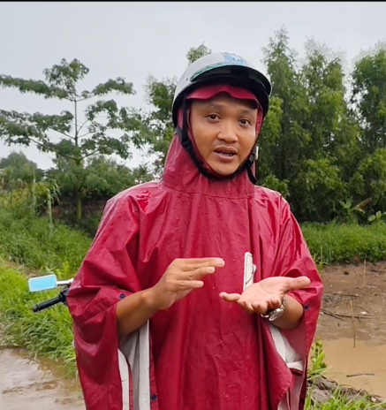 | 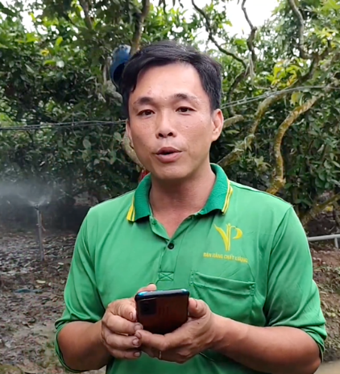 | 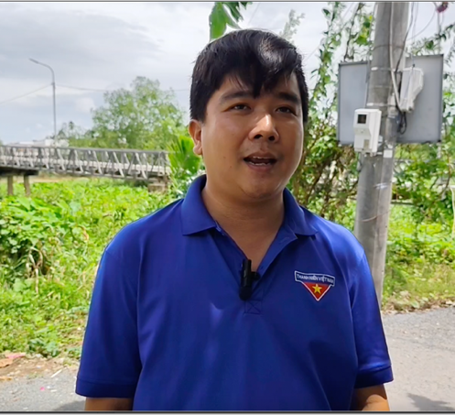
Photo: Thai Van Danh – Commune Emergency Response team | Mr. Tran Minh Hung, a young farmer who regularly uses the App "Mekong Water Source | Photo: Mr. Trần Vu Linh – Commune Emergency Response Team
Figure 5: Story 8: Shifting Perception & Action-Mindset

Outcome 2: Climate-Smart Livelihoods & Resource Mobilization

Story 2: Climate-resilient development planning based on local capacity building
- Location: An Thanh Dong, Phong Nam, Song Phung.
- Key Idea: Integration of DRR/CCA into commune-level planning through participatory approaches (PCVA).
- Highlight: Local authorities have begun adapting Disaster Risk Management Plans (DRMP) and Socio-Economic Development Plans (SEDPs) to reflect gender concerns and vulnerable groups’ needs. Challenges remain with scaling participation, post-commune mergers.
 | 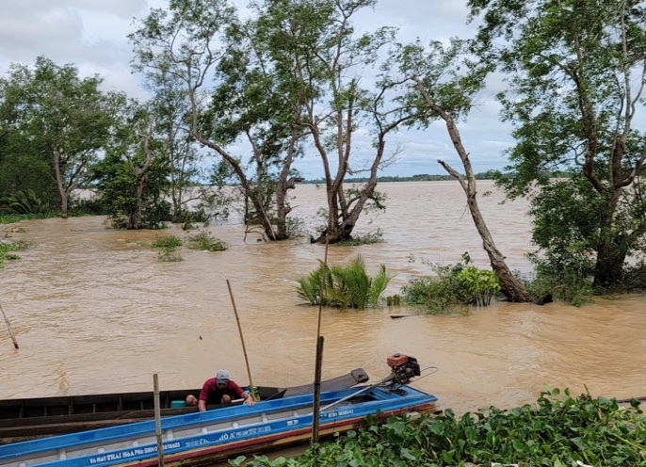 |  | 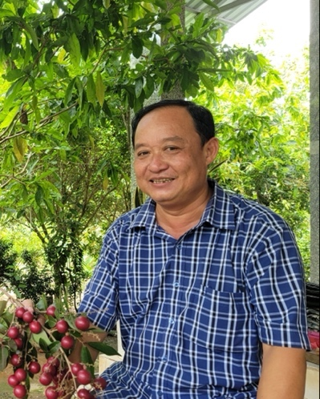
Photo: An area frequently hit by waves, causing landslides in Phong Nam commune |  | Photo: Mr. Nguyen Van Khen - one of the active commune leaders in strengthening community capacity in disaster prevention
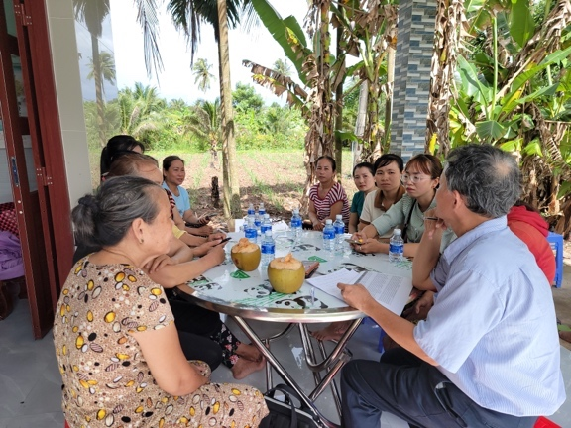 |  | 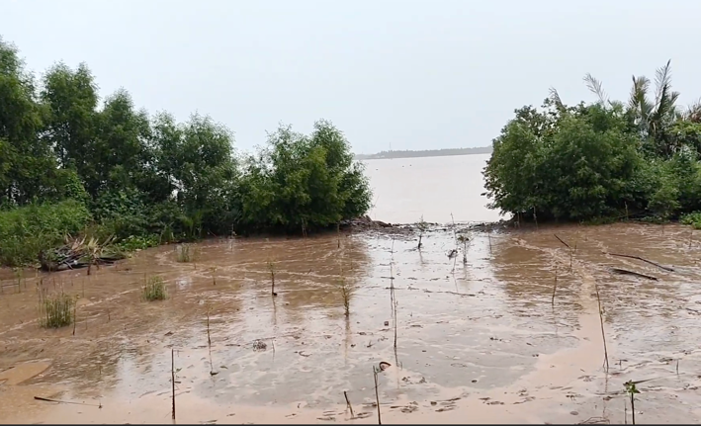
Photo: Group discussion: How do women participate in disaster response? |  | Photo: Planting mangrove trees to protect the banks of aquaculture ponds in An Thanh Dong commune
Figure 3: Story 2: Climate-resilient development planning

Story 4: “The earlier and more accurate the information, the better protected the community is”.
- Location: Song Phung
- Key Idea: Climate data and warnings empower local disaster risk reduction (DRR).
- Highlight: Commune leaders, unions (especially Women’s Union), and mobile apps (like Mekong Water Resources) are used to strengthen community preparedness.
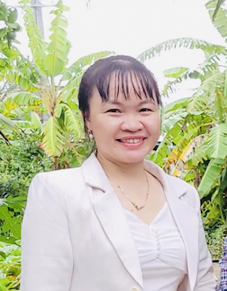 | 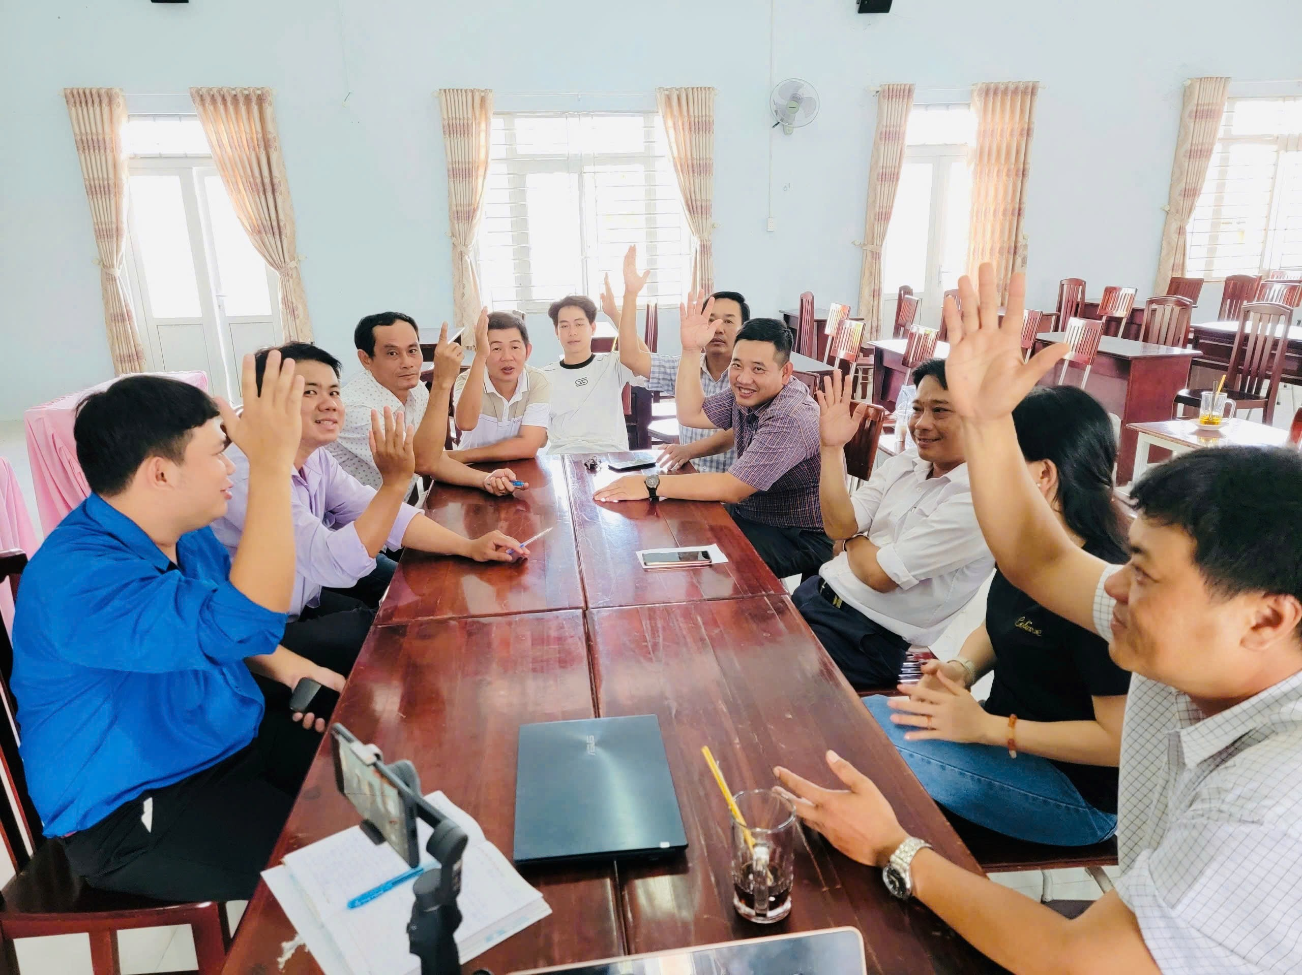
Photo: Ms. Giang T.K. Mai - Chairwoman of the Song Phung Commune Women's Union | Photo: Discussion with representatives of commune officials and unions about climate information dissemination (June 2025)
Figure 4 Story: “Better protection from earlier warning information

Story 8: “Shifting Perception & Action-Mindset of local officials is the core issue”
- Location: Soc Trang province
- Key Idea: Building local staff capacity to increase the sustainability of interventions
- Highlight: Evaluation and recommendation of Mr. Pham Tan Dao, Head of the Irrigation Sub-Department, Department of Agriculture and Environment of Soc Trang Province, Member of the Project Working Group
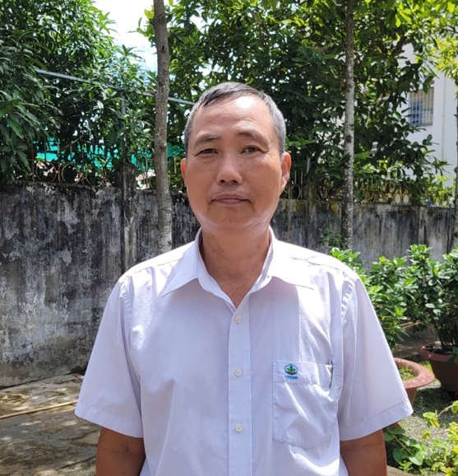
Photo: Mr. Pham Tan Dao, Head of the Irrigation Sub-Department, Department of Agriculture and Environment of Soc Trang Province, Member of the Project Working Group.
Figure 9: Story 8: “Shifting Perception & Action-Mindset of local officials is the core issue”

Outcome 3: Inclusive and Climate-Informed Governance & Planning

Story 7: Strengthening community-based early warning of climate-related information
- Location: Phong Nam, Song Phung, An Thanh Dong
- Key Idea: Improved hydro-meteorological data is used by riverine communities and authorities using the "PCTT" and "Mekong Water Resources" apps for real-time monitoring.
- Highlight: Communities use social media, Zalo, and loudspeakers for warning dissemination. Young farmers advocate combining scientific and traditional knowledge. Representative representatives of the community: Mr. Nguyen Van Khen. Tran Vu Linh, Mr. Thai Van Danh, Mr. Tran Minh Hung.
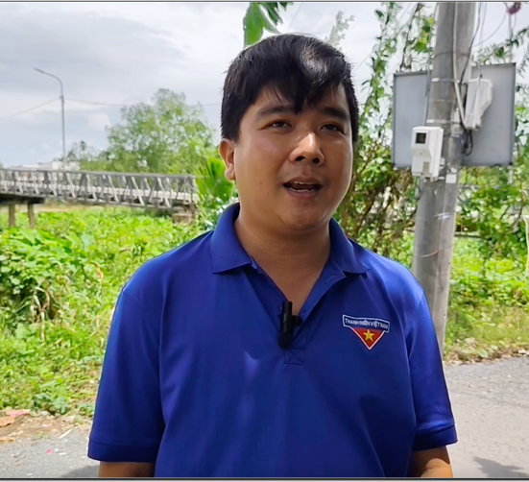 | 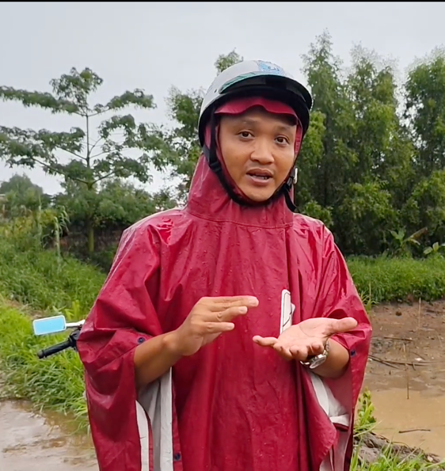
Photo: Mr. Trần Vu Linh – Commune Emergency Response Team | Photo: Thai Van Danh – Commune Emergency Response team
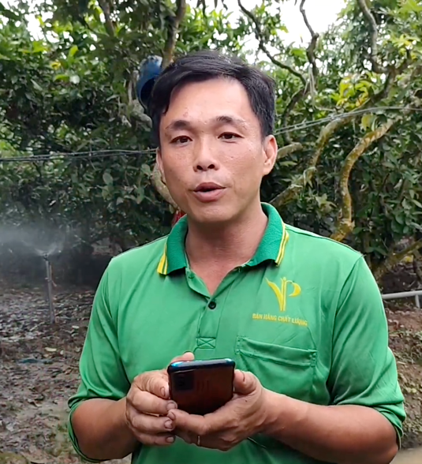
Mr. Tran Minh Hung, a young farmer who regularly uses the App "Mekong Water Source"
Figure 8: Story 7: “When the lives of disadvantaged people improves.”

STORY TELLING – DOCUMENTATION REPORT
Strengthening Climate Resilience in the Mekong
Subregion (SCR) Project in Vietnam

THE STORIES REFLECTING AND BALANCING

ACROSS THE THREE OUTCOMES OF THE PROJECT

Story 1: "Nature-based solutions have always been available, but we must act now!”
Location: Song Phụng commune (Long Phu district), Soc Trang province (Can Tho city), Vietnam
Theme: Communities implementing inclusive DRM and/or CCA plans
"Nature-based solutions have always been available, but we must act now!”
The "cù lao" — islands formed by riverine alluvial deposits in the Mekong Delta — face increasingly severe risks from climate change, particularly riverbank erosion and saltwater intrusion. The lives and livelihoods of communities on these islands are more vulnerable than ever, especially during strong waves and storms.
In the three target communes of the SCR Soc Trang project (An Thanh Dong, Song Nam and Song Phung), Traditional disaster response methods are proving ineffective, as evidenced by recent landslides that have devastated aquaculture ponds (shrimp and crab) and flooded homes. Many experienced farmers have lost everything when fierce waves, combined with high tides, broke their shrimp ponds. This critical challenge demands urgent solutions from both local authorities and residents.
In the heart of this struggle stands Mr. Nguyen Van Mung, Vice Chairman of An Thanh Dong Commune People's Committee. Having dedicated almost his entire life to Cu Lao Dung, Mr. Mung possesses a profound understanding of the relentless riverside erosion in An Thanh Dong commune and its long-term consequences. Long before the Project "Strengthening Climate Resilience in the Mekong Subregion Project in Vietnam" (SCR) arrived in Soc Trang province in 2023, he was already proactively seeking solutions. Mr. Mung diligently researched and learned about mangrove trees – species uniquely adapted to riverine environments that could help retain soil, prevent landslides, and protect rural infrastructure. He knew that this "green, soft" solution offered flexibility, resilience, and long-term benefits.
The SCR project's focus on planting mangrove trees to prevent erosion aligned perfectly with Mr. Mung's vision. With unwavering determination, he spearheaded the implementation of this model, beginning with a pilot area in Den Tho village. Mr. Mung did not only direct from an office; he led by example, embodying his philosophy: "It is important that leaders are persistent, exemplary, and learn first, act first."
Photo: Mr. Nguyen Van Mung (white shirt), Vice Chairman of An Thanh Dong Commune People's Committee, with the team to promote forest sanitation (2024) | Photo: Tree planting movement to preserve soil and prevent riverbank erosion in An Thanh Dong commune (Photo source: SCR project, 2024)
Mr. Nguyen Van Mung, along with his colleagues and dedicated local task forces/teams, meticulously surveyed each vulnerable area. He consulted with the community, viewing these interactions not just as data collection but as vital opportunities to raise awareness and educate residents about the critical role of wave-breaking trees in disaster risk reduction and climate change adaptation. Mr. Mung worked shoulder-to-shoulder with farmers, actively participating in the planting and caring of the mangrove saplings, demonstrating his commitment and hands-on approach.
Initially, many farmers were hesitant, fearing that planting mangroves would reduce their valuable aquaculture areas. However, witnessing Mr. Mung's dedication and the tangible benefits of the pilot project, their perceptions began to shift. The "fences" of resilient mangrove trees gradually took root, a testament to the close cooperation of households and authorities working together, bringing many benefits to the community. After observing the implementation of the SCR project for a period and with the persistent leadership of the local government, some households voluntarily agreed to leave part of their land for more extensive mangrove planting, in the hope that many other households would realize the long-term benefits of planting trees to protect their island.
Local leaders like Mr. Mung play an undeniably pivotal role in building community capacity for climate adaptation. They have been deeply connected to the land for decades and possess an intimate understanding of these precarious islands. As one resident of An Thanh Dong commune, though not directly part of the SCR project, observed, "Commune leaders here help us understand that planting trees will bring many environmental benefits. Like Mr. Mung, he not only calls on people to plant trees to protect the soil, but he is very diligent and active in planting trees, so our households follow suit."
When telling the story of planting forests for the future, Mr. Mung confided: "The important thing is that leaders must understand and act first. When people understand and see the long-term benefits of planting trees to block waves, they will trust, unite and voluntarily follow with their own resources."
Today, in An Thanh Dong and Song Nam communes, people begin to see more green mangrove belts on many riverbanks. This sight fills both the community and its leaders with pride. The story of Mr. Nguyen Van Mung and the thriving mangroves of Cu Lao Dung stands as a testament to the effectiveness of nature-based solutions and, crucially, to the transformative power of dedicated, local leadership in building a resilient future.
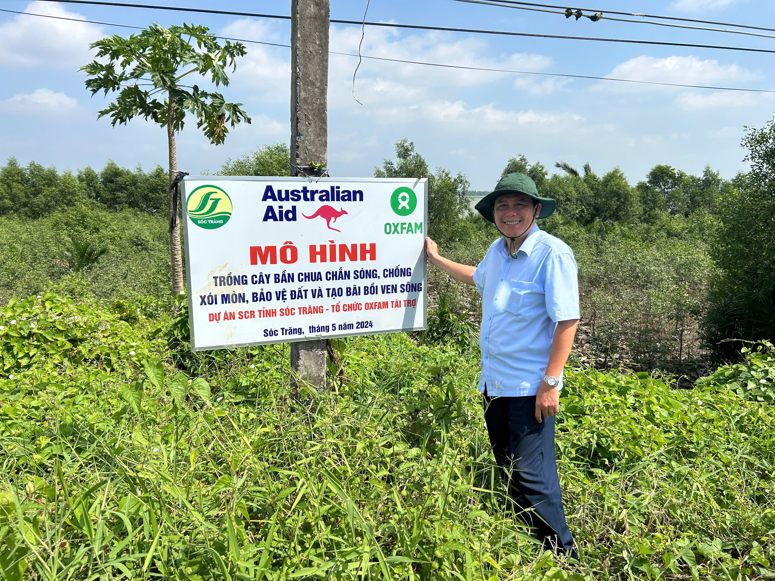
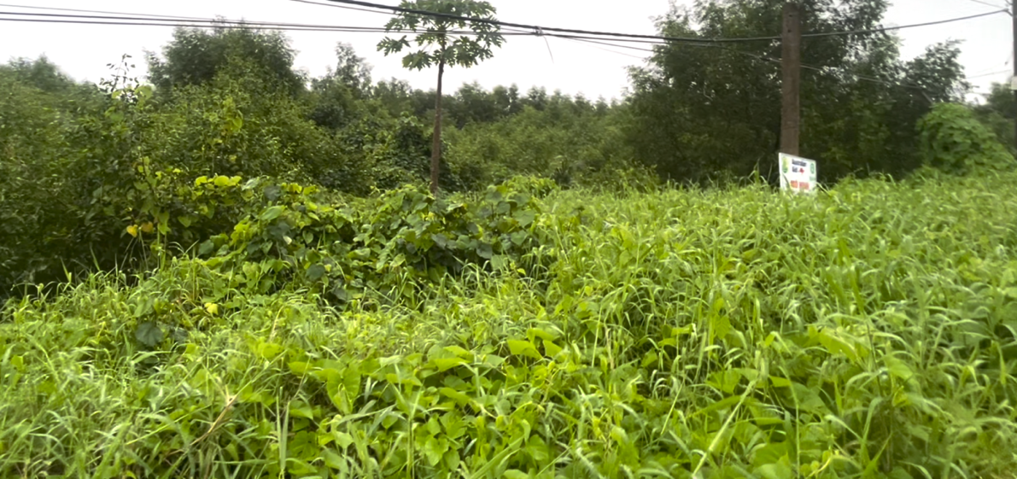
Photo: Crabapple Mangrove (Sonneratia caseolaris) (cây Bần chua), a type of mangrove tree selected for planting and growing well in An Thanh Dong commune (June 2025)

Story 2: Climate-resilient development planning based on local capacity building
Location: Song Phụng commune (Long Phu district), Soc Trang province (Can Tho city), Vietnam
Theme: Local and sub-national authorities are implementing inclusive development plans that are informed by climate and disaster risk information and analysis
Climate-resilient development planning based on local capacity building
(or Climate-informed socio-economic development planning)
For the vulnerable "cù lao" communes in Soc Trang province (now part of Can Tho city), integrating comprehensive disaster and climate risk information and analysis into Socio-Economic Development Planning (SEDP) is not merely an option, but an absolute imperative. Without embedding precise, up-to-date climate risk analysis at the heart of their development strategies, communities’ risk significant investments in infrastructure and livelihoods being undone by the next natural disaster.
The core objective of the SCR project in Soc Trang is to increase the capacity of local authorities (commune/district level) and communities in climate risk management and adaptation. This is achieved by equipping them with knowledge and skills in risk assessment, providing access to hydrometeorological data, and ensuring meaningful community participation in socio-economic development planning (SEDP). The aim is to ensure inclusive local development plans that effectively integrate the voices and needs of vulnerable groups (women, older people, People with Disability, and households in high-risk areas), with commune-level authorities playing a central role.
Previously, the annual Disaster Risk Management Plans (DRMPs) of communes developed by the Steering Committee for Natural Disaster Prevention followed standard templates, containing only basic information and lacking local risk analysis or future predictions. However, from 2024-2025, DRMPs in the three communes of An Thạnh Đông, Phong Nam, and Song Phụng have undergone significant changes. These new plans focus deeply on risk information and community participation, making them closer to the actual needs and capacities of the localities, more strategic in addressing long-term risks based on data and trends, and more attentive to vulnerable groups and gender considerations.
According to Mr. Nguyen Van Mung, Vice Chairman of An Thanh Dong Commune, “The results from the Participatory Capacity and Vulnerability Assessment (PCVA) are now considered vital information and practical input for proposing highly feasible short and long-term response solutions at the local level. The project guided us through the implementation of PCVA in detail and engaged the Women's Union as key participants". And “the DRMP and SEDP for 2025 have been improved significantly compared to previous years, this is reflected in solutions to reduce natural disaster risks in many fields and regions that are more specifically stated, including increasing technical support to improve agricultural livelihoods to adapt to climate change and expanding mangrove planting sites".
Mr. Nguyen Van Khen, a leader in Phong Nam commune, highlights the importance of inclusive data gathering. He states, "in a flexible way, community representatives also participate in the process of planning for natural disaster prevention and control and contribute ideas to commune officials and the Commune Emergency Response Team. The community here includes the voices of women, People with Disability, poor households, and older people." While acknowledging limitations in participation depth due to varying awareness levels. Mr. Khen emphasized that diverse community input is crucial, especially the participation of women in comprehensive risk identification and analysis and effective planning.
Similarly, Song Phung commune also has new points in planning DRM and SEDP for 2025. According to Mr. Bui Thanh Nhan - Vice Chairman of of the People's Committee of the commune (June 2025), "We planners have collected information and data from reality and based on the results of the 2024 risk assessment as input for the 2025 plan, and have consulted the community, of which the Women's Union is very significant". The training courses of the SCR project include guidance on integrating CCA into commune-level socio-economic development plans. Thanks to this, the capacity of commune officials and some members of the Farmer Union, Women's Union and Youth Union has been improved. “However, adaptation integration is only at the initial stage and has largely focused on agriculture and irrigation,” Mr. Nhan added.
According to Ms. Giang Thi Kieu Mai - Chairwoman of the Women's Union of Song Phung Commune, "Before 2024, it was rare for the Women's Union to truly discuss and contribute ideas to the commune's DRMP. We used to believe that planning was solely the responsibility of the commune leaders; ordinary men and women like us simply followed. But now, things have changed. We are actively participating in the planning process and have truly become part of the solution."
Photo: An area frequently hit by waves, causing landslides in Phong Nam commune | Photo: Mr. Nguyen Van Khen - one of the active commune leaders in strengthening community capacity in disaster prevention
Photo: Group discussion: How do women participate in disaster response? | Photo: Planting mangrove trees to protect the banks of aquaculture ponds in An Thanh Dong commune
Ensuring Sustainability: The Imperative of Ongoing Risk Analysis
Despite these significant strides, key commune officials in the three project communes also wondered, "will SEDP planning, which thoughtfully integrates climate risks, continue to receive attention in the coming period of 2026-2030, given the current reality of merging many communes into one large commune?". That is the ability to transfer or rehire staff whose skills have been improved in the SCR project. The potential for difficulties in integrating Disaster Risk Management (DRM) into socio-economic development highlights the critical and continuous need for robust information and risk analysis capacity.
To ensure sustainability, according to the combined opinions of the leaders of the three project communes, it is necessary to: invest in building a dedicated team at the local level through Training of Trainers (ToT) programs; institutionalizing PCVA methodologies and risk data requirements into standard planning procedures at commune and provincial levels; and ensuring communes retain consistent access to updated hydrometeorological data.
The SCR project has laid vital groundwork for integrating evidence-based climate risk information and analysis into socio-economic planning. Therefore, maintaining and strengthening this data-driven approach is important for the islands' climate-resilient future.

Story 3: “I never imagined my garden would be this lush”
(or: “Green Garden for Peaceful heart”)
Location: Song Phụng commune (Long Phu district), Soc Trang province (now Can Tho city), Vietnam
Theme: Communities demonstrating adapted livelihood strategies that promote resilience to disaster and climate change
(The story of the water-saving irrigation model of Ms. Nguyen Thi Thuy (60 years old) in Phung Tuong 1 hamlet, Song Phung commune, Long Phu district, Soc Trang province)
“I never imagined my garden would be this lush”
Song Phung Commune, known for its fruit orchards, is one of the key agricultural areas in Long Phu District. For most farmers in the commune, farming is their primary source of income. Climatic challenges have made traditional irrigation difficult, especially during hot summer days and dry seasons, threatening the main livelihood of most local farmers.
The physical labor required is demanding for ordinary households with couples working together, but it is much more difficult for households with single and older women like Mrs. Nguyen Thi Thuy in Ap Phung 1 village, Song Phung commune. Mrs. Thuy raised her children alone after her husband's early passing. Her entire income depended on her more than 4,000 square meters garden, making life very difficult. She recounted, "In the past, it took me at most two days to water this garden manually, which was incredibly difficult for my small frame and limited health." Her son, who recently started working for a company in Soc Trang city, could only occasionally help on his rare days off.
Photo: Mrs. Thuy happily shows off her garden, which is regularly watered by an automatic irrigation system that she never dared to dream of before
In March 2025, a turning point arrived when the project supported the installation of an automatic water-saving irrigation system for Mrs. Thuy's household. She shared emotionally, "Automatic irrigation like this has so many benefits because it saves everything—time, labor, and water ". She added, "The first week after installing this irrigation system, I was so happy that every time I went to the garden, I cried. Before, I only watered manually with a hand sprayer. In the hot season, plants need a lot of water, so regular watering is very tiring. Not to mention, in the dry season, there was a shortage of water, and hand watering didn't distribute moisture evenly, leaving many plants under-hydrated, which led to low productivity."
Now, with the automatic irrigation system, "I just need to stand in one place and control it on my phone, and it only takes about 20 to 30 minutes to water the whole garden." This year, her garden's guava and longan trees are exceptionally fruitful, promising a good harvest. Mrs. Thuy attributes this success to the system: "Because this season the trees are watered evenly, with enough moisture, and I have more time to take care of the trees, such as fertilizing, pruning, and monitoring for pests and diseases." Even though May and June this year were hotter than last, Mrs. Thuy is not worried. "I never dared to dream that my garden would be as lush as this while I got to rest more and feel healthier. This year, my income will definitely be higher."
Mrs. Thuy's son noted that he had never seen his mother so happy in her garden. He recounted that at a community meeting; his mother enthusiastically spoke about the benefits of the automatic misting system. "She was so happy that she spoke very loudly and talked a lot, making everyone in the meeting room laugh and feel emotional." Mrs. Nguyen Thi Thuy's story is a testament to how strengthening climate change resilience can bring positive and sustainable changes to communities.

Story 4: “The earlier and more accurate the information, the better protected the community is”
Location: Song Phụng commune (Long Phu district), Soc Trang province (Can Tho city), Vietnam
Theme: Local authorities making climate-related information and data available to communities
“The earlier and more accurate the information, the better protected the community is”
This insight underpins the work being done in local communities in SCR project areas. With comprehensive support from the SCR project—encompassing training in Disaster Risk Management and Climate Change Adaptation (DRM & CCA), Participatory Vulnerability and Capacity Analysis (PVCA), and improved access to crucial climate information—commune leaders are now stepping up their efforts to disseminate vital climate and extreme weather data to their communities.
Song Phung (from July 2025, Nhon My commune, Can Tho city) stands out as a prime example of this proactive approach. Mr. Bui Thanh Nhan - Vice Chairman of the commune said, "After the riverbank landslides that caused great damage in 2023 and 2024, people here have paid more attention to information related to climate, and have been more proactive in preventing, protecting assets and production. Local leaders are always proactive in synthesizing and promptly providing information on climate, natural disasters and extreme weather to the community, in many different ways. The earlier and more accurate the information, the better protected the community is."
Mr. Nguyen Huu Duc - an officer of the Commune Farmers’ Union and a member of the Commune Emergency Response Team (CERT) said, "After being trained on climate change and conducting a disaster risk assessment of the commune, I and other commune officers have seen more clearly the importance of providing timely climate-related information to people and businesses."
Crucially, local women are also a part of the CERT. Ms. Giang Thi Kieu Mai, Women's Union of Song Phung commune, highlights the impact of PVCA assessments that actively involve women. She shared, “Before, women here were very passive, considering disaster response as a man's job. But in fact, women can also participate very effectively. Currently, we have integrated content about DRM/CCA into meetings, radio news or Zalo groups. When there is official information related to landslides or drought, we immediately notify members. Being warned early means having early prevention plans.”  The “Mekong Water Resources” app, previously built for some provinces in the Mekong region, is also one of the useful information channels related to salinity intrusion and water resources. The SCR project introduced the app to commune officials and local people. According to Mr. Duc, “The app is very useful because it allows access and monitoring of parameters on salinity intrusion, such as salinity, water temperature, water level, etc. However, not many people know about this app yet, so the government needs to promote it more and provide guidance to extend to a larger population and communes across the province, especially island and coastal communes." | Photo: Ms. Giang T.K. Mai - Chairwoman of the Song Phung Commune Women's Union
 | Photo: Discussion with representatives of commune officials and unions about climate information dissemination (June 2025)

Story 5: When the lives of the disadvantaged improve, their communities will also be stronger!
(Or: Empowering Vulnerable People: Technology as a catalyst for Change)
Location: Song Nam commune (Ke Sach district), Soc Trang province (Can Tho city), Vietnam
Theme: local authorities integrating the perspective of women, People with Disability, and marginalized groups into DRM/CCA policies and programs
When the lives of disadvantaged people improve, their communities will also be stronger!
In areas identified as high risk from climate change—such as the river islands of Soc Trang and, more broadly, the Mekong Delta - vulnerable groups within the community appear to face increasing levels of risk.
In Cu Lao Dung district or Long Phu and Ke Sach districts - the target areas of the Oxfam SCR project - are People with Disability, poor and single women, and isolated, older people. In the three project communes, the main household income is from traditional farming with low productivity, which is labor-intensive and weather dependent. Limitations in physical health have led to other difficulties, such as access to knowledge and materials, access to financial or social resources, and it is very difficult for communities to improve their lives on their own. The SCR project in Soc Trang targets interventions for this group to support them to improve their lives and increase their ability to adapt to climate change and reduce disaster risks through tailored livelihood support.
At least 36 households with People with Disability have directly benefited from the project’s interventions in 2023-2025, mainly in terms of training to improve awareness, knowledge and skills on disaster risk reduction and climate change adaptation (DRM & CCA) and support for smart automatic irrigation solutions. This support has created turning-point changes in the lives of many vulnerable people. For example, in Phong Nam Commune, two farmers who are People with Disability - both living with leg impairments and experiencing poverty, with fruit tree farming as their only source of income - saw their lives change significantly in just one year.
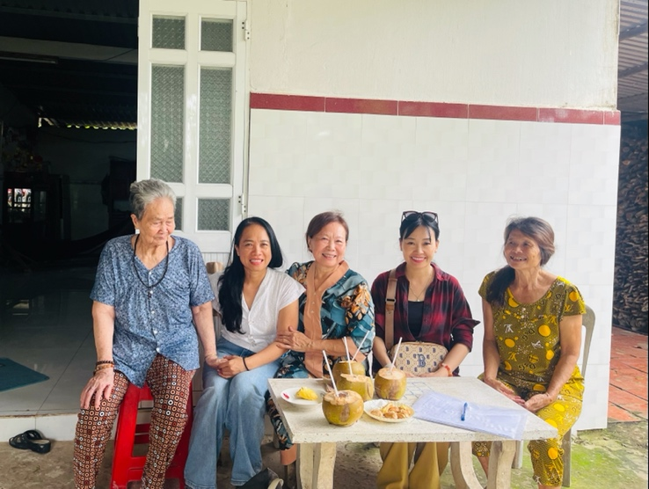 |  | 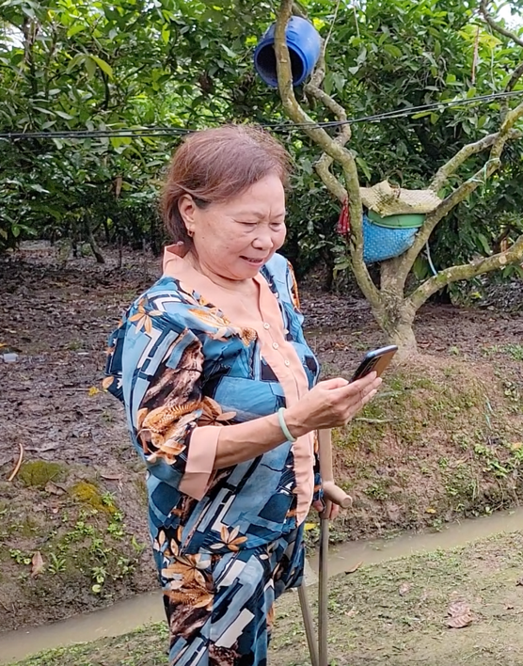
Tran Thi Ung (60 years old) with her family (June 2025)
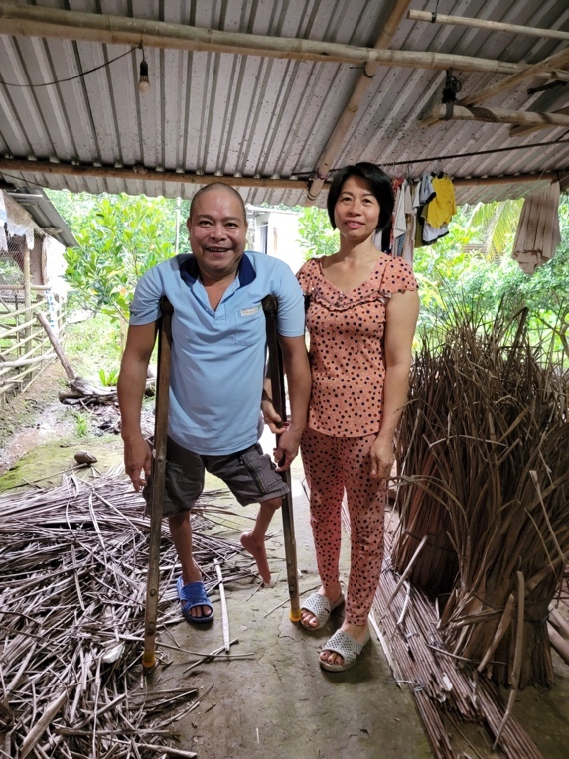 |  | 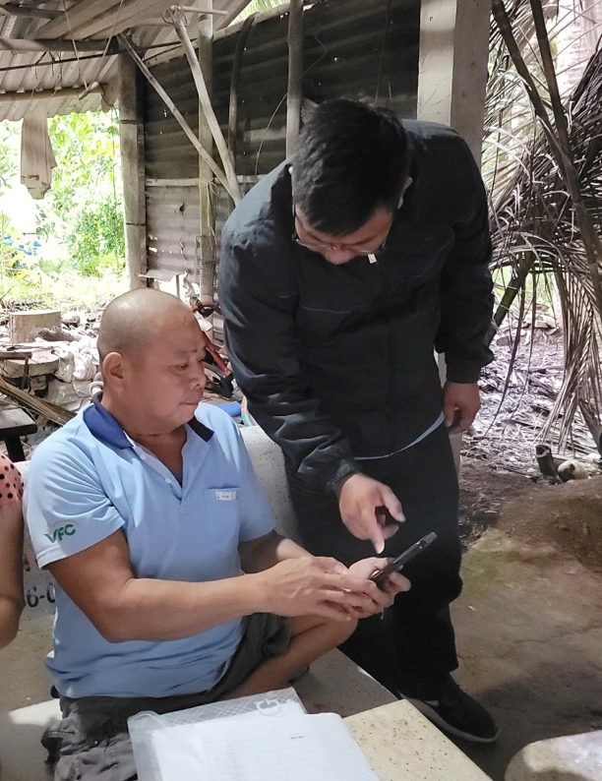
Mr. Dinh Quang Chuc (51 years old)
 | Photo: Households of People with Disability are supported to improve their livelihoods in Phong Nam commune, Ke Sach district, Soc Trang province (July 2025, Can Tho city).
In the case of Ms. Tran Thi Ung (60 years old), she lost a leg due to a terrible accident when she was young. This led to her not being able to marry and limited her ability to go to school. She said, “My biggest asset and main source of income is this nearly 5,000 square meters fruit garden - inherited from my parents”. Mrs. Ung has shown remarkable resilience in balancing multiple responsibilities. Since she was young, she has supported her sister, who has a mental health condition, as well as her sister’s child. In recent years, she has also cared for her mother, who is now over 83 years old, all while continuing to provide for herself.
Mrs. Ung said, “I am old now and watering the garden every week is very hard and time-consuming for me. It usually takes several days to water, and there is less water in the dry season. I also wished to have an automatic sprinkler system, but that is impossible because the cost is simply too high for me.”
Ms. Ung’s experience is similar to that of Mr. Dinh Quang Chuc, a 51‑year‑old farmer who has been living with a leg impairment since childhood. Together with his wife, he has built a life around their 7,200 square meters fruit garden, which remains their main source of income. Over more than 30 years of marriage, they have shared responsibilities: his wife often manages physically demanding tasks such as watering, fertilizing, weeding, harvesting, and transporting fruit, while Mr. Chuc takes primary responsibility for cooking, cleaning, and other household work. Their collaboration ensures that both the household and farm sustain their livelihood.
For both Ms. Ung and Mr. Chuc, as well as others in the SCR project, significant changes came when they received support to install automatic sprinkler irrigation systems.
It is not just a smart irrigation solution; it is a pair of technological legs!
This innovative system brought immediate and tangible benefits. "It helps reduce a lot and increase a lot," Mr. Chuc elaborated. "It cuts down on labor costs and reduces the need for fertilizer and pesticides because pest issues are minimized. Conversely, it improves tree health, leading to more fruit and tastier produce."
Mrs. Ung echoed this sentiment, “When I water, I don’t have to move as much. I just set a timer or press a button on my phone, and it's done in 15-20 minutes. Before, it took several days, and moving with only one leg and crutches to cross ditches was incredibly difficult."
Beyond personal convenience, the environmental benefits are significant. Automatic sprinkler irrigation conserves water, enables proactive watering during the dry season and supports resilience against drought and salinity intrusion. Mr. Chuc noted: "From now on, I worry less about water scarcity during the dry season, because this watering method requires very little water, yet the plants remain moist enough."
The social impact, however, is perhaps the most heartwarming. Mr. Chuc shared, “One of the things that makes me very happy now is that my wife doesn’t have to work hard doing most of the work anymore. I can handle it all with just this phone. And my wife has time for her favorite job - cooking. I am very grateful because this modern irrigation system is like giving me a pair of technological legs”.
As for Mrs. Ung, “this irrigation system helps People with Disability, older people and women like us to reduce the hard work, have time for ourselves. It has only been a few months since I installed this system, but I feel like my life has completely changed; I am healthier and much freer. Now I have more time to rest and take care of my elderly mother and sister. I am so happy!”
Providing appropriate, climate-adaptive livelihood interventions for People with Disability and vulnerable groups yields simultaneous economic, environmental, and social values, improving the quality of life and, by extension, strengthening the entire community.
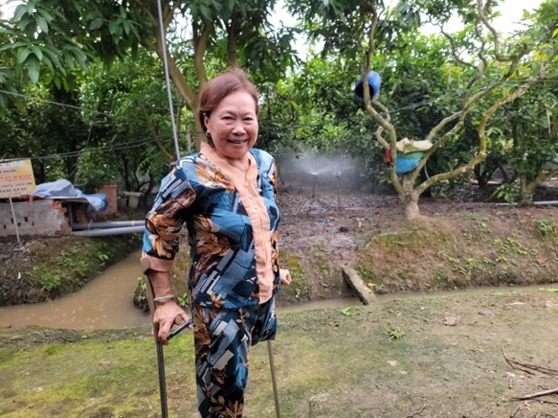 | 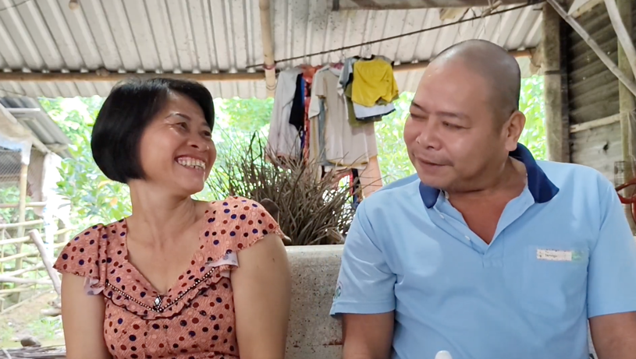
Photo: Mrs Ung and Mr and Mrs Chu received support to improve their livelihoods in response to climate change.

Story 6: A green solution for climate-smart livelihoods
Location: An Thanh Dong commune (Cu Lao Dung district), Soc Trang province (Can Tho city), Vietnam
Theme: Local authorities with increased resource allocations for DRM and/or CCA in target communities, in particular, climate-smart livelihood options.
A green solution for climate-smart livelihoods
Fruit growing is the main traditional livelihood of many farmers in Cu Lao Dung of the Mekong Delta, but riverbank erosion, saltwater intrusion and lack of irrigation water in the dry season have caused many households to face difficulties. Mr. Le Van Tam, 87, lives with his grandchildren, who often work away as seasonal laborers. He continues to manage his grapefruit garden, though he faces challenges such as limited labor support, scarce resources, and saline soil conditions.
Recognizing the need and based on community consensus, the An Thanh Dong commune authority, in coordination with the SCR project, extended support to Mr. Tam's household. An automatic sprinkler irrigation system was installed, not just to alleviate the immediate challenges of drought and saltwater intrusion, but also to sow the seeds of a larger vision: to encourage young people to invest in local agriculture rather than migrating for work.
At the end of 2024, Mr. Tam passed away, and his granddaughter, Ms. Dinh N.K. Tien, and her husband returned to focus full-time on developing the garden. By leveraging the effectiveness of the automatic irrigation system, the previously barren garden became a lush fruit garden in just over half a year. Ms. Tien said, “The garden would not be as good as it is today if it were still watered the old way. This new method saves both water and time, and it also waters evenly and keeps everything moist. The soil is better, and less chemical fertilizers are needed. Before, my husband bore the brunt of the watering because it was such back-breaking work, but now, it’s reversed; it’s so much easier for me to manage!”
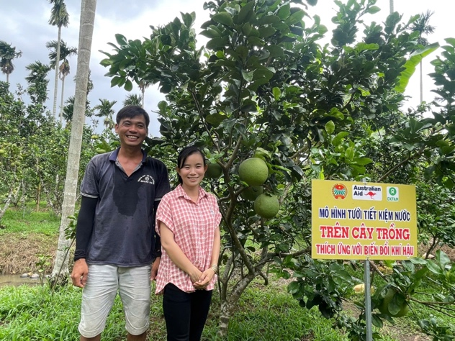
Photo: Fruit garden of Dinh N.K. Kieu Tien's family in Den Tho village, An Thanh Dong commune, Cu Lao Dung district, Soc Trang province (Can Tho city)
In June 2025, Ms. Tien’s family’s orchard had become more than just a source of fruit; it was a destination. People visited not only to purchase fresh produce but also to explore, take photographs, and learn from their success. Ms. Tien’s husband shared, “This year, we have intercropped some other short-term fruit trees so that we can sell fruit all year round. We plan to raise more snails and frogs in these canals next month to help us diversify income sources. Many people who come to buy fruit also ask how to improve their garden. It’s hard to do it alone, but we can certainly learn and grow together.”
This case demonstrates how a targeted intervention, such as a climate-smart irrigation solution, can transform farmers' awareness and actions, catalyzing a ripple effect throughout the community. Climate-adapted livelihoods are helping reduce vulnerabilities and strengthen the resilience of participating households.
Mr. Thai Van Danh, Chairman of the Commune Farmers' Union of An Thanh Dong Commune. encapsulated the broader impact: “This success story is a prime example of the harmonious synergy between the project’s technical intervention, the dedication and creativity of the households, and the proactive support of the local government. We have already proposed to the commune leaders to establish a mechanism for supporting other households with resources in the coming year, drawing valuable lessons from this transformative model.”

Story 7: Strengthening community-based early warning of climate-related information
Location: Song Nam, Song Phung commune, Soc Trang province (Can Tho city), Vietnam
Theme: Improved hydro-meteorological data is used by riverine communities and authorities

Strengthening community-based early warning of climate-related information
Accurate and timely weather and climate-related information—including rainfall, river flow data, water management parameters, and salinity intrusion forecasts—is indispensable for the lives and livelihoods of communities along the Mekong River. It is an input to support disaster risk management and climate adaptation processes. In the three target communes of the Soc Trang SCR project, two available applications on "Cuu Long Water Resources" and Phòng chống thiên tai "PCTT" of the Ministry of Agriculture and Environment have been improved and introduced to the locality.  Mr. Nguyen Van Khen, Vice Chairman of Phong Nam Commune, emphasized the critical role of this data: “For communes that are prone to landslides and saltwater intrusion like Phong Nam, hydrometeorological data is very useful for production and life. Because it provides information and data on water levels, salinity, temperature and disaster response instructions, etc. The more people know and use it, the better. Many people are still unaware and do not take community forecast information seriously”.  Echoing this sentiment, Mr. Tran Vu Linh, a member of the Commune Emergency Response Team (CERT) of Phong Nam commune, highlighted the utility of the "PCTT" application, “The "PCTT" application ("Phòng chống thiên tai" in Vietnamese language) is smartphone software that provides information, warnings and instructions for responding to various types of natural disasters. It's particularly helpful for responding to drought and saltwater intrusion. In my commune, the problem of saltwater intrusion is increasing, so people are hoping that the commune will have a monitoring station that warns of saltwater to be able to warn early and prevent saltwater intrusion more effectively.”  To ensure wide dissemination of climate and natural disaster information, An Thanh Dong commune employs various communication channels, Mr. Thai Van Danh, Farmers’ Union of An Thanh Dong commune, explained: "The commune's CERT sometimes quickly synthesizes the most necessary information and data, including meteorological and hydrological information, and shares it on the Zalo group. This group often has many members who are farmers, so they are interested and share quickly. In addition, the commune also has to use loudspeakers and social networks such as Facebook to broadcast information widely." | Photo: Mr. Trần Vu Linh – Commune Emergency Response team
 | Photo: Thai Van Danh – Commune Emergency Response team
 | Mr. Tran Minh Hung, a young farmer who regularly uses the App "Mekong Water Source"
According to Mr. Tran Minh Hung, a young farmer in Phong Nam commune who specializes in growing fruit trees, “I have installed the Mekong Water Source app on my phone and look at it very often. The way to use it is not complicated, but for many older farmers, it is sometimes difficult. There are also occasional internet problems. In my opinion, we should also combine this scientific information with traditional knowledge and local experience. If we can flexibly combine both, it will be very good.”

Story 8: Shifting Perception & Action-Mindset of local officials is the core issue
Location: Irrigation Sub-Department, Department of Agriculture and Environment of Soc Trang province (Can Tho city), Vietnam.
Theme: Strengthening the capacity of local officials to promote the long-term effectiveness of interventions.
Shifting Perceptions & Action-Mindset of local officials is the core issue
The SCR project combines a range of interventions such as awareness raising, windbreak planting and support for adaptation. Based on SCR project documents and direct surveys conducted in the three project communes (June 2025), findings revealed that before 2023, most project participants had a limited understanding of Nature-based Solutions (NbS) and their role in addressing climate change within Soc Trang’s Island communes. More than two-thirds of those participating in group discussions and in-depth interviews (65/83) affirmed that, before participating in the SCR project, they had neither received training nor gained direct implementation experience in PVCA or climate-risk-integrated socio-economic development planning before joining the SCR project.
“From the perspective of a professional unit that has implemented many projects in the Mekong Delta, I always believe that adaptation to climate change in specific areas such as the river islands in Soc Trang province is not just a matter of technology or infrastructure investment. The core must be the awareness and mindset of long-term adaptation of government officials themselves, relying on local resources, especially people.
One of the most meaningful long-term results of the SCR project through practical interventions in Soc Trang province, for me, is that it has changed the awareness and thinking of local government officials, especially at the grassroots level in DRM&CCA.
..... For example, through this project, commune-level officials have learned a lot about nature-based approaches, using locally available natural solutions, such as using native mangrove trees (bần chua - Crabapple mangrove) to create a bio-wall to protect riverbanks.
..... Or like the way mass organizations such as Women’s Union, Farmer’s Union and even the Disaster Prevention Team have been more proactive in disseminating information related to climate so that the government and the community can proactively take preventive measures.
.... Moving towards nature-based adaptation solutions with community participation and ownership will ensure sustainable adaptation for vulnerable areas and communities. Local officials must deeply understand this.”

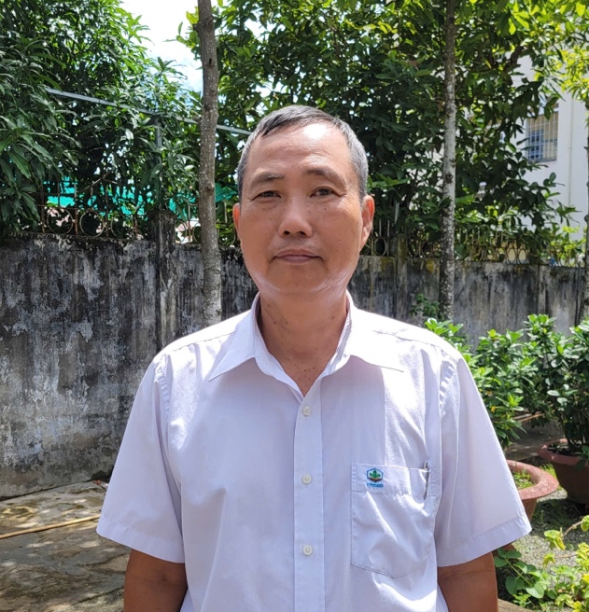
Photo: Mr. Pham Tan Dao, Head of the Irrigation Sub-Department, Department of Agriculture and Environment of Soc Trang Province, Member of the Project Working Group.
Localities are currently entering a transformative phase of national development, marked by the ongoing merger of commune-level administrative units. This strategic shift presents numerous opportunities for developing climate-smart communities. The local project working group’s main recommendations for localities include:
  - Prioritizing the development of a cadre of local facilitators through robust Training of Trainers (ToT) programs and comprehensive community communication initiatives.
  - It is necessary to integrate proven successes from the SCR project into the 2026 socio-economic planning process, with a focus on: Green adaptation solutions (Nature-based Solutions - NbS, Ecosystem-based Adaptation - EbA), Climate-smart livelihoods, Gender Equality, Disability, and Social Inclusion (GEDSI) and Community-based Early Warning Systems.

Annex

Table 1. List of KII and FGD participants
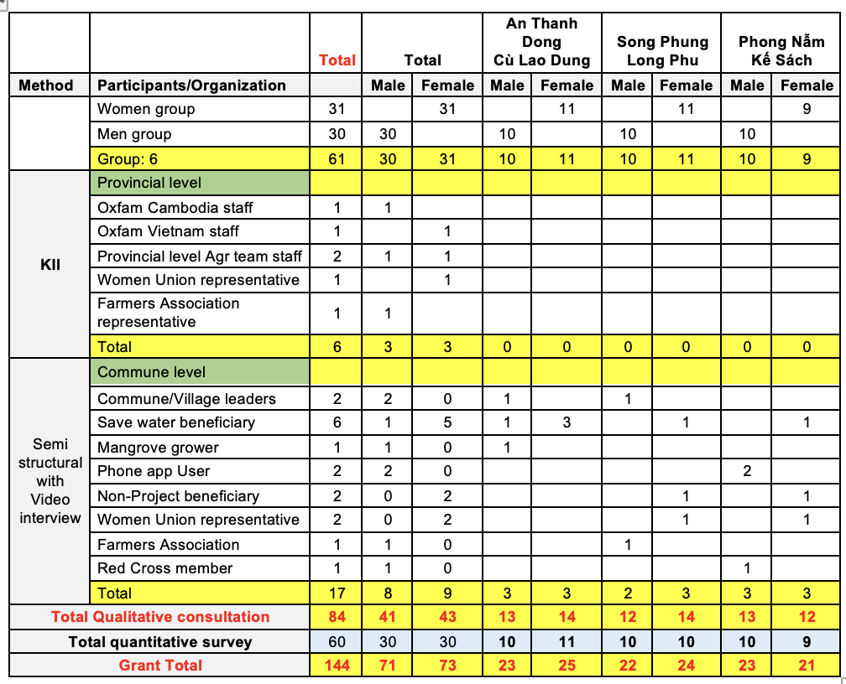

LIST OF INFORMANTS
DANH SÁCH NGƯỜI CUNG CẤP THÔNG TIN TẠI THỰC ĐỊA
Thời gian: ngày 20 – 24/76/2025
(Dự án SCR - Oxfam, tỉnh Sóc Trăng)

Table 2. List of participants to the in-depth interview in Soc Trang city
No. | Full Name | Address | Phone number
Hoạt động: Phỏng vấn sâu
Thời Gian: 20, 23/6/2025 Địa điểm: Thành phố Sóc Trăng, tỉnh Sóc Trăng
1 | Pham Tan Dao | Head of the Irrigation Sub-Department, Department of Agriculture and Environment | 0919892036
2 | Nguyen Van Hon | Soc Trang Farmers' Association | 0919166654
3 | Nguyen Van Mung | Chairman of the People's Committee of Song Phung Commune, Long Phu District, Soc Trang Province | 0969910109
4 | Nguyen Thanh Loan | Soc Trang Women's Association | 0919618814
5 | Nguyen Thi Hong Van | SCR Project Coordinator - Oxfarm Soc Trang | 0336037853

Table 3. List of participants in An Thanh Dong
LIST OF INFORMANTS - AN THANH DONG COMMUNE
(Cu Cao Dung District, Soc Trang Province)
No. | Full Name |  | Address  (Village, Commune, District) | Phone number
Activity: Group Discussion (Male)
Time: 21/6/2025 Location: An Thanh Dong Commune, Cu Lao Dung District, Soc Trang Province
1 | Tran Van Thanh | Nguyen Cong Minh A Hamlet, An Thanh Dong Commune, Cu Lao Dung District |  |  | 0866983681
2 | Le Vu Lam | Nguyen Cong Minh A Hamlet, An Thanh Dong Commune, Cu Lao Dung District |  |  | 0363861121
3 | Nguyen Vinh Phuc | Nguyen Cong Minh A Hamlet, An Thanh Dong Commune, Cu Lao Dung District |  |  | 0855886001
4 | Duong Van Ha | Nguyen Cong Minh A Hamlet, An Thanh Dong Commune, Cu Lao Dung District |  |  | 0384969732
5 | Nguyen Van Lich | Nguyen Cong Minh A Hamlet, An Thanh Dong Commune, Cu Lao Dung District |  |  | 0907594622
6 | Huynh Phi Lan | Nguyen Cong Minh A Hamlet, An Thanh Dong Commune, Cu Lao Dung District |  |  | 0377064 637
7 | Tran Van Kiet | Nguyen Cong Minh A Hamlet, An Thanh Dong Commune, Cu Lao Dung District |  |  | 0348672203
8 | Pham Van Dan | Nguyen Cong Minh A Hamlet, An Thanh Dong Commune, Cu Lao Dung District |  |  | 0907546718
9 | Tran Minh Dong | Den Tho Hamlet, An Thanh Dong Commune, Cu Lao Dung District |  |  | 0327457209
10 | Hai Truong Thinh | Den Tho Hamlet, An Thanh Dong Commune, Cu Lao Dung District |  |  | 0373281159
Activity: Group discussion (Women)
Time: 21/6/2025; Location: An Thanh Dong Commune, Cu Lao Dung District, Soc Trang Province.
1 | Tran Thi Cam Quyen | Den Tho Hamlet, An Thanh Dong Commune, Cu Lao Dung District |  |  | 0377849738
2 | Nguyen Thi Tuoi | Den Tho Hamlet, An Thanh Dong Commune, Cu Lao Dung District |  |  | 0908062913
3 | Nguyen Thi Xiu | Den Tho Hamlet, An Thanh Dong Commune, Cu Lao Dung District |  |  | 0366471649
4 | Tran Thi Giang | Den Tho Hamlet, An Thanh Dong Commune, Cu Lao Dung District |  |  | 0349437035
5 | Tran Thi Hong Tham | Den Tho Hamlet, An Thanh Dong Commune, Cu Lao Dung District |  |  | 0368743586
6 | Cao My Xuyen | TC Hamlet, An Thanh Dong Commune, Cu Lao Dung District |  |  | 0333345463
7 | Nguyen Thi Mai Kim Trang | Den Tho Hamlet, An Thanh Dong Commune, Cu Lao Dung District |  |  | 0336774899
8 | Vu Thi Trang | Nguyen Cong Minh A Hamlet, An Thanh Dong Commune, Cu Lao Dung District |  |  | 0365953059
9 | Nguyen Thi Hoang | Nguyen Cong Minh A Hamlet, An Thanh Dong Commune, Cu Lao Dung District |  |  | 0353346655
10 | Tran Thi Du | Nguyen Cong Minh A Hamlet, An Thanh Dong Commune, Cu Lao Dung District |  |  | 0386639165
11 | Nguyen Thi Huan | Nguyen Cong Minh A Hamlet, An Thanh Dong Commune, Cu Lao Dung District |  |  | 0377064637
Hoạt động: Phỏng vấn sâu
Thời Gian: 21/6/2025 Địa điểm: Xã An Thạnh Đông, Huyện Cù Lao Dung, Tỉnh Sóc Trăng
1 | Diệp Thị Bích Tiền | Den Tho Hamlet, An Thanh Dong Commune, Cu Lao Dung District |  |  | 0357880201
2 | Phan Minh Tiễn | Den Tho Hamlet, An Thanh Dong Commune, Cu Lao Dung District |  |  | 0344572358
3 | Đinh Nguyễn Kiều Tiên | Den Tho Hamlet, An Thanh Dong Commune, Cu Lao Dung District |  |  | 0967946217
4 | Nguyễn Thị Huấn | Den Tho Hamlet, An Thanh Dong Commune, Cu Lao Dung District |  |  | 0377064637
5 | Anh Phong | Den Tho Hamlet, An Thanh Dong Commune, Cu Lao Dung District
6 | Anh Danh | Farmers' Association, Thach Dong Commune, Cu Lao Dung District |  |  | 0364 367 010
 |  | Tổng: 27 người

LIST OF INFORMANTS
(Phong Nam Commune, Ke Sach District, Soc Trang Province)
Table 4. List of participants in Phong Nam commune, Ke Sach district
No. | Full Name | Address  (Village, Commune, District) | Phone number
Activity: Group Discussion (Female)
Time: 22/6/2025 Location: Phong Nam Commune, Ke Sach District, Soc Trang Province
1 | Nguyen Thanh Hien | Phong Phu Hamlet, Phong Nam Commune, Ke Sach District | 0763264040
2 | Ha Thi Kim Dong | Phong Phu Hamlet, Phong Nam Commune, Ke Sach District | 0973563096
3 | Tran Thi Ngoc Lan | Phong Phu Hamlet, Phong Nam Commune, Ke Sach District | 0349383520
4 | Phan Thong My | Phong Phu Hamlet, Phong Nam Commune, Ke Sach District | 0796444827
5 | Le Thi Tam | Phong Phu Hamlet, Phong Nam Commune, Ke Sach District | 0856092450
6 | Vo Thi Hong Van | Phong Phu Hamlet, Phong Nam Commune, Ke Sach District | 0362985456
7 | Nguyen Thi Thanh Tu | Phong Phu Hamlet, Phong Nam Commune, Ke Sach District | 0764931277
8 | Nguyen Thi Thanh Thuy | Phong Phu Hamlet, Phong Nam Commune, Ke Sach District | 0375525664
9 | Nguyen Thu Mai | Phong Phu Hamlet, Phong Nam Commune, Ke Sach District | 0364631682
Activity: Group Discussion (Male)
Time: 22/6/2025 Location: Phong Nam Commune, Ke Sach District, Soc Trang Province
1 | Le Quoc Doan | Phong Nam Commune, Ke Sach District | 0966067978
2 | Nguyen Minh Tri | Phong Phu Hamlet, Phong Nam Commune, Ke Sach District | 0986747994
3 | Ngo Van Y | Phong Phu Hamlet, Phong Nam Commune, Ke Sach District | 0963178595
4 | Huynh Thanh Hien | Phong Phu Hamlet, Phong Nam Commune, Ke Sach District | 0794333222
5 | Le Nguyen Hoang Dung | Phong Phu Hamlet, Phong Nam Commune, Ke Sach District | 0367743320
6 | Vuong Tan Tai | Phong Phu Hamlet, Phong Nam Commune, Ke Sach District | 0819299993
7 | Tran Vu Linh | Phong Phu Hamlet, Phong Nam Commune, Ke Sach District | 0969747649
8 | Vo Linh Tuan | Phong Phu Hamlet, Phong Nam Commune, Ke Sach District | 0374912175
9 | Nguyen Tan Vu | Phong Thach Hamlet, Phong Nam Commune, Ke Sach District | 0365132010
10 | Huynh Van Lam | Phong Thach Hamlet, Phong Nam Commune, Ke Sach District | 0778895 358
Activity: In-depth Interview
Time: 22/6/2025; Location: Phong Nam Commune, Ke Sach District, Soc Trang Province
1 | Tran Thi Ung | Phong Hoa Hamlet, Phong Nam Commune, Ke Sach District | 0387756640
2 | Tran Minh Hung | Phong Hoa Hamlet, Phong Nam Commune, Ke Sach District
3 | Tran Van Suoi | Phong Nam Commune, Ke Sach District | 0909515109
4 | Dinh Quang Chuc | Phong Nam Commune, Ke Sach District | 0939882261
5 | Dang Thi Be Tam | Phong Nam Commune, Ke Sach District
6 | Nguyen Thi Thanh Loan | Phong Nam Commune, Ke Sach District | 0919619184
 |  | Total: 25 people

LIST OF INFORMANTS

(Song Phung Commune, Long Phu District, Soc Trang Province)

Table 5 List of participants in Song Phung commune, Ke Sach district
No. | Full Name | Address  (Village, Commune, District) | Phone number
Activity: Group Discussion (Female)
Time: 24/6/2025 Location: Song Phung Commune, Long Phu District, Soc Trang Province
1 | Pham Nha Uyen | Phung Tuong 1 Hamlet, Song Phung Commune, Long Phu District | 0977674153
2 | Pham Thi Oanh | Phung Tuong 2 Hamlet, Song Phung Commune, Long Phu District | 097949036
3 | Giang Thi Hien Mai | Phung Tuong 1 Hamlet, Song Phung Commune, Long Phu District | 037 6663 980
4 | Nguyen Thi Quynh Nhu | Phung An Hamlet, Song Phung Commune, Long Phu District | 0335013 015
5 | Nguyen Thi Kim Chung | Phung Tuong 1 Hamlet, Song Phung Commune, Long Phu District | 0354886473
6 | Nguyen Thi Diem Chi | Phung Son Hamlet, Song Phung Commune, Long Phu District | 0349987932
7 | Nguyen Hong Ni | Phung An Hamlet, Song Phung Commune, Long Phu District | 0989995441
8 | Trieu Thi Kim Ngan | Phung Son Hamlet, Song Phung Commune, Long Phu District | 0932935994
9 | Tran Thi Truc Ly | Phung Son Hamlet, Song Phung Commune, Long Phu District | 0969707850
10 | Nguyen Thi Cam Trang | Phung Son Hamlet, Song Phung Commune, Long Phu District | 0353857512
11 | Pham Hong Chau | Phung Son Hamlet, Song Phung Commune, Long Phu District | 0365273 892
Activity: Group Discussion (Male)
Time: 24/6/2025 Location: Song Phung Commune, Long Phu District, Soc Trang Province
1 | Tran Van Ket | Phung Son Hamlet, Song Phung Commune, Long Phu District | 0386726754
2 | Nguyen Van Vu | Phung Tuong 1 Hamlet, Song Phung Commune, Long Phu District | 0944555080
3 | Tran Van Hoa | Son Phu, ST | 036 6246 681
4 | Le Hoang Thac | Phung Son Hamlet, Song Phung Commune, Long Phu District | 0984 542264
5 | Bui Thanh Nhan | Phung An Hamlet, Song Phung Commune, Long Phu District | 0901242080
6 | Dang Van Tri | Phung Tuong 1 Hamlet, Song Phung Commune, Long Phu District | 096 44 40043
7 | Nguyen Huu Duc | Phung Tuong 1 Hamlet, Song Phung Commune, Long Phu District | 0987126278
8 | Pham Van Phung | Phung Tuong 1 Hamlet, Song Phung Commune, Long Phu District | 0986203876
9 | Tran Huu Trung | Phung Tuong 1 Hamlet, Song Phung Commune, Long Phu District | 037 6477 619
10 | Tran Van Ket | Phung Tuong 1 Hamlet, Song Phung Commune, Long Phu District | 0355279718
Activity: In-depth Interview
Time: 24/6/2025 Location: Song Phung Commune, Long Phu District, Soc Trang
1 | Bui Thanh Nhan | Vice Chairman of Song Phung Commune, Long Phu District | 0987902443
2 | Nguyen Huu Duc | Song Phung Commune Farmers' Association, Long Phu District | 0987126278
3 | Giang Thi Kieu Mai | Song Phung Commune Women's Association, Long Phu District | 037 6663 980
4 | Nguyen Thi Thuy | Single-parent household, Phung Tuong 1 Hamlet, supported with water-saving irrigation system), Song Phung Commune, Long Phu District | 0355363036
5 | Huynh Thi Tuyet Suong | Phung Tuong 1 Hamlet, Song Phung Commune, Long Phu District | 0984 542857
 | Total: | 26 people

Activity: In-depth Interview
Time: 24/6/2025 Location: Song Phung Commune, Long Phu District, Soc Trang

Table 6: Summary of Survey Participants by Stakeholder Group and Gender
Method | Participants/Organisation | Total | Male | Female
FGD | Women groups (3 groups I 3 communes) | 31 |  | 31
 | Men group (3 groups in 3 communes) | 30 | 30
KII | Oxfam Cambodia staff | 1 | 1
KII | Oxfam Vietnam staff | 1 |  | 1
KII | Provincial level leaders/key technical staff | 2 | 1 | 1
KII | Provincial Women Union representative | 1 |  | 1
KII | Provincial Farmers Association representative | 1 | 1
KII | Commune/Village leaders | 2 | 2
KII | Save water beneficiary | 6 | 1 | 5
KII | Mangrove grower | 1 | 1
KII | Phone app User | 2 | 2
KII | Non-Project beneficiary families | 2 | 1 | 1
KII | Commune Women Union representative | 2 |  | 2
KII | Commune Farmers Association representative | 1 | 1
KII | Red Cross member | 1 | 1
Quantitative survey | Quantitative survey in 3 project communes | 60 | 30 | 30
Total |  | 144 | 72 | 72

