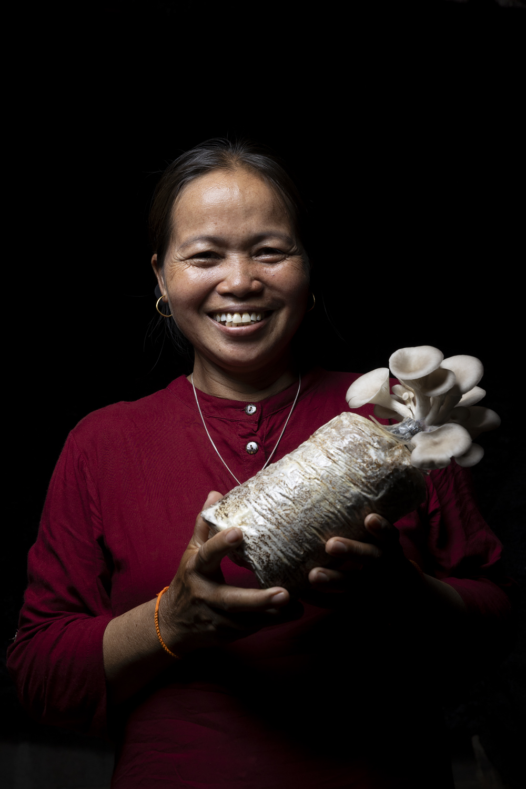
Three mushroom growers in Houay Kang

Three mushroom growers in Houay Kang
Houay Kang is a village that sits astride Route 13, around an hour north of Luang Prabang in Pak Ou district. The highway goes through a dip to the level of the Ou River and then rises steeply on the northern side. The whole community is composed of people from the Khmu upland minority, who have been in steady transition in their livelihood strategies since moving from their previous upland area in Vieng Kham to live along the river and the highway. In Vieng Kham, nearly all of them practised shifting cultivation of upland rice and other crops as their core livelihood. Since moving to Houay Kang, as the older people explained, most have been transitioning to raising cattle on rotating pastures across the slopes. Recognising that this strategy also involves risks, as weather events cause erosion, floods, and shortage of pasture, they have been exploring complementary strategies which could be more sustainable in the long term.
Mushroom cultivation was the strategy that a large group of women in Houay Kang opted for when project partners visited to consult on different options for making a living that are not as exposed to climate-related risks. Three of the six women who have continued with mushroom cultivation joined the meeting called at the village centre, and afterwards were very happy to talk about their individual experiences, and also to show firsthand how they go about growing and selling their produce.
Ms Voy,( aged 37), has lived in this village since she was born. She had two children, she said, but the eldest died, so now she has just the one daughter.
She and her husband used to practice shifting cultivation, but three years ago, they decided to stop that and start cattle raising. Explaining how she first launched into mushroom cultivation, Ms Voy spoke of how she and her daughter first read online about how to grow mushrooms commercially, and decided to start on their own. She ordered mushroom spawn ready for use from a company in Vientiane and had it delivered by a logistics company. First, she said, she ordered 300 ‘boxes’; when she had successfully sold the produce from these, she bought more. Now, she said, she has 600 boxes, 100 provided by the SCR project. As the two other women in the meeting explained, it was Ms. Voy’s success that inspired the group of village women to choose this option as their preferred strategy for livelihood diversification, among the various options presented by project partners during consultations on transitioning to more sustainable and secure sources of income.
The time it takes to grow the mushrooms depends on the seller’s advice, Ms Voy said. Each lot of blocks is different, and the seller gives specific instructions. On average, about 15 days after injecting the spores to open up the plastic wrapping and then another two days to harvest. After that, she said, they can be harvested every two or three days.
Sometimes Ms Voy said, she sells the mushrooms around the village, sometimes she takes them to market. Initially, she took them to the village market in Namthuan, the next village to the north along the highway, but now she takes some to Hardpang village, which is closer. In fact, by now, she said, she can easily sell most of what she produces within the village, where she has a small roadside stall in front of her house selling different kinds of produce. Lots of buyers come to their place to purchase directly, she said, as everyone knows she produces a lot of mushrooms.
Initially, she didn’t have anywhere to grow the mushrooms, so she rented a chicken house from her cousin. She explained that she has now built a dedicated mushroom shed adjacent to her house.
Ms Voy spoke about why she and her husband stopped shifting cultivation. She said it just wasn’t worth it. It takes very high inputs of labour, and the returns were increasingly poor. They currently pasture just ten head of cattle. It used to be double that, she said, but last year she sold ten head to build a new house. She was happy to show us her house and the stall where she does business. The house seemed to be of very good quality construction, well painted and spacious, and with the dedicated mushroom shed adjacent. She and her husband don’t want to raise too many cattle, she said, as they only have two plots of pasture land (the local average is three plots of two hectares, over which the cattle are rotated). That was one more reason for pursuing the mushroom business.
Her husband is the one who usually goes to tend the cattle. The work is not too demanding, she said – they just lead them to one pasture plot and leave them there for ten days. As for her own workload, she sells fruit and other items from her stall, and takes care of the mushrooms. It only takes 20 – 30 minutes per day, except in the hot, dry season, when she has to spray the packages with water three rather than two times per day, partly also because as she explained, their house is in quite a high position, so much windier than the rest of the village, and things dry out faster.
Ms Cher explained that her family livelihood is now based on animal husbandry and the mushroom business. They have 30 cows and about 20 chickens – they used to have a lot more, but 24 chickens were stolen just last week, she told us.
Her family’s cattle are raised for market, she said. Also, one is killed every year for the annual village ritual/festival. Every year, they would normally sell five or six head. They sell 10 to 20 chickens every six months, and kill one every three days for household consumption. They grow some vegetables, just for family consumption, and don’t have any rice land.
She said that she has two children, one daughter already married with two children of her own, and one son, who is currently studying Year 10 of school.
When asked about future prospects for her family, Ms Cher said she doesn’t worry much about her daughter, whose life she sees as fairly well set, but is more concerned that her son does well at school, so he can get a good job in the future.
Ms Cher said she became interested in mushroom cultivation because she saw Ms. Voy cultivate and sell them on her initiative. So, when the project partner (Souphanouvong University) was consulting with the community to identify strategies for livelihood diversification to adapt to climate change Ms Cher and other women in the group were clear that they wanted to go with mushroom cultivation. She said the group then received training from the partner and took home the mushroom spawn to do an initial trial batch. Ms Cher found that the mushrooms grew successfully. The family consumed them, and she was happy and motivated by the result, as this was a kind of activity she had never attempted before, she said.
She, with other women, then came together and produced the next batch of mushroom spawn by themselves, using the equipment that had been provided by the project. All of them agreed that potentially, they could actually afford to source the equipment themselves, as there are not many component items, and all of them are easy to find. Up until now, she has not sold any of her mushrooms, she said, only using them for family consumption, but she expects that she will have a substantial surplus from the next batch produced, and will sell them then.
Ms Cher has now set up a structure next to her house specifically for the mushroom production, which she was happy to show. Initially, the group tried doing all their mushroom cultivation together, she said, but they found it didn’t work, because of the distances several of the group had to travel to care for their packages, so each one of them has now set up her separate structure. The batch of spawn that the women produced together is enough to last for at least five or six months of production, she explained, and when the cultivation is in full swing, the producers can harvest two or three times per week.
Ms Cher says she doesn’t find it hard to make ends meet. They have three plots of land fenced off for cattle pasture and rotate their herd across these. She feeds the chickens morning and evening, and doesn’t find her workload excessive, between the mushrooms, small trade and cattle raising.
Mrs Khampet Kampang was the oldest of the mushroom growers’ group, and happy to tell us that she is now 62 years old, with seven children – four daughters and three sons. They are now all married with children of their own. At home, she said, there is now just her and her husband, plus one daughter and son-in-law and their children.
She came here from another district, Meung Ngoi, where she had lived for 40 years, and has now been in Houay Kang for 22 years. She said she has two or three hectares of her own irrigated rice land and gets her children to farm it, returning some of the crop to her and her husband. They also raise fish fingerlings to sell for others to raise in aquaculture ponds – her husband is the main one looking after that side of the business, she said.
Ms Khampet said she moved here for family reasons. Her husband is a jeweller, and this location is better for his business, as it is on the main road, with good vehicle access. Now he has reduced his business activity a bit, she said, and they have just a small truck and a car for all the different family farming and trading activities.
Mrs Khampet said she had started doing mushroom cultivation just a few months ago, when the project started in the village. There was a big meeting with project staff, she said, where they introduced the cultivation technique. The trainees were told to find straw and shown how to mix the cultivation medium. They also had to collect firewood, she said, as steam is needed to provide the necessary moisture for cultivation. She has lot of time to do this at this stage of her life and is very happy to grow the mushrooms. It fits in well with her family life and responsibilities, she explained, as her grandchildren love to watch her doing the mushroom growing, and she can send her children out to other places to sell the mushrooms.
She spelled out the process, and how the tasks are shared in the family. First, she makes up a block, then puts in the spore, and wraps it up. When it’s time to open it, she hands it over to her children to look after the final stage. She said it is actually the son-in-law who lives with her who cooks the mushrooms she keeps for the family.
At the moment, Mrs Khampet said she is growing mostly for family consumption, and shares the produce with her cousins and others. She said she’s a bit worried about her children and their future. One is a soldier, one is a tour guide, and one is an official. She says she sends them mushroom blocks so they will be proud of her, and recognise the work she does. After the initial technical training, she sent 15 mushroom spore-injected boxes to her daughter and son-in-law. When they harvested the mushrooms, they called to her to say how successful it had been, and to say that they also needed to learn to produce mushrooms. As a 62-year-old grandmother, she said she was very proud that she could do this kind of production and get others to adopt it.
Currently, she has 40 or 50 boxes under cultivation. She said she wants to keep growing these for her children, and eventually to start selling them. Her children ask her why she doesn’t just give it up and relax, but she laughed when she said she just tells them no, she’s going to keep on with it.
She’s the elder in the mushroom growers’ group. If they’re lacking materials to make up the blocks, she gets the family truck, and the women go out together to gather what they need. She volunteered that she would be happy to teach others about mushroom cultivation if there was another stage of the project.
Mushrooms are in high demand in the area, Mrs Khampet confirmed. Whatever the women produce, they can either sell to other people in the village or go to the markets in Namthuam and Hadpang villages, both of which are easily accessible along Route 13. A few people who originally joined the mushroom training have since dropped out, Ms Khampet said, but this was because they had gotten busy with other livelihood activities.
Each of the three growers told her own full, individual story, but it also became clear that they continue to collaborate and support each other as the mushroom business proves to be a viable strategy for improving their families’ livelihoods.

