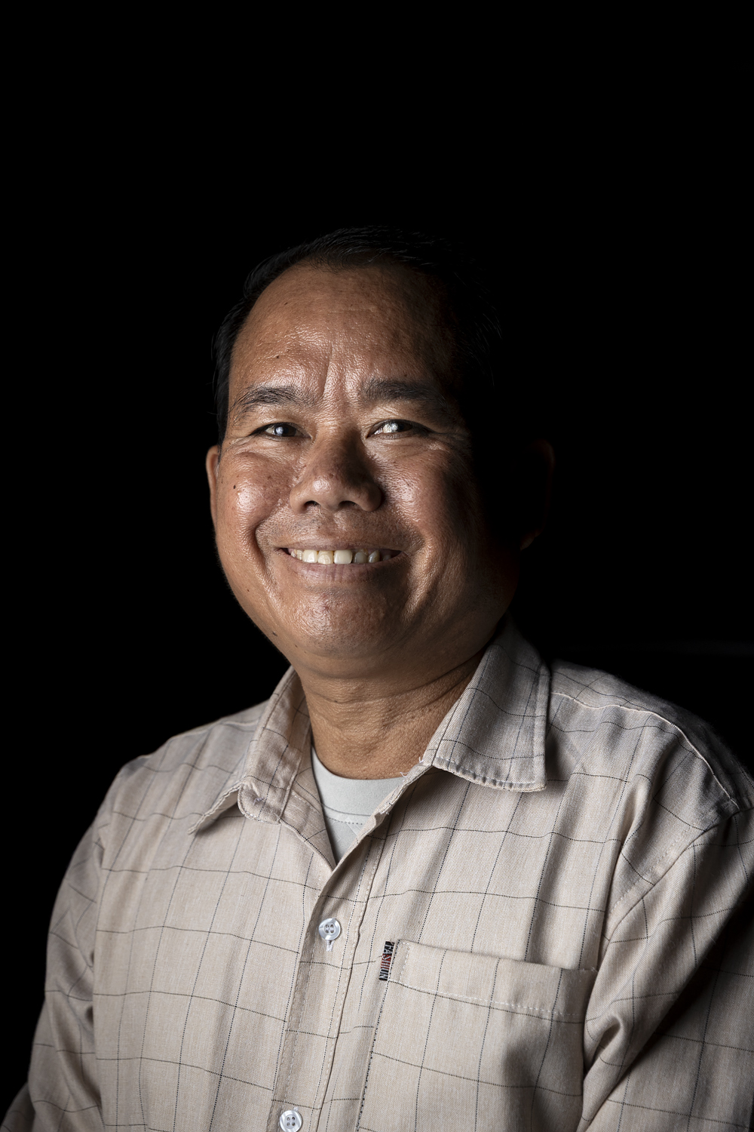
Mr Boauvong Sengthivanh
Interview with staff of Pak Ou district Labour and Social Welfare

Mr Siaat Hommachanh
Conversations with staff of Pak Ou district Labour and Social Welfare:
Throughout the story-gathering journey in Luang Prabang province, we were joined by the key staff of the Pak Ou District Labour and Social Welfare office: Mr Siaat Hommachanh, the head and Mr Vilavong Phalamesay, his deputy. The stories they recounted were not in the form of a single interview, but rather short conversations as we travelled between locations in the car, or as we walked between different sites in Houaymard and Houay Kang villages. The experiences and insights they communicated here are complemented with information drawn from project documentation, to make clear the connection between the project’s work from the national and policy level to village implementation and development.
Mr Siaat Hommachanh, the head of the office, explained that in his role, he is a representative on and vice chair of the District Risk Management Committee (DRM). He said that his reflections are based on his personal, real-time experiences in real-life situations dealing with disaster risk and response in Pak Ou.
In Laos, he said, disaster preparedness and response differ between regions and their specific needs, especially between the north and the south. In the north of Laos, especially in Luang Prabang province, he said the big issues are storms, floods and landslides. Even when landslides don’t directly harm people, they can wipe out crops and agricultural land. Insect pests on crops are also a big issue.
Previously, he said that the pattern would be that reports would be sent to him from villages on disaster events, and he would then go out to collect data to feed to higher-level authorities. This was necessary because the district itself has very little budget to distribute for relief. There was a storm in this area just this year. It damaged houses and cropland, and one person died in the resulting floods.
Now, the district is moving to create a forward plan, to proactively send out warnings rather than waiting for reports of damage, and to restructure the DRM committees because there has been a change of district heads. He spoke about the meeting held to establish the district DRM Committee, which is developing its strategic plan for disaster response. This will include how to take preparation and prevention measures ahead of disaster events, and how to respond afterwards, and also inventorying what material resources there are, and how to mobilise them. The planning process will also include conducting a climate assessment, he confirmed, and getting the public transportation office to do cost estimates, particularly of the cost of damage to housing and other infrastructure. He explained that in the event of any disaster, his office needs to get a decree from the government so that urgent social assistance can be provided.
Though it did not come through in Mr Siaat’s explanations, the changes underway in district policy and planning have cascaded down from the SCR project’s national-level intervention with the Department of Labour and Social Welfare. This has resulted in reworking the policy to establish direct local capacity in each village, with support and oversight from the district, and also in providing direct practical training to District level Labour and Social Welfare staff, in areas including tracking weather development and communicating warnings; and simulation exercises for post-disaster rescue.
Mr Siaat said that the resources the district currently has don’t match the level of needs they are officially expected to respond to.
“Each household has to pay an annual risk management fee of 10,000 kip [approximately AUD 0.70]. This forms the budget for the District Risk Management Fund. It’s not much.”
Based on the decree, the province and central government are responsible for providing 60% of the budget for disaster response, and the district should provide between 30 and 50%. The reality, though, Mr Siaat said, is that the district can’t come up with anything like that level of funding.
“I hope a better way of funding can be found, so the district will be in a position to provide a better level of help straight after disasters,” Mr Siaat said.

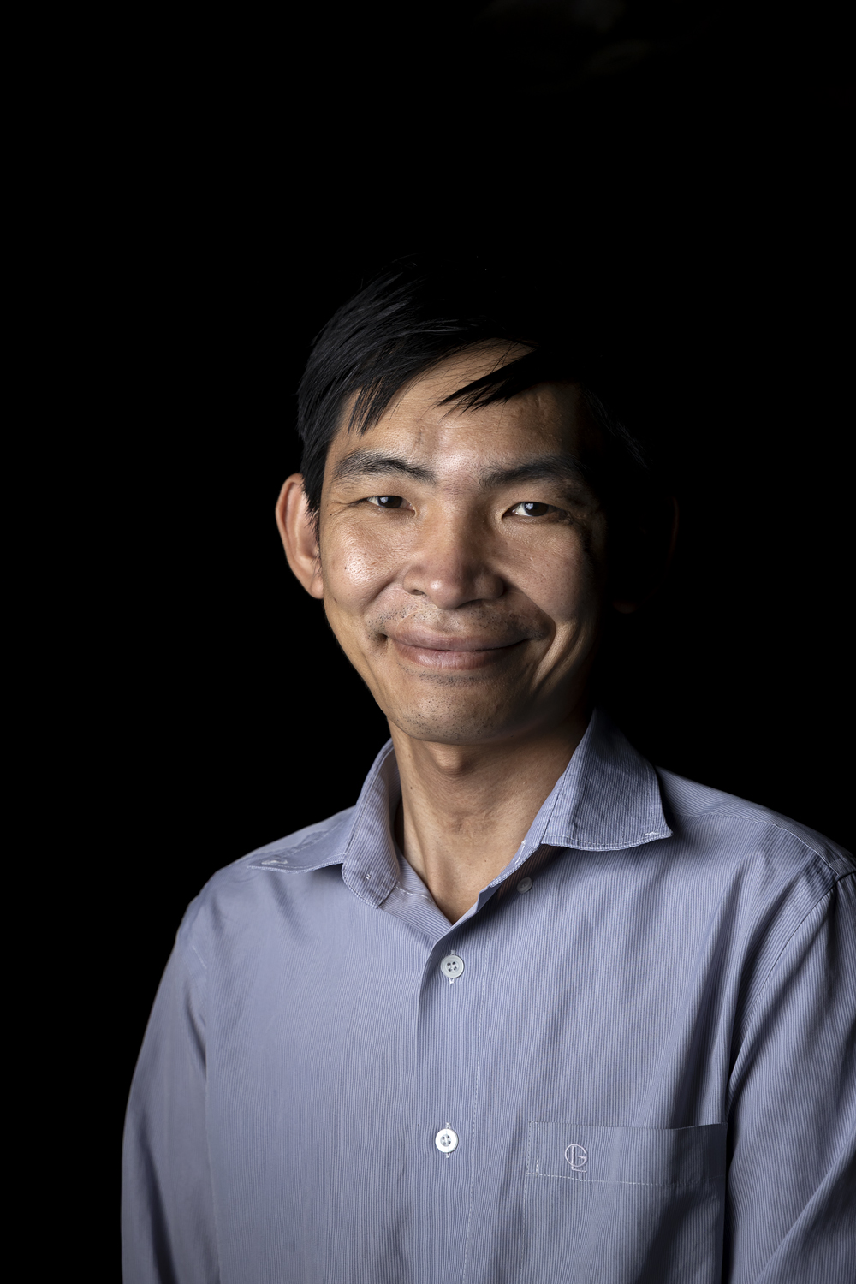

Mr Vilavong Phalamesay
Mr Vilavong Phalamesay, Deputy head of District LSW:
Mr Vilavong said that his role is to go out to villages to collect statistics directly, both pre - and post-disaster. If the situation is urgent, he has to report it directly to the province, he said. He also has to conduct and report on needs assessments.
Just what form this takes can vary a lot, he explained, and likewise the response he recommends,
“It depends very much on the type of disaster – it can be floods, storms, insect pests, hail or fire – the latter is because most houses are wooden, and in a storm, the cooking fires can blow out of control,” he said.
A much smaller number of house fires are caused by electrical faults, he said.
As to what resources are available for disaster relief, Mr Vilavong said:
“It depends. I need to see the specific conditions to make a recommendation. For instance, the district can’t provide enough funds to cover the rebuilding of a whole house, but we can provide some emergency shelter materials, as well as emergency food supplies.”
He said that so far, he hasn’t had any requests from villages in the district to assist with disaster preparedness and mitigation. He said that it seems that only a few villages have active DRM committees – despite the fact that under the new national policy, every village is supposed to have its committee, including the village head, deputy head, Lao Women’s Union representative, local military, and other official roles. The active ones are mainly where the Strengthening Climate Resilience (SCR) project has activated the committee and given some ongoing support.
However, Mr Vilavong said, some villages have been requesting help to get drainage pipes installed to reduce flood risk – so they are showing early signs of awareness that wasn’t there before. This could be linked to the basic training that the Labour and Social Welfare office has provided, following the model introduced by the SCR project at the national level. Other communities, which have not been so directly affected, don’t have that awareness yet, but it may develop.
Mr Vilavong named two villages in the district that experience floods every year.
“They just don’t know how to deflect or mitigate the floods. What they need often goes beyond the district’s capacity to provide.”
Mr Vilavong said communication is a big issue, particularly poor telephone and internet connections in many parts of the district. So, even if the district has information that should go out as an early warning, they cannot communicate it in time – the only way to get a message through is for a staff member to take an official letter by motorbike. This includes information needed by the two annually flooded villages mentioned.
Mr Vilavong said that in his opinion, the district government needs to follow up more, particularly getting more serious with livelihoods interventions, not just short-term handouts, which he said are ‘like giving sweets to kids’. He noted the small number of beneficiaries of the frog-raising project, which was intentionally designed as a pilot.
“This kind of thing needs to be done on a larger scale,” he said. “And there’s a need to bring people together to meet and plan better responses in the future.”
He named several interventions which are critically needed by the villages, such as food and fodder preservation, and water reticulation, but the district has not had the resources to support these, he said.

