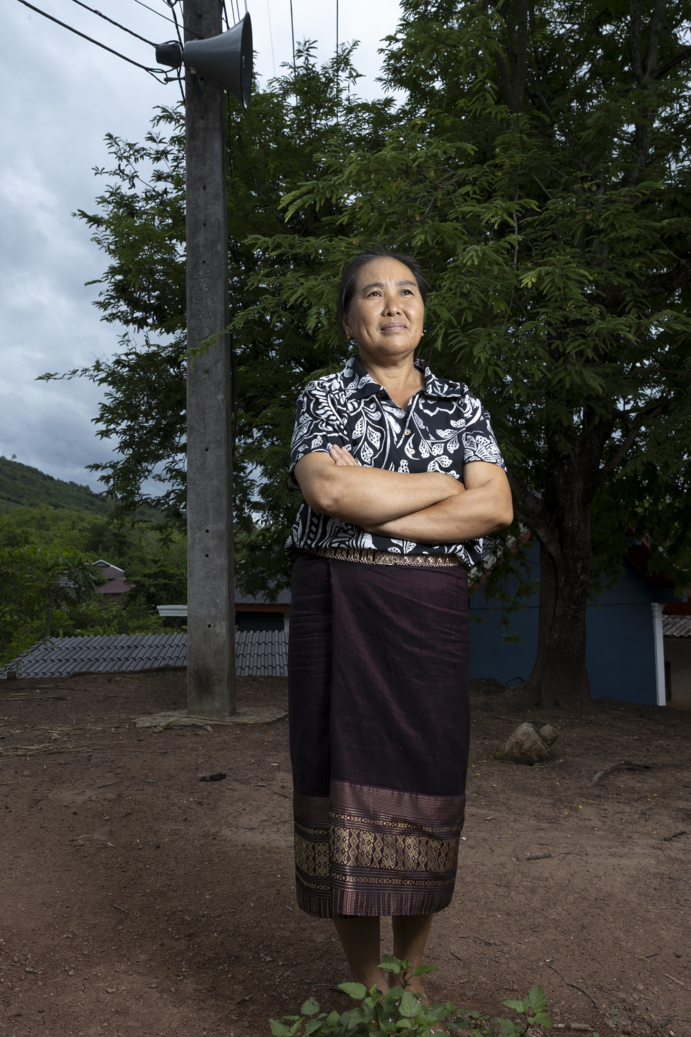
Houaymard Disaster Risk Management Committee

Ms Bounmy Thor
Houaymard Disaster Risk Management Committee:
Houaymard is a village that sits astride Route 13, around one hour north of Luang Prabang in Pak Ou district. The site slopes steeply on each side of the road. The village was founded in the 1990s by people migrating in from other areas, and is made up of several different ethnic groups who have migrated into the area from elsewhere. There are currently 139 households in the community.
The Committee comprises two women – Ms Bounmy Thor, the chair, and village head, and Ms Dao; and two men, Mr Bouavong Sengthivanh and Mr Sauosa Va. Together they explained the history and current environmental and economic situation of the community
The committee members detailed the unusual ethnic composition of the community and their settlement. Lao Loum people came from elsewhere in the province and from Oudomxay; Khmu people relocated from highland areas, and also Hmong and Yao people coming into Laos from Thailand. The process of settlement here had begun back in 1985 – 86, with people settled haphazardly around the area, mainly along the road. Some of those who’d come from the highlands initially found it hard to deal with the lowland climate and moved away. In 1990, the Ministry of Labour and Social Welfare moved to consolidate the village into the present location.
There are now 135 households in the village, the committee members said.
They explained that most people work as wage labourers, particularly those who have arrived in the village more recently. The main employer is the cigarette factory, about 3km from the village. It is mostly the longer-established people who have agricultural land. The main agricultural activity is growing rubber, and also pasture for grazing cows and buffalo. At the moment, there are around 500 heads of cattle in the village, they said, but the headcount tends to average around 1,000. There are only about 5 – 6 hectares of paddy rice fields in total. Some people are still growing upland rice through shifting cultivation (het hai).
Nearly everyone has livestock, they asserted, including the factory workers. When they get home from work, they go to tend their cattle. The cows and buffalo are raised for market, bought by Lao middlemen. The top-quality beasts are exported to Vietnam and Thailand; the poorer-quality ones are sold on the Lao market.
In the opinion of the committee members, the people of Houaymard feel that as local farmers, they don’t have much technical knowledge, so they are struggling to deal with many of the changes they are facing. They think that the presence of a lot more chemicals in the environment could be the reason for new human and animal diseases that have been occurring, including maybe COVID-19.
They find that now, pasture grasses grow really fast in the rainy season, but in the dry period from March to July, there is not enough pasture, so most of the cattle go short of fodder until the rains start again. So, the committee members expressed strongly that farmers here need to learn techniques to preserve the grass as hay or straw, and maybe also to get machinery for this. The committee agreed that a priority is for farmers to learn about and have equipment for storing water through the dry season, maybe plastic sheeting to line ponds, as there is now not enough water to water the cattle through that time – there are periods during the wet when the rains stop for a while. These would be of critical value in allowing them to complete the transition from shifting cultivation and its related deforestation.
Drought is an increasing problem, they noted. Last year it was really severe, and leaves dried and fell from the trees – trees had no leaves from December to February, they said.
Lack of fencing is also a problem, as sometimes cattle stray. They need fencing wire and steel droppers.
From 1998 to 2005, the climate didn’t change much, the committee members who remembered that time said, and there were far fewer households in the village. Since then, a lot more people have migrated to live in the village, and people have been cutting the forest to plant teak or to grow pasture for cattle. Since 2010, it has been very noticeable that there is a real drought period in the dry season. Also, floods have become frequent in the rainy season.
Last year, they said, there was a serious flood in the village. One house was destroyed; one motorbike was washed away. Twenty households lost all their cooking pots and utensils [kitchens are separate outbuildings for many houses, closer to the watercourse]. They had to seek aid from the district to replace what had been lost. The district government sent staff to help, support the rescue operation and meet urgent needs, providing rice, dry foodstuffs and cooking utensils.
Work of the Disaster Risk Management Committee: Three years ago, before the SCR project started, there was no Committee. Then there was a big change, they said. The Committee was officially formed when the District DRM Committee came to Houaymard and got the names of village authorities, then proposed who should be the committee members. The District Labour and Social Welfare office arranged for the leaders of several village committees to go and do training on how to manage a flood response, also how to use the Public Announcement (PA) system. Also, how to follow weather tracking online, through Facebook and other platforms.
The committee didn’t mention it at the time, but the training provided through the District authorities had cascaded down from the project’s early intervention with the National Department of Disaster Preparedness. This involved technical and organisational capacity building in all the areas the Committee listed above. It meshed with training on the new national policy developed to support disaster preparedness, response and recovery at the district and local community level.
The PA system was set up with hardware provided by the government to give information to the community, and to give advance warning of when heavy rain would come, provided by text messaging from District LSW. This had also originated through the project’s national level engagement with government, providing training on accessible forms of observing and predicting the weather, and when and how to generate warnings from this.
What has really enabled the Committee to work effectively with the community has been the targeted support from the project. This came through in comments made by all four committee members throughout the half day spent in the village, talking and visiting different sites. The District DRM committee has formally set up DRM committees in nearly every village of the district, but most of these exist mainly in name, and don’t have the knowledge or other resources to follow through from initial formation and basic training. Project training expanded and deepened knowledge of climate change effects; the increasing frequency of climate-linked disasters; linkages between livelihood strategies, climate change and vulnerability; and what more resilient livelihood strategies could be. Work with the project partners also emphasised the importance of shared community understanding of the problems and ownership of the possible solutions.
From this basis, the Committee has been working to raise the whole community’s awareness and understanding both of the risks created by climate change, and how they could organise together to mitigate the risks and ensure more stable livelihoods for the future.
There are three different ethnic groups in the village but the committee explained that the warning system is organised so everyone can understand what is announced over the PA: seventy percent of the population can understand Lao language announcements easily. All of the younger people speak Lao, whatever their ethnic background. Some of the older Khmu and Hmong people cannot easily use the Lao language. So, whenever there is a really urgent and time-critical announcement, it is made in Lao, Khmu and Hmong language. Less urgent messages are delivered only in Lao. The village head pointed out that whenever the PA system is used, everyone pauses what they are doing to listen. For Lao-only announcements, a neighbour or family member will always translate for any older people who have not understood.
Talking about their needs and expectations for the future, the committee members said that people in the village really need to stop deforestation, as some are still doing it for shifting cultivation. Everyone needs to shift to ‘permanent’ occupations, such as growing rubber trees, which will not cause continuing degradation of the environment and aggravate the drought/flash flood cycle.
The village head said she would like the younger generation to have sustainable jobs, such as raising frogs, growing mushrooms and raising chickens, so there would be no need to migrate out or shift around, but people could build a livelihood in their own community. Speaking personally, she said that last year she and her family had just stopped shifting cultivation, and were now pursuing only more sustainable livelihood strategies.

