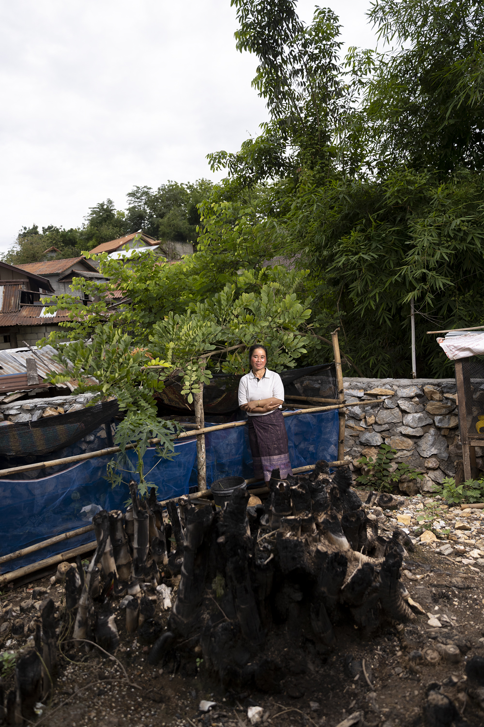
Mr Boauvong Sengthivanh

Frog raising – Houaymard

Ms Dao
Frog raising – Houaymard
Houaymard is a village set in a steeply sloping location in Pak Ou district, around an hour north along Route 13, the main north-south highway. This area began to be settled by people of different ethnic groups from the 1980s, and was formally established as a village in the 1990s. There is very little flat agricultural land, and most of the community relies on wage labour in the nearby cigarette factory, while also pasturing cattle and growing rubber trees. Some still practice shifting cultivation to grow upland rice, and there is increasing awareness of the changes in local climate conditions which make the need to transition to more sustainable livelihoods essential.
Ms Dao, DRM committee member, is one of the six women heads of households in the village that benefited from the trial frog-raising initiative which was introduced to Houaymard as part of the Strengthening Climate Resilience (SCR) project, by Oxfam’s partners Souphanouvong University, and Click, a Lao NGO. The householders were first provided with technical training, which also explained how frog raising could be part of developing livelihoods that are more resilient to climate change. Ms Dao explained that she had built the frog enclosure herself, with family help, digging the pond, and erecting the bamboo frame structure. Some materials that could not be gathered locally, like plastic sheeting and mesh, were provided by Souphanouvong University, together with xxx frogs, and an initial stock of 3kg of frog food.
Ms Dao says that the workload involved in raising the frogs is pretty light. She feeds them every morning and evening. Since the initial food stock ran out, she goes to buy further stock, which is available and affordable in the nearby market.
Ms Dao said she also has to clean out the ponds and replace the water regularly, to get rid of the frog faeces and other build-up, so the frogs will stay healthy. It will take six months until the frogs have fully matured. She is not sure yet if they will use them for household consumption, or if they will sell them in the market, she said. However, she knows that if she decides to sell the frogs for income, there is a ready market for them in the village, and also from people who pass through on the highway, which is less than 50m from her home.
Ms Dao said that she was happy to take up the opportunity to try small livestock raising – both frogs and poultry (another NGO provided her with ducklings and training in raising ducks) – because she and her husband were keen to find an alternative to doing shifting cultivation (het hai). This type of upland rice cultivation is becoming less and less useful for her and people in Houaymard as the population increases, soils are exhausted, and more and more labour is required for a shrinking crop. Ms Dao said she is also aware of the environmental damage caused by clearing trees and scrub to plant rice on slopes, and especially the increased risk of flash flooding.
For all of these reasons, Ms Dao said, she had been ready to take up the opportunity to try this as a possible better way to make a living, even though she has not yet earned any income from it. She is confident that she can make it work to her family’s advantage.
