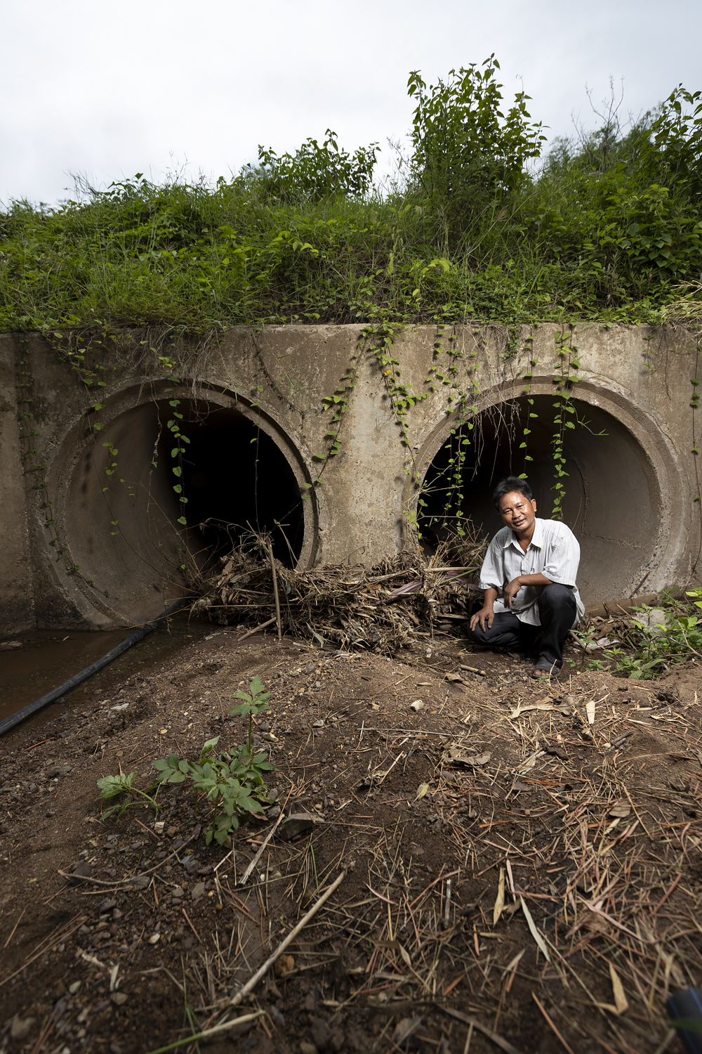
Drainage and prevention of flash flooding – Houaymard
Mr Bouavong Sengthivanh
Mr Sauosa Va

Drainage and prevention of flash flooding – Houaymard

Houaymard is a village that sits astride Route 13, around one hour north of Luang Prabang in Pak Ou district. The site slopes steeply on each side of the road. The area began to be settled in the mid-1980s by people of several different ethnic groups migrating in from other areas. It was formally established as a village in the mid-1990s. There are currently 139 households in the community. Some still depend on shifting cultivation of upland rice for their livelihood. Many of the village people depend on wage labour in the nearby cigarette factory. Nearly all families in the village pasture cattle on the slopes, and they are aware of the impacts of increasingly unpredictable and unreliable rainfall patterns on the availability of fodder and water.

The terrain is steeply sloping, with very little flat agricultural land, and nearly all houses are on sloping sites. One of the main issues the village Disaster Risk Management (DRM) Committee mentioned in describing the situation of the village, the risks it faced, and how they had mobilised to respond was flooding with runoff from the steep surrounding slopes, and that one of the most critical sites for this was where drainpipes carried the runoff under the highway that bisects the village.

Mr Souasa Va, one of the two male DRM committee members, took us a few hundred metres up the highway to show us the sites where floods had occurred due to the drainpipes going under the road becoming blocked with sticks, leaves and other debris. Both drains are located in very steeply sloping locations, so when heavy rain falls in the area, a massive flow of water builds up very quickly and can easily overwhelm the capacity of the concrete drainage pipes if they are not kept completely clear, he explained. The under-road drainpipe is the same diameter as the two that bring the run-off downhill, he pointed out, so the system is already at full capacity even without blockages in the pipe.

Mr Boauvong Sengthivanh showed us the site near the upper drain where last year the floods had risen due to a blockage and swept away the kitchen building belonging to one household. More were swept away or gutted further downstream. He said that under the guidance of the DRM committee, the community has now been organised to collaborate on the regular cleaning out of all the under-road drains.
He said that the cleaning schedule is organised particularly before the onset of the rainy season, and also every time that the village DRM committee receives a warning from the District that there is a heavy rain event about to hit the area.
Since the community had been mobilised in this way, the committee members said, they had a higher awareness both of flood risk and what they could do to mitigate it. Now that the community has organised to do the regular checking and cleaning, there has been no more flooding of the at-risk areas around the under-road drains, and no further loss of or damage to property.
Also, on the uphill side of the road, the cluster of households in one particularly at-risk area had organised with Committee support to dig a new channel which could more effectively cope with the runoff in heavy downpours.
Beyond the immediate issue of the drains, the committee members described specific advice they were now giving to all community members: for those who are building new houses, they give guidance on how to factor in flood risk, particularly choosing sites that are above the likely level of flash floods. Also, Mr Bouavong and Mr Souasa said they had been advising householders downstream from the drains not to build any more concrete walls, particularly in locations where this could block the natural flow of the runoff from above, and cause or aggravate floods.
In discussing with the Committee as a whole, they described the changes they had helped to bring about as not just increased knowledge of the community around causes and risks of floods, but a sense that they could work together to achieve beneficial change.
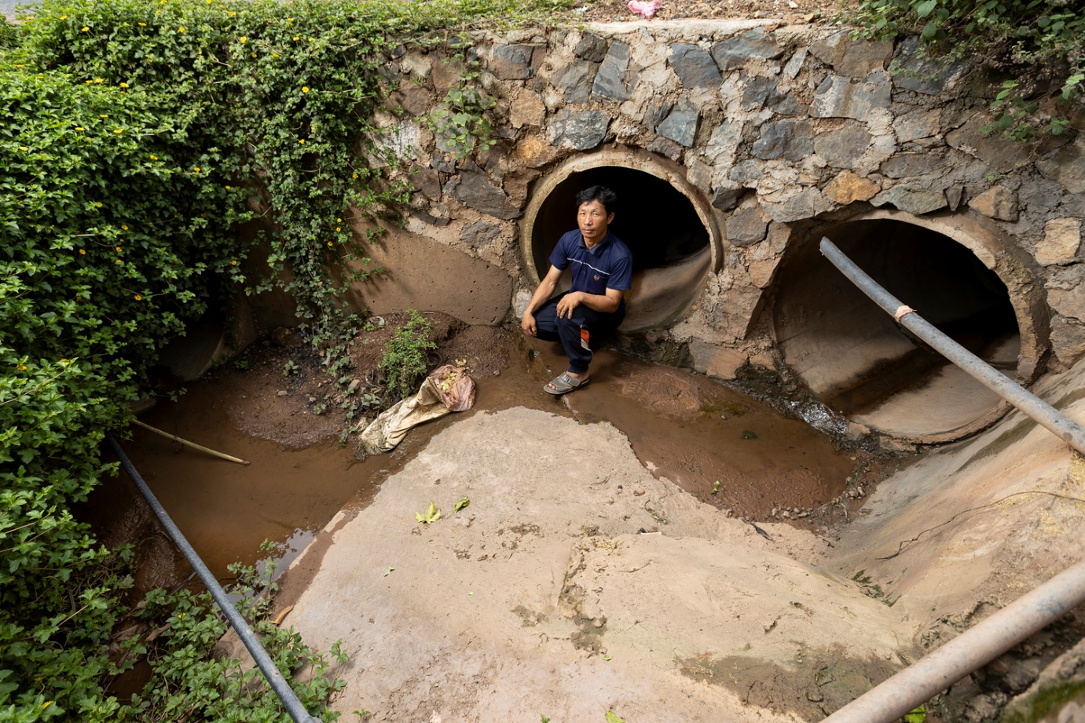
Mr Sauosa Va

