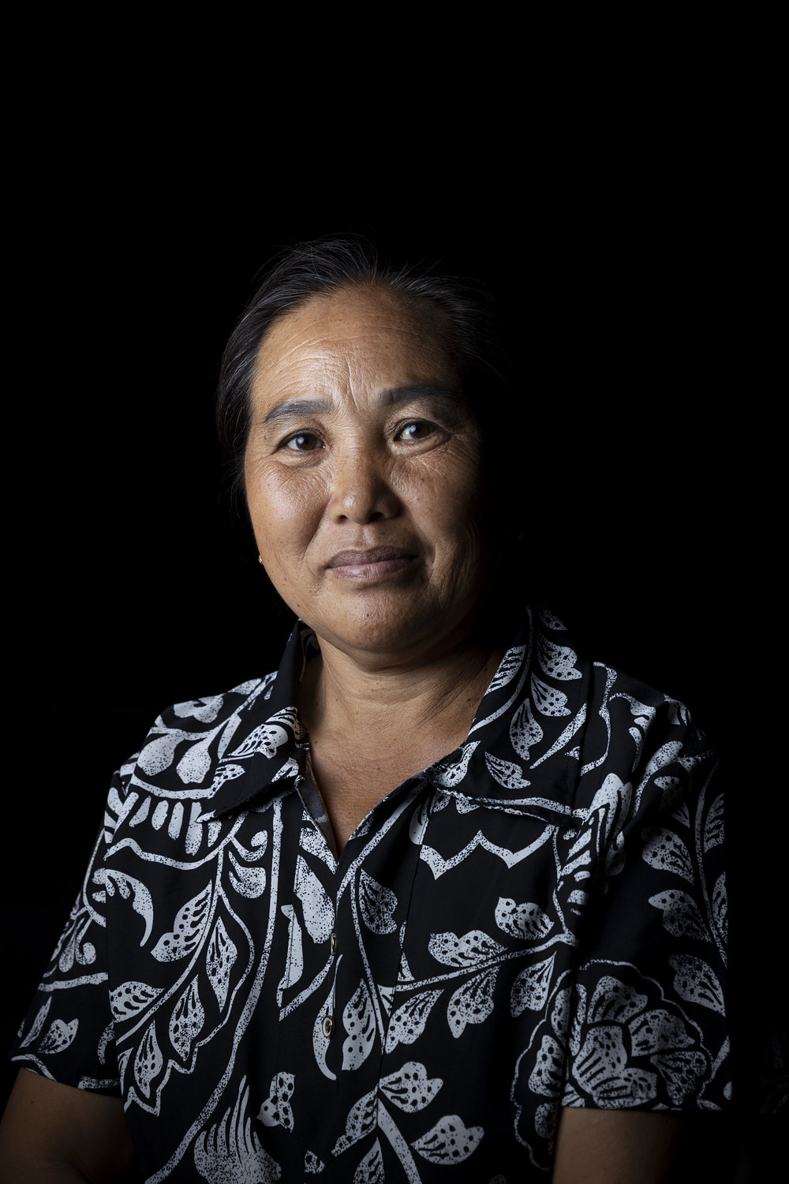
Houaymard Village Head
Ms Bounmy Thor

Houaymard Village Head, Ms Bounmy Thor.
Ms Bounmy is the village head of Houaymard, a village that sits astride Route 13, around one hour north of Luang Prabang in Pak Ou district. The site slopes steeply on each side of the road. The village was founded in the 1990s, by people migrating in from other areas, and is made up of several different ethnic groups, who have migrated into the area from elsewhere.
Ms Bounmy said that she had begun from a young age helping her parents who were involved with village management, so she was very familiar with the processes and structures from an early age, and also the systems and channels for liaising with other agencies and higher levels of government. She said that her parents had originally come from another district of Luang Prabang province, and were part of the revolutionary struggle. After 1975, they moved to Luang Prabang city, and took up positions as officials. When they retired, they moved to Houaymard. Ms Bounmy and her family are from the Hmong upland minority.
Ms Bounmy confirmed that she was the first woman to be elected as Village Head for Houaymard. She did her first stint as Head from 2010; having previously been head of the village branch of the Lao Women’s Union, and later on, assistant village head. In her position, she already had relationships with district and province authorities, so it was natural that Disaster Risk Management and coordinating the committee fell into her role. This is also mandatory in the legal framework established for the community disaster response organisation. She brings together the different committee members and also other community members for planning and training activities. She was therefore the natural initial contact point for the Oxfam SCR project, and the formation of the DRM committee.
Although the village is composed of three different ethnic and language groups, and many are quite recent arrivals, Ms Bounmy said that the level of cooperation and solidarity in the village is high. She said that 90% of the village people cooperate. As for the remaining 10%, their lack of engagement is not because they are unwilling, but very often the heads of household are only-children, and sole labour-age members of their family, supporting elderly parents and others, so they find it hard to find time to come to meetings and other joint activities.
In floods, and before they occur, the committee’s responsibility is to survey the area and provide data to the higher levels, Ms Bounmy explained. She also mobilises young people to undertake necessary work, and to evacuate both vulnerable people and assets that could be damaged.
Ms Bounmy said that in the ‘rich’ area of the village, there were quite a few frail elderly people who needed to be evacuated. Some families have Children with Disability, but they live in areas on higher ground, so are not vulnerable to flooding.
Speaking about her participation in the conference organised by Mae Fah Luang University in Chiang Rai in May 2025, Ms Bounmy said she was very proud and happy to attend, and that she could see a completely different context and draw lessons from it. She noted that in Thailand, in contrast to Laos, there were large areas of fertile plains that are very good for agriculture. Also, there is good resourcing available from different sectors for the prevention of and response to disasters.
When she came back to Houaymard, she compared what she had seen in Thailand with the mountainous terrain where her community lives. There is not much flat agricultural land at all here, she pointed out. It would be good to get the opportunity to visit other mountainous areas where there has been good adaptation to climate change, so they could learn how to apply those strategies in Houaymard.
“There is genuine respect for women’s leadership in the community,” Ms Bounmy said, noting that two of the four members of the DRM Committee are women. She emphasised that women leaders are now held in much higher regard than in the past. Since assuming her official roles, she has worked to ensure that gender equity is integrated into equity into the way everything is done.
When asked about the biggest problems currently facing women in the community, Ms Bounmy said that now women are truly equal.
” It is mostly women who come to meetings, and vote to make decisions for the community. There are now only a few women in the community who do not fully believe in themselves, their self-worth and autonomy.”
Speaking for herself, Ms Bounmy said that she had come to take on her leadership role in the community even though she and her family were just normal citizens – pasason tommada – and not at all well-off. She also mentioned that her own family had recently ceased doing shifting agriculture, recognising the need to use more sustainable livelihood strategies in the face of climate change.

