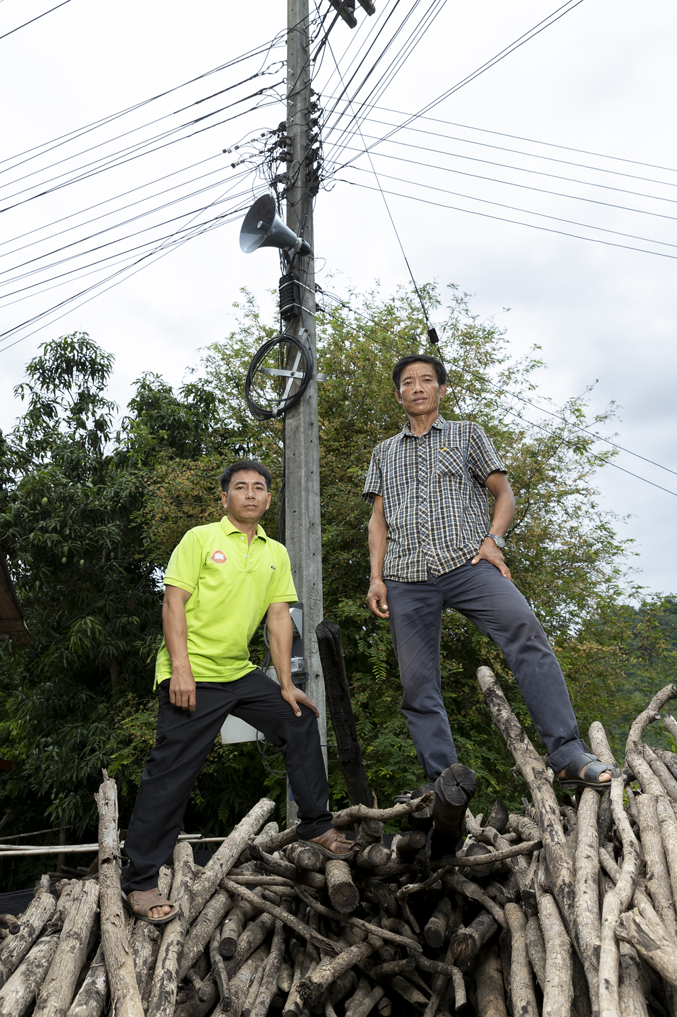
Houay Kang – the Village Disaster Risk Management Committee

L: Mr Sivone Khonephajick
R: Mr Somnuek Xayyavong
Houay Kang – Background, and function of the Disaster Risk Management Committee
Houay Kang is a village located on the Ou River and on the Route 13 highway, which runs north from Luang Prabang city. All of the community members are from the Khmu minority, who moved from their previous upland areas following government encouragement to resettle closer to main roads and services.
To hear from people who had participated in the Strengthening Climate Resilience (SCR) project, a gathering was organised at the village school, which sits on higher ground slightly to the south of the main village centre, which is in a dip in the road, but then extends northward along the road as it slopes up steeply. People who gathered included the village Disaster Risk Management (DRM) Committee; the group of three older men who had been trained in animal vaccination through project assistance, and three of the six women in the village who are now practising mushroom cultivation as an alternative livelihood strategy introduced through the project.
Mr Sivone Khonephajick, the chair, Mr Somnuek Xayyavong and other members of the DRM committee spoke about how they manage their responsibilities.
“When we get the warning letter from the district, we announce it over the Public Announcement (PA) system. This is mainly about storms and heavy rain. We can’t give early warning about landslides, as they generally happen higher up, and we don’t see the location”
Later, they pointed out the site on the main road where a landslide had carried away one house (belonging to one of the animal health group), which has since been rebuilt on the other side of the road. Apart from this, they pointed out, floods have not been a major problem in the village, as all the houses are in elevated locations which are not subject to floods. Effects on the flat agricultural land along the river were not mentioned.
There used to be an issue with watercourses getting blocked, the committee members said, which aggravated flash floods. Now the committee regularly organises people to clear these out, particularly drains that run under the road. They take these measures both before the onset of the rainy season and whenever the District issues a warning about an approaching heavy rain event, which has reduced the recurrence of the problem.
A big problem, the committee members said, is the lack of internet and phone connection – the main part of the village is in a dip, so it is a dead zone for the internet. You can get a signal around the school area, which is higher up, but that’s not where any of the committee (or others) live. So, the communication from the district has to be physically carried out. The District Labour and Social Welfare chief confirmed that this means sending out a messenger with a physical letter, by motorbike, which takes around an hour on the road from Pak Ou district centre. This means a significant delay when severe weather conditions are developing fast, and also carries real risk to the messenger.
The Committee said they now get very close cooperation within the village since the project has supported and guided them on communication, a deeper understanding of climate-related risks, and the importance of cooperation to mitigate them. If there is a storm warning, people will not stay out overnight in their fields – otherwise, their custom is to frequently stay overnight in the small shelters that are built on the upland pastures. Overall, they felt that the village community had come to understand climate risks much better, and also how they could act and organise to mitigate them.
The village Lao Women’s Union (LWU) representative said she has just joined the DRM committee and took up the role this year. According to the national policy on local management of disaster preparedness and response, every village DRM committee should include LWU representation. She explained that she comes to help when the village head assigns her tasks, and looks after the village fund. She facilitates and plans for meetings and sets up the meeting room. She helps to raise awareness around key issues, and gets people to come together for project activities.
The group discussed and described the normal gender division of labour in the village. They all agreed that roles aren’t permanently assigned – husband and wife normally talk together and agree on what needs to be done on any given day, or season. For instance, if there is fencing work, they will often go and do it together. Raising pigs and chickens, they share the work. Mostly, women look after the feeding of any small livestock, and the husbands will go to the forest to collect the animal fodder.
The Khmu and other upland minority groups in Laos are sometimes characterised as being more patriarchal in their community and family structures, compared to the lowland Lao. However, from the different conversations and observations in Houay Kang, it was clear that women engaged with the project were highly articulate, and clearly taking leadership roles in adaptation to climate change, and especially with market-oriented livelihood strategies.

