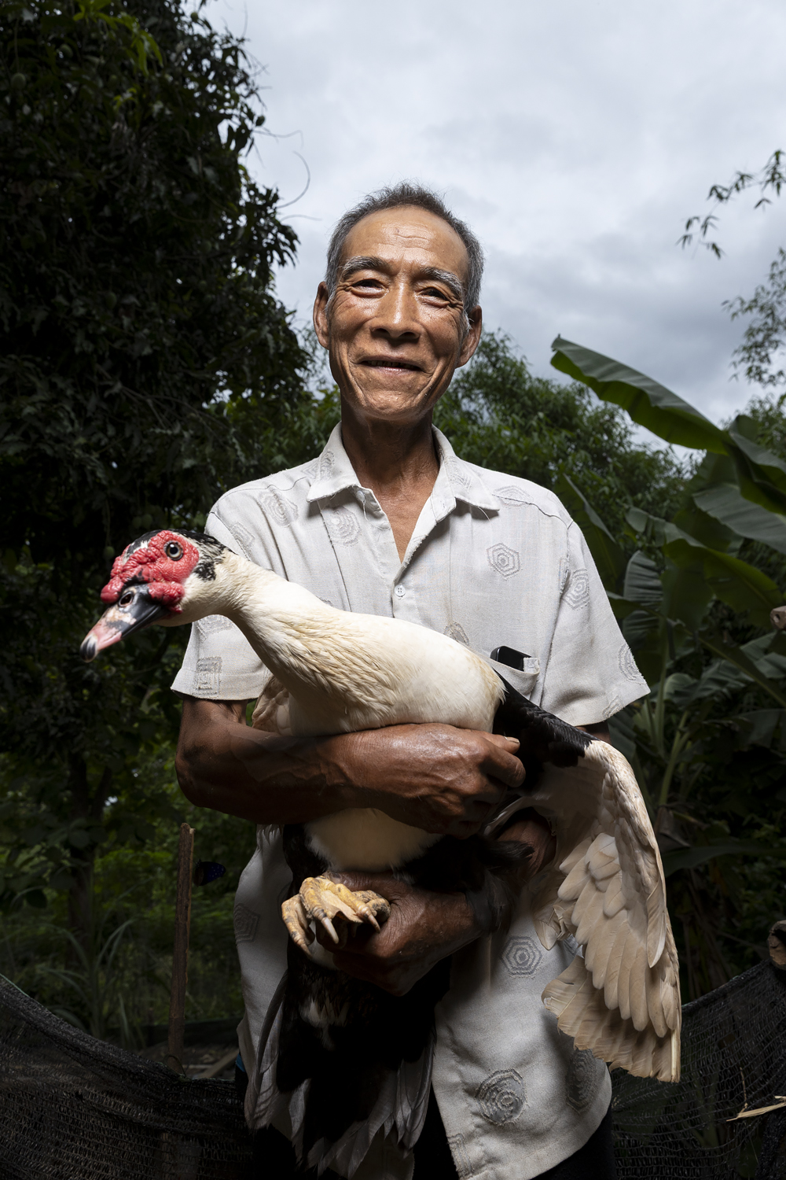
Houay Kang – Development of the Village and the Livestock Vaccination Project

Mr Khamsing Soulivanh
Houay Kang – Development of the Village and the Livestock Vaccination Project
Livestock raising is one of the core economic activities of Houay Kang village, located in Pak Ou district, around an hour north of Luang Prabang. The village sits astride Route 13, the main north-south highway, on steeply sloping land. The people of Houay Kang are all from the Khmu upland minority, and moved to this location from more remote areas relatively recently.
The village Disaster Risk Management (DRM) Committee members had called the group of three men who had been trained in livestock health – Mr Thonxay Xayyavong, Mr Khamsing Soulivanh, and Mr Khammuan Kornnupha to come to the meeting to talk about their experiences and insights. All of the group said that they had moved here from their previous villages to be in this location nearer the road, some of them from Viengkham district, also in Luang Prabang province. Initially, they agreed, there were then about 40 households here. The village as it now, was formally established in 1998, the head of the DRM committee explained. The older men said that they chose to relocate here following a recommendation from the government, because the location near the main road is much more convenient (government policy is also to encourage movement from more remote upland areas so communities will have better access to infrastructure and services). There are now 77 families, but 80 houses, because a few families have more than one house. They are all from one sub-group of the Khmu minority.
The main livelihood activity in the village, they said, is growing pasture for cattle. Some families still do shifting cultivation, but most have now changed to cattle raising. The pastures are mostly on sloping land – the village does have a small area of flat land along the river, they pointed out, but it is used for irrigated rice and also vegetable crops. Currently, 69 out of the 77 families are raising cattle, with an average of 10 head per family. Usually, each family has around 6 hectares of pasture, divided into three plots, and they rotate the cattle across these. Everyone agreed, erosion of the pasture slopes is a frequently occurring issue, especially when there is heavy rain.
The three men present agreed raising ten head of cattle is not enough to cover a family’s livelihood needs. They listed supplementary activities that different families have engaged in, including growing corn and other field crops, and different vegetables in season. Vegetables - such as chilis and eggplants, are grown mainly for household consumption. They said they grow two kinds of corn – one for their own consumption, the other for animal fodder. This is under contract, in an arrangement for Foreign Direct Investment in Laos, approved by the government. Explaining the system, they said the company comes and distributes the seed, then returns to collect the harvest, and pays out accordingly. There is some problem with insect pests, particularly a type of worm that eats the leaves of the corn, and some of the group suggested that this had become more prevalent as weather had become warmer and some of the patterns of the seasons had changed. Most households also raise pigs and chickens.
In talking about the most serious disasters and setbacks facing the community, the group commonly agreed that animal diseases affect the cows, and are a critical problem, as livelihoods are so strongly dependent on cattle raising. Besides this, there are landslides, and also insect pests. But everyone agreed cow disease is definitely the worst. There’s no vet in the village, so in the past, they would just go to the pharmacy, and ask which medicine they should use to treat the cattle. There hasn’t been a veterinary volunteer in the village either, they said. This has affected their lives for a long time. But, they said, things started to change for the better when the animal health project started last month. A team came to the village, combining staff from Souphanouvong University, the Ministry of Labour and Social Welfare and the district Agriculture office, to teach them how to diagnose and vaccinate for the most common diseases affecting their livestock.
The three trainees described the course, which ran for three days. Topics covered included how to observe the symptoms of different diseases and also training on preparation and preservation of different kinds of animal fodder. The focus was not just on cows, they made clear, but also diseases and treatment for pigs, dogs and chickens.
The vaccination team is all older men, and they talked about the past, when they’d first moved from their old location in Viengkham. First, they moved to the old village site near here – they’d been very poor, they all agreed. Since then, there’s been a lot of improvement.
“All the houses we had then, just had thatched roofs – now we all have metal roofs on our houses.”
The group all agreed that the location near the road is much better.
“Now we all gather together to help each other,” they said more than once, “and life is much better”.
Since they moved, they have been happy to fit in with the government plan, and changed their main livelihood strategy from shifting cultivation and deforestation to animal raising. For at least 70 or 80% of the population, they estimated, life is now substantially better than it was when they arrived here.
When they came here, most families had no cows at all, or at most, one or two. Now every household has cattle. If there was no cattle disease, life would be even better –
“I could get rich”, Mr Khamsing Soulivanh said, laughing.
Chicken and pig diseases have also been one of the biggest ongoing problems people face. Poultry diseases spread fast when they are kept close in the village, they said, but not when hutches are 100 – 200 metres away. However, as they further explained, when the hutches are out of earshot of the owners’ homes, the birds are much more likely to be stolen. Since the team has been trained in vaccination and diagnosis for pig and poultry disease, as well as for cattle, they now have hopes that some of the biggest obstacles to improved and more sustainable livelihoods will be removed.

