GEDSI Change Stories

Content summary

Strengthening Climate Resilience
Oxfam
June 2025

Background
The Strengthening Climate Resilience in the Mekong Sub-Region (SCR) project aims to improve the resilience of communities along the Mekong River and its tributaries by increasing adaptive capacity and improving access to hydrological and water-related data to inform local contingency planning. Active integration of GEDSI (Gender, Equality, Disability and Social Inclusion) has promoted broad, inclusive participation, including women, men, People with Disability, youth and older people, raising local knowledge, strengthening community ownership, and developing authorities’ capability to lead disaster-preparedness efforts.
The Mid-Term Review recommended that SCR strengthen its documentation to substantiate indicators and demonstrate project outcomes. In response, the Project Management Unit recruited an external consultant to support documentation in Thailand and Laos, while Cambodia drew on internal resources.
The primary objective of this exercise is to document project outcomes, with particular attention to how GEDSI integration has shaped the effectiveness of climate-resilience interventions. This GEDSI outcome documentation, aligned with the project’s GEDSI action plan and the project closure phase, will inform the final evaluation and the final project report and help shape future, context-relevant interventions. The process aimed to capture stories and evidence from all target countries, building on documentation already gathered, and to identify areas of challenge, and explore for further support (if relevant) to future interventions.
Story development process
The GEDSI stories were developed to capture the lived experiences of communities and the tangible changes that have occurred within the Strengthening Climate Resilience in the Mekong project. First, the consultant and project team met to agree on the objectives and identify which communities and groups to interview. Preliminary interview questions were then drafted and based on the story structures used in previous data collection exercises to ensure consistency of scope and comparability with earlier materials.
Field data collection took place in Cambodia from 10 to 13 June 2025 across four villages in Stung Treng and Ratanakiri provinces. Data was collected at project sites with the support of partner staff from My Village Organisation and the 3S Rivers Protection Network, and the Oxfam team provided translations. In total, 55 people were interviewed: 23 women, 31 men, and one person who identified as LGBTQI+. Two of the interviewees are People with Disability.
Following the fieldwork, the consultant shared a draft of story structures that highlighted the key findings. The Oxfam team reviewed the proposed story structures and key findings, identifying areas for change and expected results. Themes, patterns and similarities across the interviews were then used to determine framing and selection. Drafts were then prepared and reviewed in consultation with MEAL and programme colleagues. The first drafts were presented to and circulated among team members for feedback, which was incorporated before the stories were finalised.

Story #1: From the Margins to the Frontlines: Women Leading Resilience through Local Partnership
Location: Stung Treng and Ratanakiri Provinces
Theme: Strengthening GEDSI and Women’s Leadership through NGO Partnerships
Partners: My Village Organisation (MVI), 3 Rivers Protection Network (3SPN)
Linked Indicator: IOI 1.3 – Inclusive participation in DRM/CCA planning
For years, the communities in the flood-prone provinces of Stung Treng and Ratanakiri faced the consequences of disaster risk management decisions made without the input of those most affected. In many villages, women, People with Disability, and LGBTQI+ individuals often had no voices in local leadership, even though they were often the first to respond when disaster struck. When Oxfam’s Strengthening Climate Resilience in the Mekong project started and activities were delivered through local partners like My Village Organisation (MVI) and the 3 Rivers Protection Network (3SPN), changes began to be seen. Having been implementing partners of Oxfam in Cambodia and the Oxfam Mekong Governance Programme for years, the two organisations have embraced GEDSI principles and translated them into action thanks to the commitment and dedication of their women field staff.
Ms. Sovanthong Sit, a dedicated staff member and GEDSI advocate from MVI in Stung Treng, remembers those early days clearly. “At the start, not even the communities knew what GEDSI meant. I also didn’t know what it meant. But when I joined the project’s trainings and workshops, I realised that it was something I already practiced. I mean, I included everyone who is often excluded—women, People with Disability, LGBTQI+, older people - in the project purposefully.”
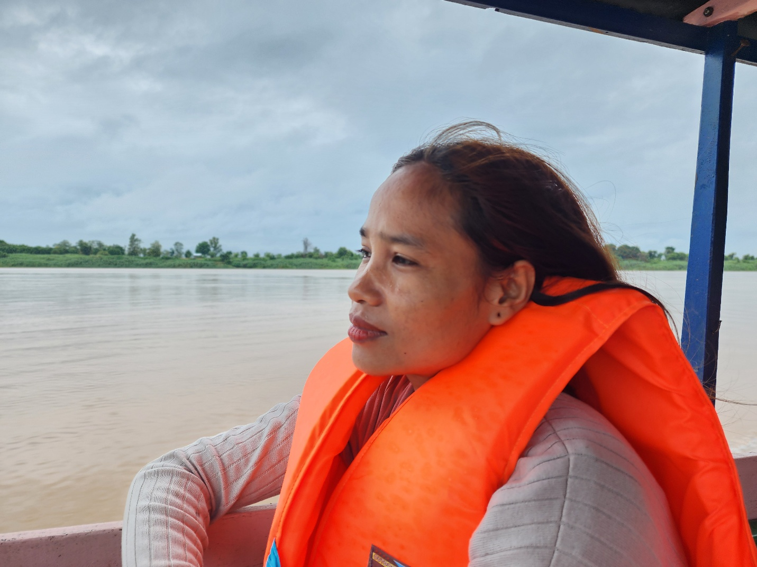
Photo 1 : Ms. Sovanthong Sit, MVI staff
Together with her colleague Ms. Chanthorn, who also works on Oxfam’s Inclusion project, Sovanthong began integrating GEDSI across their work. “Many people had never heard of inclusion as a concept,” she explained. “In the past, women, poor families, older people, People with Disability, and LGBTQI+ individuals were discriminated against. It takes time, but the effort is worth it. I can now see these groups being included and consulted in project activities, climate change adaptation plans, and disaster management plans.”
As a long-established organisation embedded in local communities, MVI didn’t stop GEDSI work with just one project. Their learning has extended to other programs and vice versa. The organisation’s deep commitment to GEDSI has become a key contributor to success.
3SPN is also an organisation that values GEDSI in its longstanding work. The practical support from Oxfam to its staff and operations has helped weave inclusion into their day-to-day work ethic with communities. Ms. Nen Cannvatha of 3SPN, whose own experiences of exclusion informs her work, is well trusted by the community, especially by the women she supports.
Ms. Cannvatha brought her lived experience into her leadership style. She helped identify women with leadership potential and offered them extra coaching and confidence-building support. Her approach was deeply personal, driven by a belief that leadership can be nurtured with care and trust.
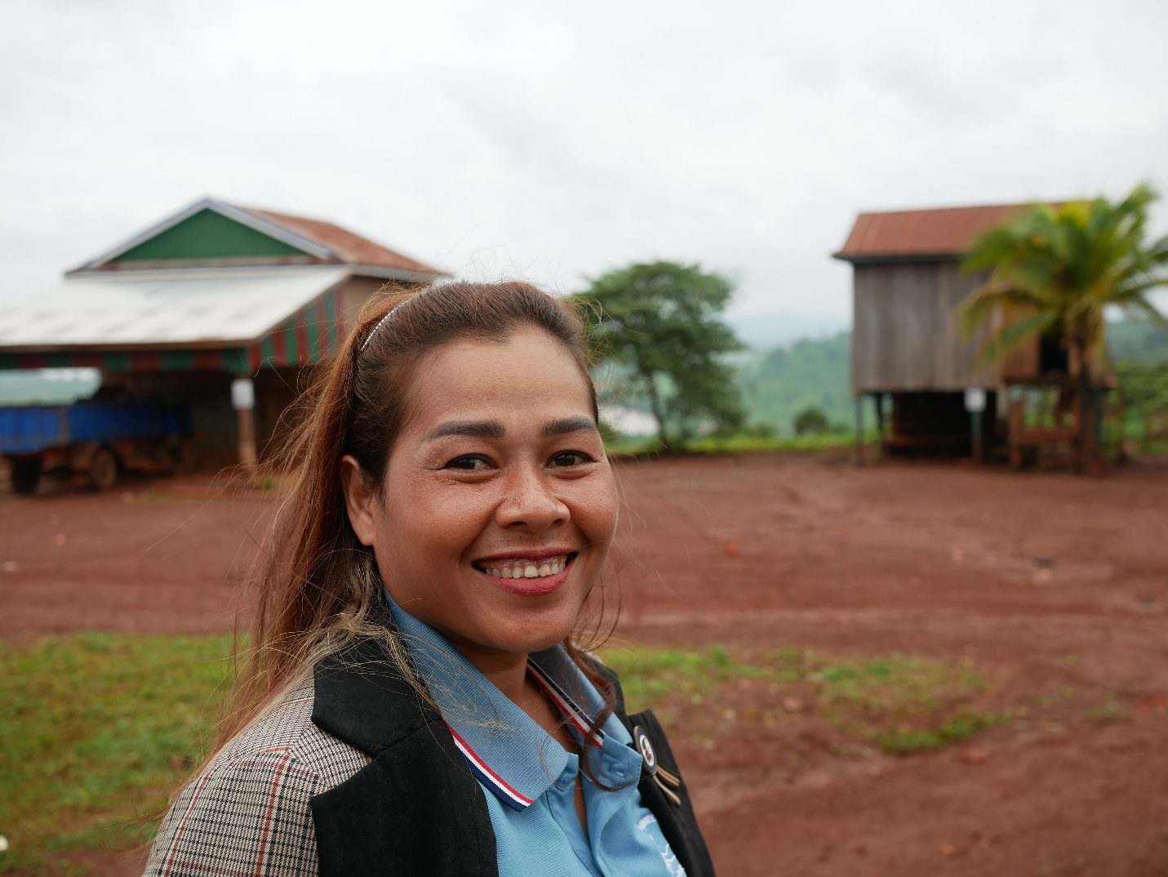
Photo 2 : Ms. Nen Cannvatha, 3SPN staff
Through a combination of hands-on mentorship, technical training, and community outreach, MVI and 3SPN set out to change not just perceptions but participation. They worked closely with Village Disaster Management Groups (VDMGs), encouraging them to include and support women, youth, People with Disability, and other marginalised groups.
Crucially, they didn’t stop at one-off trainings. The field teams have built relationships with local authorities, community leaders, and households and ensured new committee members felt supported. In many cases, this also meant bridging tensions within families. One woman leader in Ratanakiri, for example, initially faced resistance from her husband when she joined the VCDM. But through repeated engagement and encouragement from Ms. Cannvatha and her colleagues, he gradually came to understand and eventually support his wife’s role in the community.
These efforts paid off. Across target villages, women began stepping into active leadership roles. Sav Myan, a woman in Dal village once silent during public meetings, now leads community discussions on climate risks and household preparedness. Also in Dal Village, newly appointed VCDM members include one Person with Disability who now helps ensure contingency plans are inclusive and effective.
“I can see the change in the women’s confidence when I go to the community,” said Ms. Sovanthong. “They can speak up and represent other women during meetings. They are the ones promoting the value of leaving no one behind.”
Women farmers also benefited from climate-smart agriculture (CSA) training, which had a ripple effect on their confidence. “The women farmers who use CSA techniques are also VCDM members,” said Ms. Sovanthong and Ms. Nen. “They’re showing more leadership—maybe because the income helps boost their confidence. It shows they can take on both production and community roles at the same time.”
As the project looks to the future, both MVI and 3SPN believe this local model, which is grounded in coaching, trust, and community ties, can and should scale. To sustain momentum, they recommend continued GEDSI coaching, greater and repeated engagement with family members, especially men, and stronger integration of GEDSI in sub-national climate and disaster planning.
When women lead and communities include those who have been left out, true resilience becomes a reality.

Story #2: Cultivating Confidence: How Climate-Smart Agriculture Is Growing Women's Leadership
Location: Koh Sralao Village, Stung Treng Province, Cambodia
Theme: Women’s Leadership, Inclusion, and Climate Adaptation through Climate Smart Agriculture (CSA) Linked Indicator: POI 4 – Evidence of communities demonstrating new/improved/adapted livelihood strategies that promote resilience to disaster and climate change.

Koh Sralao is a quiet village. It sits among the floodplains of Stung Treng Province. Life here has always revolved around the land. The riverine fishing community depends on seasonal water regimes. Fishing and small-scale agriculture are its primary livelihoods. Its remoteness increases vulnerability to floods and sudden changes in river flow. Climate change is shifting the timing and intensity of rains and dry spells, raising flood risk in the wet season and water stress in the dry season. As a result, hazards translate quickly into livelihood shocks: reduced fish catches, damaged rice paddies and vegetable farms, loss of household assets, disrupted schooling and health services, and heightened safety risks. For generations, women worked tirelessly in small-scale farming by traditional ways of planting, watering, and harvesting, yet rarely received recognition or the tools they needed to thrive. Their days were long, incomes were low, and climate change only made everything harder.
Rice farming didn’t guarantee a steady livelihood for Mrs. Thoeung Lam and Mrs. Duong Pi, two women farmers in the village. Like many households here, they needed to diversify their income and improve food security by growing vegetables. But each season brought new uncertainty. Traditional methods, reliant on seasonal floods and vulnerable to pests, left them increasingly exposed. Sometimes, the vegetables they managed to grow weren’t even enough to cover their families’ needs, let alone produce a surplus to sell.
That changed in 2023, when the Strengthening Climate Resilience in the Mekong project, part of Oxfam’s regional Mekong Water Governance Programme, introduced climate-smart agriculture (CSA) in Koh Sralao. With the support of local partners, families were selected to join training sessions on techniques like organic composting, seed saving, raised-bed preparation, and efficient watering systems. They also learned basic financial management and recordkeeping, skills they’d never been offered before. Local partners provided gender equality training and leadership support, so women in the CSA groups could benefit fully.
CSA training became more than agricultural tools. it became a new way of thinking. As their yields increased and labour became easier, the women discovered that CSA didn’t just grow vegetables, it grew their confidence. While the income from their produce remains modest, its impact on daily life has been profound. Each woman now earns a steady amount. “It’s not a lot,” Duong Pi shared, “but it fills the gap. It supports things we couldn’t afford before.”
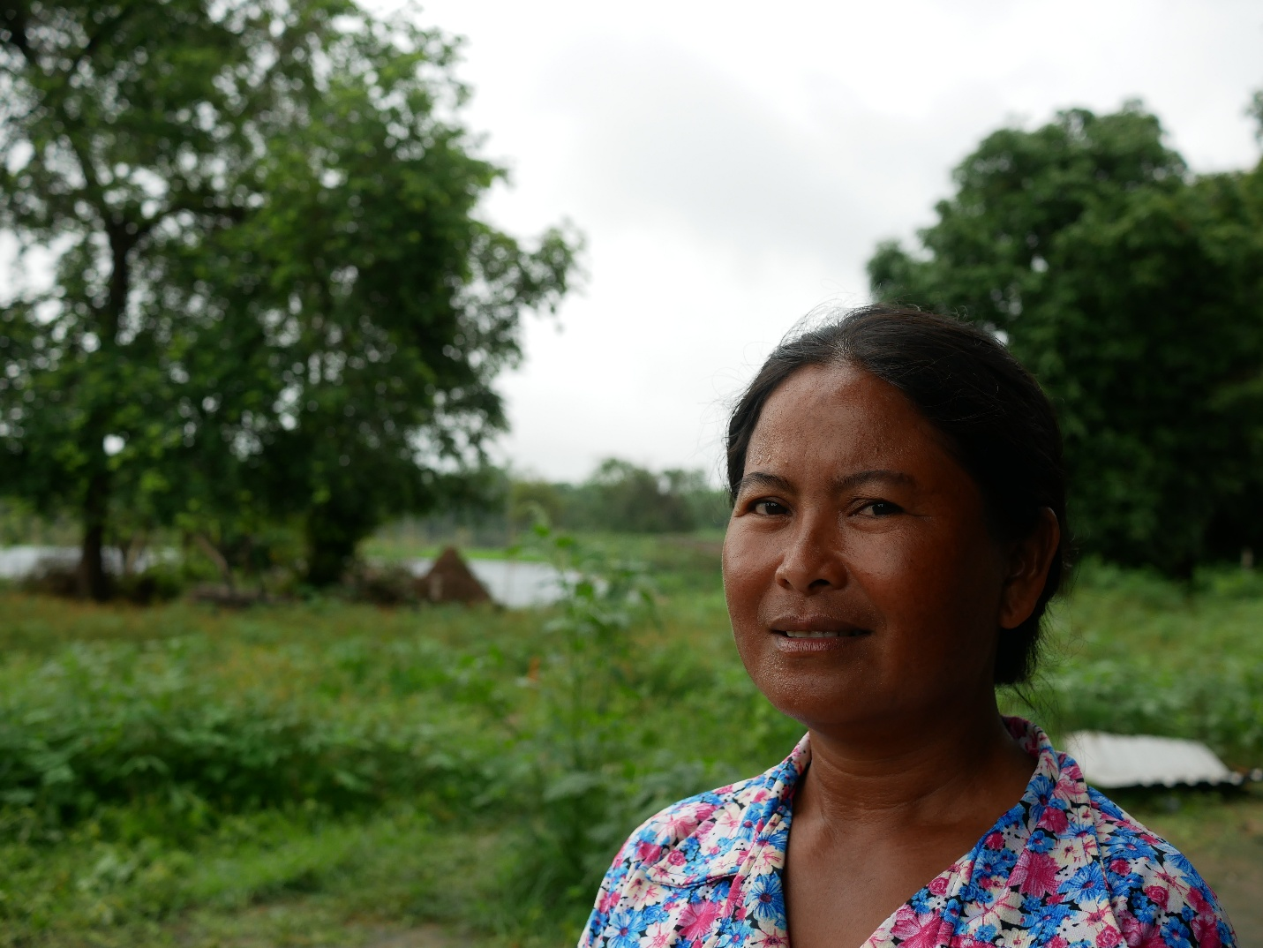
Photo 3 : Mrs. Thoeng Lam. Woman farmer who practices CSA, Ko Sralao
Rice still provides the bulk of the family income, but the vegetables have become an essential complement. “These techniques really help with production,” Lam said. “I now want to grow bigger crops or maybe fruit that brings in more money.”
With better soil health and smarter planting schedules, they now cultivate leafy greens, cucumbers, eggplants, and long beans even during erratic rainfall. Their vegetables look healthier, last longer, and sell more easily at the local market. Soon, they became role models: other families began adopting CSA techniques on their own, supporting one another and investing in equipment.
New challenges also emerged. Improved yields sometimes led to market saturation. “We have more vegetables to sell,” Lam explained, “but sometimes prices drop because many farmers harvest at the same time. And fuel for our water pumps keeps getting more expensive. We want to switch to solar power like some neighbours, but the initial cost is high. We’re saving up for that.”
Combining climate smart agriculture with basic financial and leadership training creates both economic security and social capital for women, which reinforces their participation in community decision-making. To consolidate benefits, future programs can support by providing knowledge on market cycles, collective marketing, price knowledge, and access to affordable irrigation (for example, solar solutions for irrigation).

Despite these hurdles, CSA brought much-needed stability. The women could now plan, budget, and contribute directly to their families’ welfare. “My husband and I can manage these large gardens ourselves,” Duong Pi said. “We don’t need outside labour, and our children can focus on their studies because the system eases the hard work. I even have more time for other things.”
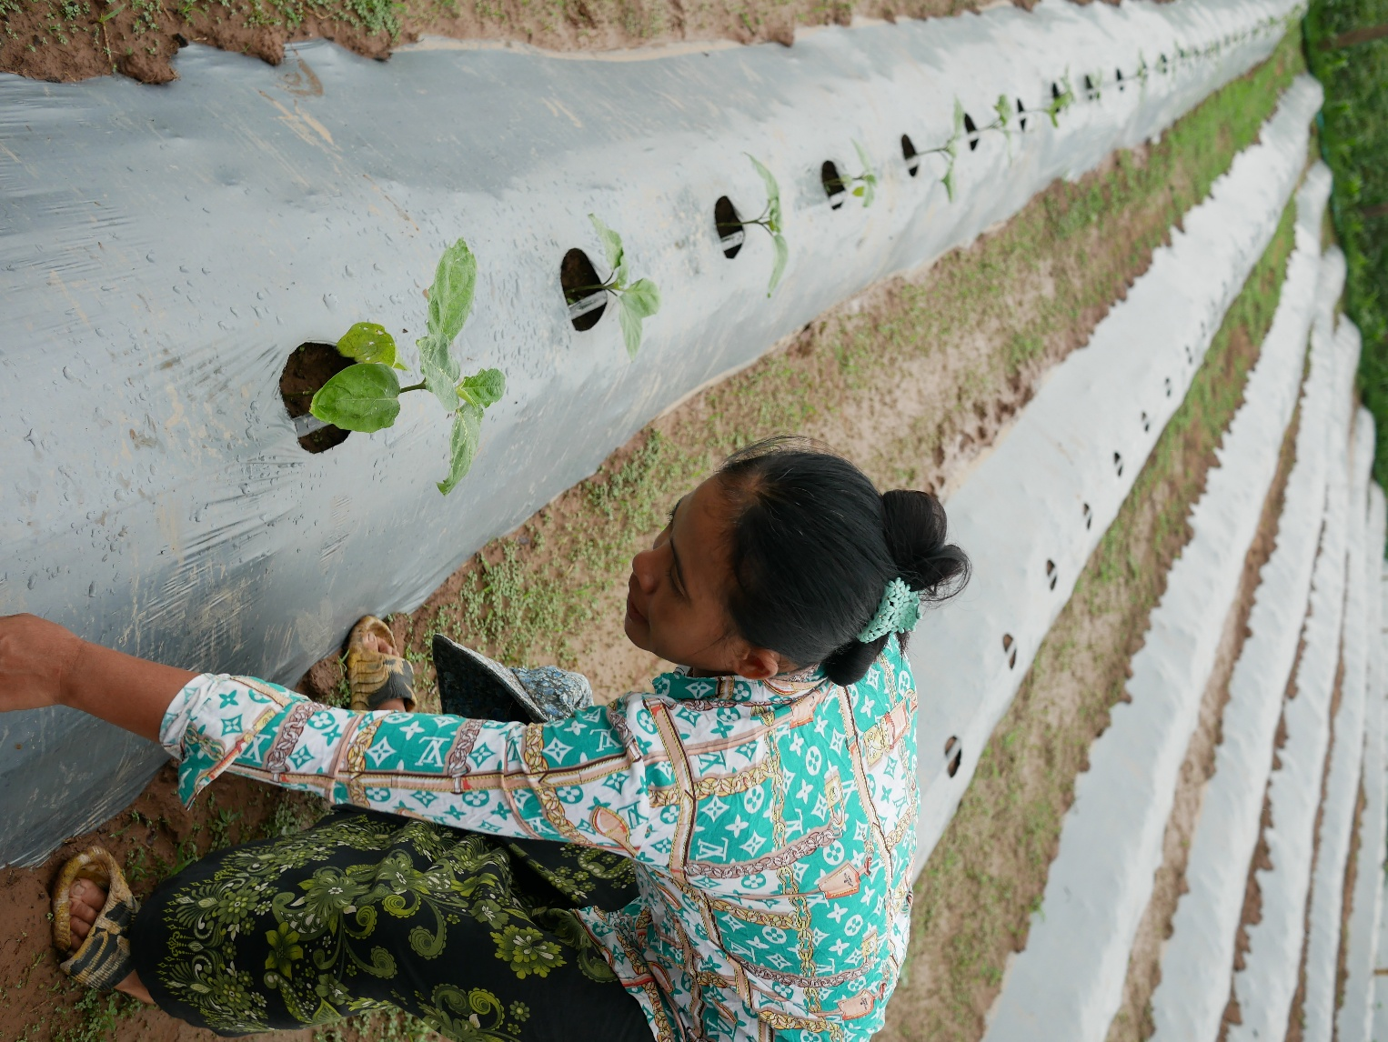
Photo 4: Mrs. Duong Pi, a Woman farmer with her CSA farm
Beyond income, these women became community leaders. Neighbours sought their advice as gardens flourished, and confidence grew. Freed from endless manual labour, the women began attending village meetings, participating in community events, and encouraging others to follow their path.
Looking ahead, they envision expanding their gardens, organising household finances more systematically, forming a collective, and improving market access. They want to learn how to set fair prices and track costs. But most of all, they want to keep growing.

Story #3: “We Speak Because It Matters”: Women Shaping Disaster Resilience in Koh Snaeng
Location: Koh Snaeng, Stung Treng Province, Cambodia
Theme: Increasing Women’s Leadership in Village Disaster Management and Inclusive Planning
Linked Indicator: IOI 1.3 – Evidence of participation of women, youth, People with Disability, and marginalised groups in the planning of DRM/CCA activities
Seasonal flooding and extreme wet-season events are the main hazards in Koh Snaeng, with recent large floods affecting stretches of the Mekong and its tributaries. Intense storms and flash floods also damage crops, homes, and infrastructure, causing displacement and short-term livelihood shocks. Climate change is shifting the timing and intensity of rains and dry spells, increasing flood risk in the wet season and water stress in the dry season.
Historically, men made the decisions about evacuations and preparations; women, though often first to carry children to safety, pack food, and care for older people, were rarely invited into the planning space.
But that’s changing. Through the Strengthening Climate Resilience in the Mekong project—supported by Oxfam and local partners like My Village Organisation (MVI)—women here are stepping up, speaking out, and shaping the decisions that protect their community. For three women Mrs.Na Ousa, the deputy chief of the commune and Chief of Commune Women and Children Committee; Mrs. Phang Nin, a Kindergarten teacher; and Mrs. Samut Chenda, Cambodia Red Cross Volunteer, the path to genuine influence was paved with persistence, training, and ongoing support.

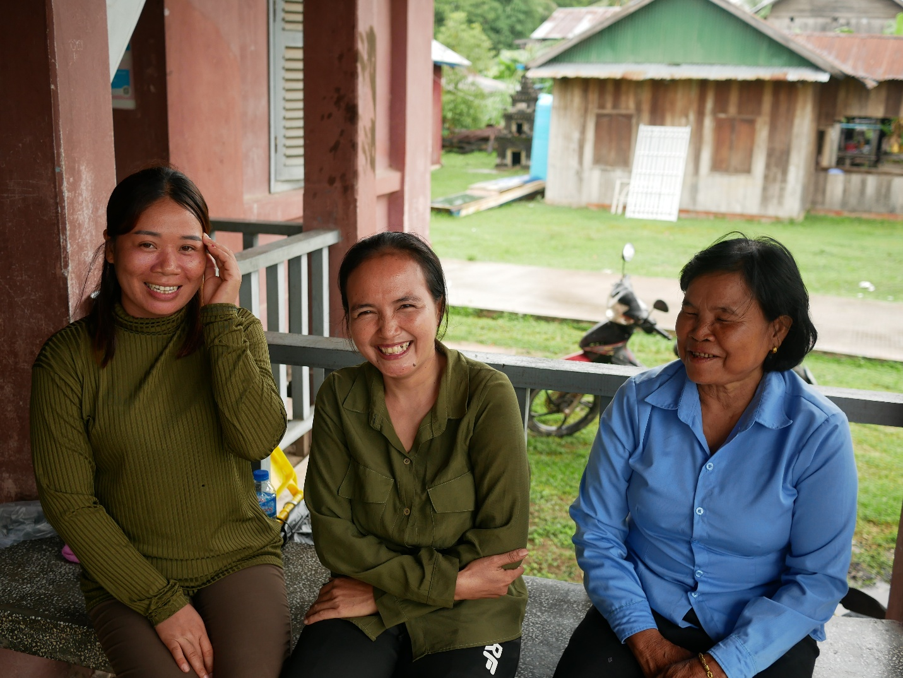
Photo 5: The women of Koh Sneang ‘s VDMG; From left to right- Mrs. Phang Nin, Mrs. Samut Chenda, and Na Ousa.

Before joining the Village Disaster Management Group (VDMG), each had taken part in other development initiatives such as education, health, nutrition, but none were seen as “disaster managers.” When MVI reformed the VDMG to include women, youth, and People with Disability as full members rather than tokens, everything shifted. With coaching, regular mentoring, and encouragement from project staff, each woman found her voice.
As a mother and farmer, Mrs. Phang Nin struggled to juggle home duties and community roles until climate information training made her the go-to person for flood alerts and early warnings. During the 2024 floods, the restructured VDMG, now equally composed of women and men, activated its preparedness plan faster than ever. They mapped out vulnerable households, notified commune and district authorities, and organised support for older people and People with Disability, with women leaders at the centre of every step.
Na Ousa shared how hard she’d worked to rise through the ranks: “I have my own mission, which is to help people to increase their knowledge in anything, including this disaster preparedness, so that they can help themselves.” As one of the few women holding a commune position, she now plays a core role in the VDMG, mentoring others along the way.
Not all challenges have disappeared. Some husbands were initially reluctant; one teacher’s husband even discouraged her involvement in the community work; however, her steady perseverance ensured her voice was heard. As respect for her leadership increased in the community, her husband’s resistance was somewhat reduced; although his support is still limited, it is steadily growing
This was revealed in conversations with women leaders, who reported that they face ongoing risks of gender-based violence when stepping into public roles. The women leaders reported that they support one another when facing disapproval from their husbands, and that they receive support from project partners, such as MVI staff, who talk to their husbands on their behalf. However, the project could do more to promote behavioural change and raise awareness of gender-based violence in the village.
The transformation has been profound. “I used to feel like I wasn’t doing anything important. Now, I know I’m protecting people.” Said Samut Chenda. Their success is encouraging others to change. Younger women are expressing interest in community groups, local authorities now consult women when updating contingency plans, and the broader perception of women’s roles is shifting from helper to decision-maker. The Chief of Commune in Koh Sneang shared that the current women VDMG members are active and really helpful in disseminating disaster information, especially to young women, as they are more familiar with technology and help evacuation decisions to be made more quickly.
This wouldn’t have happened without integrated support by coaching for women leaders, specialised climate-and-disaster training, and formal links to local government, ensuring inclusion became functional, not just symbolic.
Reforming village disaster committees to include marginalised groups — plus coaching and climate information training - produces faster, more inclusive preparedness in practice. Remaining priorities are addressing household resistance (through spouse/household awareness), protecting women from exposure to gender-based risks, and creating clear pathways and mentorship for younger women to take leadership roles.
Looking ahead, the women of Koh Snaeng see more to be done. They’d like training extended to spouses and male relatives to break down resistance at home, protecting women from gender based violence risks, and creating clear pathways and mentorship for younger women to take leadership roles, and opportunities to connect across villages and share lessons.
Speaking because it matters, their voices now carry the power to transform.

Story # 4: “Speaking Up, Standing Strong”: How Women and Inclusion are Shaping Dal Village’s Disaster Management
Location: Dal Village, Andoung Meas District, Ratanakiri Province, Cambodia
Theme: GEDSI in VDMG – Women and People with Disability Members meaningful participation
Linked Indicator: IOI 1.3 – Participation of women, youth, People with Disability, and marginalised groups in DRM/CCA planning

Dal village is an officially recognised Jarai Indigenous community in Andoung Meas. The village is located in Andoung Meas area which is part of the communities along the Sesan/Sre Pok river systems where it is prone to seasonal flooding. These flood events have required short-term evacuations and emergency relief distributions coordinated through commune/district disaster committees and local Village Disaster Management Groups (VDMGs), with national actors and humanitarian partners supporting Non Food Items (NFIs), shelter and food assistance where access permitted.
What’s changed is who’s guiding the response - women and People with Disability are now at the forefront of planning, preparedness, and action.
In 2023, under Oxfam’s Strengthening Climate Resilience in the Mekong project and with support from the 3S Rivers Protection Network (3SPN), Dal restructured its VDMG. The new framework prioritised inclusion, bringing in women, older residents, and People with Disability groups previously excluded from community decision-making.
One of those new members, Sav Myan, quickly made her mark. Utilising project training and 3SPN’s encouragement, she began speaking up in meetings about the specific needs of women-headed households and children. At home, her husband criticised her public role, even suggesting tribal beliefs that a woman who leaves the village can bring illness upon the community. Despite the emotional pressure, Sel Myan refused to back down. Supported by fellow VDMG members and project staff, she pushed through, and now her proposal to pre-position flood kits for vulnerable families is part of the updated contingency plan. She hopes future project phases will include awareness sessions for spouses, so women leaders receive support both at home and in the field. “When I saw other women from other villages who are confident, and have capacity, I want to be like that too, and this (disaster) issue is very close to our village, I have to do something,” she said.
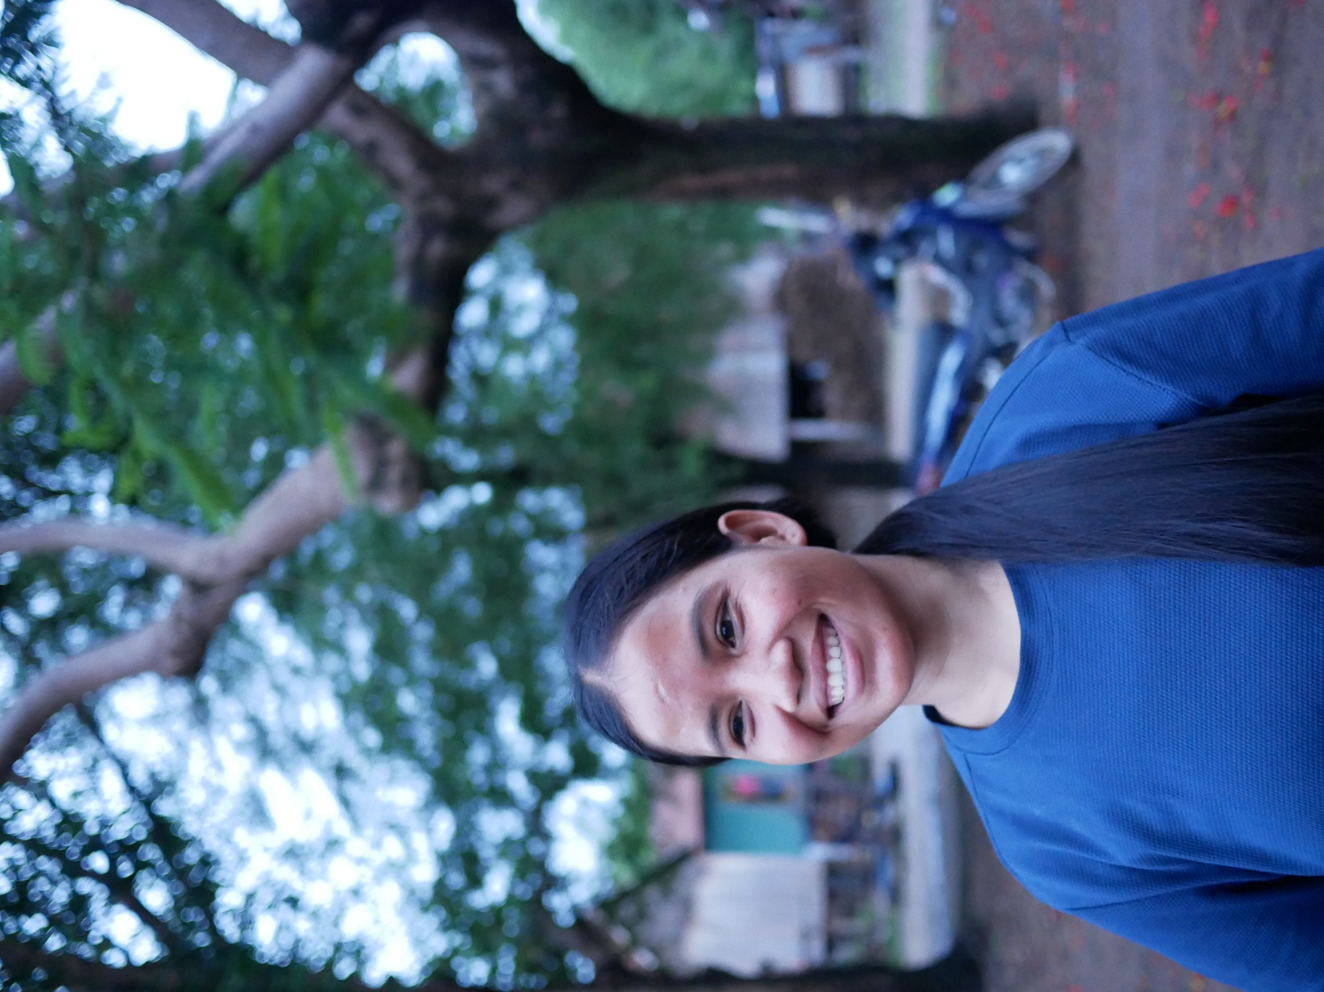
Photo 6: Sav Myan, VDMG member
Another standout is Sal Liv, an older Person with Disability. Though soft-spoken and less mobile, he’s enriched the committee’s strategies with insights on evacuating those with limited mobility. “I feel that my work is meaningful, I can help people and encourage the younger generation to have capacity and care for others,” he said.
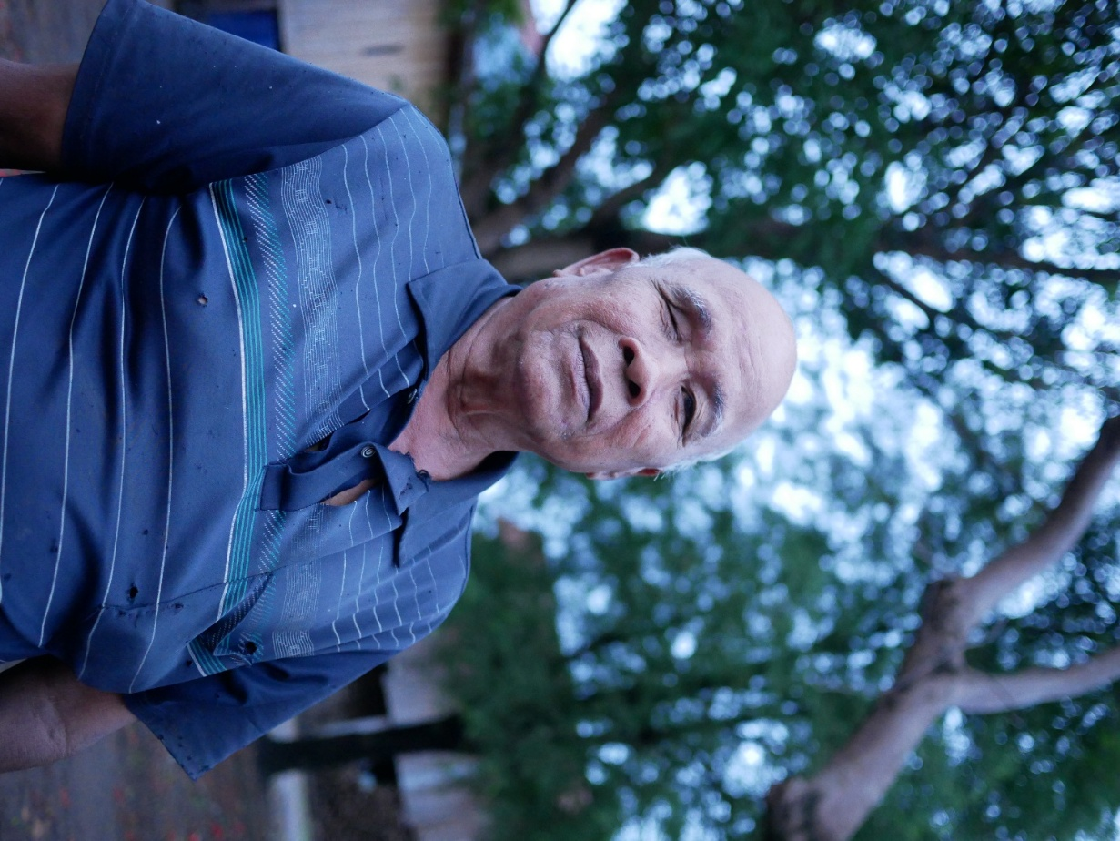
Photo 7: Sal Liv, VCDM member
These leaders are now central to Dal’s resilience planning. Their willingness to speak out and contribute is not only strengthening disaster plans but also challenging local norms about who belongs at the decision-making table. The story shows the value of supportive peer networks and partner backing and also highlights the need for targeted awareness with families and culturally sensitive risk-mitigation measures so everyone can participate safely and effectively.
Dal Village’s experience shows that true resilience isn’t built just on equipment or early-warning systems it’s built on inclusion, courage, and the everyday bravery of those who once sat in silence but now stand at the centre.

Story #5 : “Together We Prepare”: Shared Leadership in Kaengsan Village
Location: Kaengsan Village, Seda Commune, Lumphat District, Ratanakiri Province, Cambodia
Theme: GEDSI in VDMG – Collective Participation and CSA Enabling Women’s Effective Roles
Linked Indicator: IOI 1.3 – Participation of women, youth, People with Disability, and marginalised groups in DRM/CCA planning
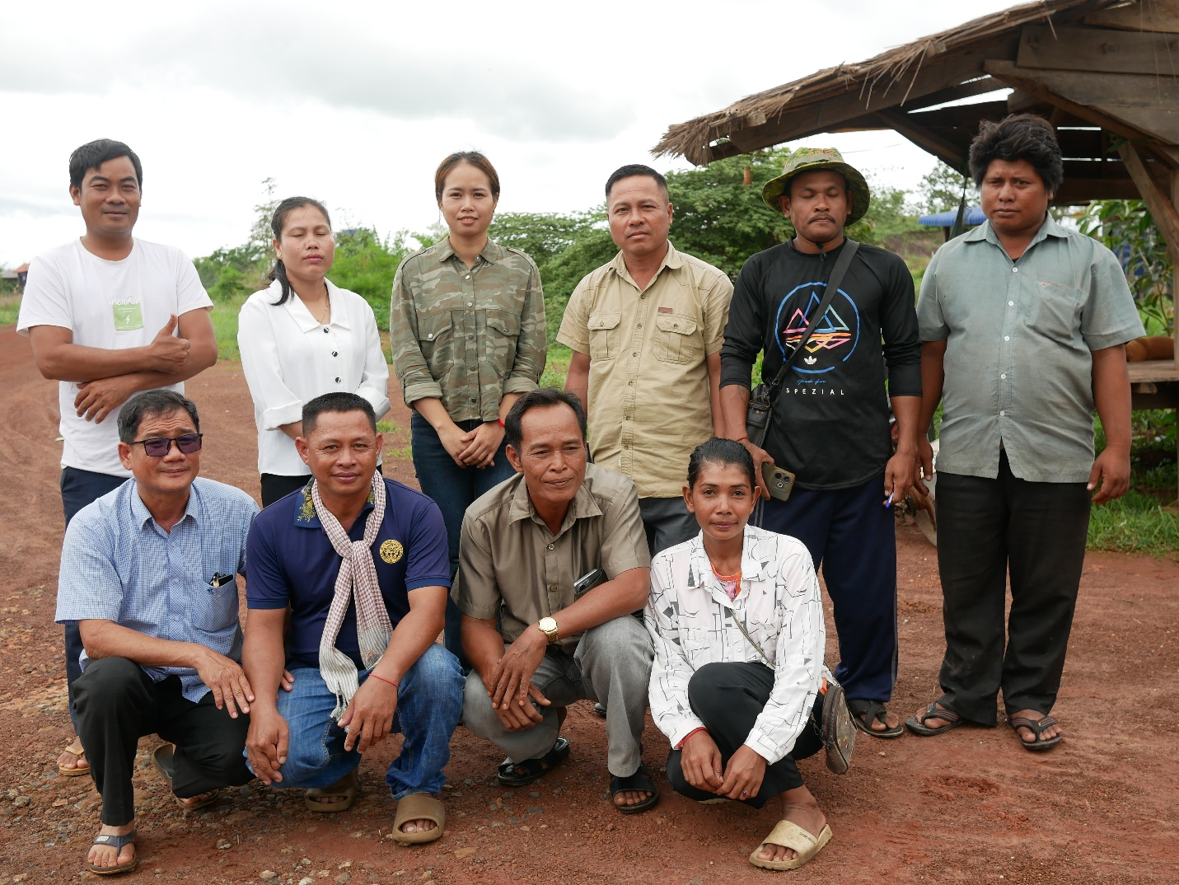
Photo 8 : Kaengsan Village VDMG
In Kaengsan Village, just across the district line from Dal, the risks are the same—unpredictable rains, seasonal flooding, and heat waves that threaten livelihoods. Here, however, the Village Disaster Management Group (VDMG) has struck a powerful balance of inclusion and collaboration, and it’s paying off.
With support from Oxfam’s Strengthening Climate Resilience in the Mekong project, facilitated by 3SPN, Kaengsan’s VDMG now includes three women, one older community member, and a Person with Disability, each with clear roles, responsibilities, and the authority to take initiative. Before the support was introduced, vulnerable groups in the village were never considered a priority when seasonal flooding occurred. They had to wait several days for someone to come to their house.
Now, the VDMG members were mapping vulnerable households, creating visual preparedness guides for low-literacy groups, and even calling border police to monitor water levels during heavy rains. Members report that using the 1294 call-and-message early-warning system, together with a ten household information sharing network, helps them spread alerts quickly across far-flung zones and prepare more effectively.
Ms. Savat Savoeun, a CCDM member and representative on the commune’s Women and Children Committee, explains why this matters: “We need to get people safe, especially women whose husbands work outside the village. They manage children, care for young or sick relatives; this group needs to be safe.”
Trained in vulnerability and risk assessment, the women play especially active roles: issuing early-warning calls, leading community discussions, and ensuring no household is overlooked. What keeps them engaged isn’t just the training, it’s stability. Many have also benefited from the project’s climate smart agriculture (CSA) support: their vegetable plots, boosted by drip irrigation and organic techniques, now generate reliable income.
Economic security and community leadership have proven mutually reinforcing. With greater autonomy over their time, these women are more engaged, more confident, and more consistent in their VDMG roles.
Kaengsan’s VDMG has become a model for inclusive, effective disaster management. Its story isn’t one of dramatic crises, but rather a quiet success built on collaboration, mutual respect, and steady support. The project didn’t simply train individual leaders; it nurtured a team. Together, they’re showing that inclusive disaster planning doesn’t need to be revolutionary to be truly transformational.

Story #6: “From Plans to Action”: How Sub-National Leadership is Mainstreaming Inclusion in Disaster Response
Location: Provincial Committees for Disaster Management (PCDM) in Stung Treng and Ratanakiri, Cambodia
Theme: Strengthening GEDSI Through Government Leadership and Systems Coordination
Linked Indicator: IOI 2.3 – Evidence of local authorities integrating the perspectives of women, People with Disability, and marginalised groups into DRM/CCA plans

The Provincial Committees for Disaster Management (PCDM) in Stung Treng and Ratanakiri may look like typical government bodies, but they’ve become hubs for planning provincial responses with inclusion at their core thanks to strong, forward-thinking leadership.
Before Strengthening Climate Resilience in the Mekong project (SCR), Oxfam had an established programme footprint in Ratanakiri that included community-based disaster risk reduction (CBDRR), vulnerability mapping and capacity-building activities carried out in coordination with provincial and district disaster authorities. As climate impacts worsen across Cambodia, local governments have been on the front lines of floods, droughts, and landslides. Until recently, however, their planning often overlooked the specific needs of women, People with Disability, and other marginalised groups. During the SCR project, local partners began working closely with both Provincial Committees for Disaster Management (PCDM) to address these gaps. What started as a series of training sessions has since evolved into a fundamentally new approach.
In Ratanakiri, PCDM Chairperson Mr. Mar Vichet, himself a veteran disaster responder, recognised the pitfalls of top-down planning early on: “I’ve seen what happens when we plan for the general population and forget about the specific needs of older people, women, or People with Disability. We cannot discriminate who to help; we need to ensure that these groups receive timely assistance.” As some areas of Ratanakiri are prone to recurring floods, he draws on his experience to ensure that the PCDM is well equipped with resources. For example, he asks the private sector for support with evacuation equipment (such as boats), and he encourages donors to fund projects that empower communities to prepare for disasters. Under his leadership, resource mobilisation and communication between provincial, district, and village levels have been significantly strengthened.
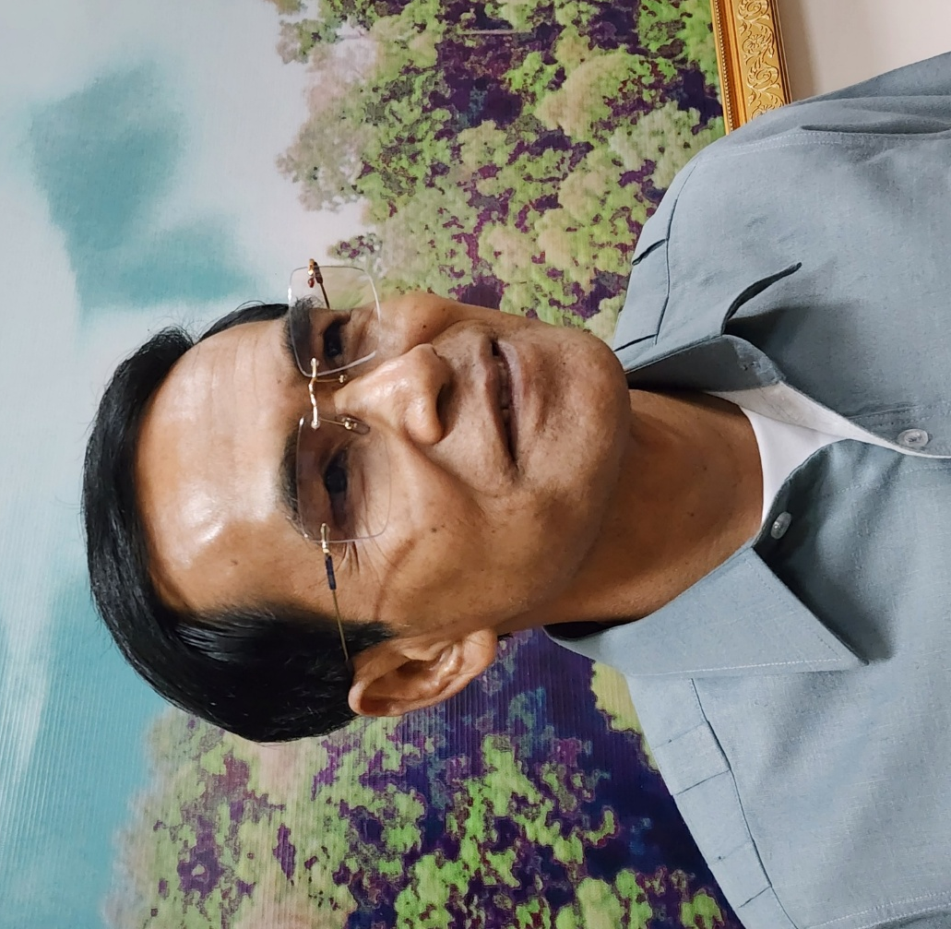
Photo 9: Mr. Mar Vichet, Deputy Provincial Governor of Ratanakiri and a PCDM Secretariat Chairperson
One key shift has been in data gathering and sharing. With project support, the village, commune (CCDM), district, and provincial levels now coordinate closely to map vulnerable households—tracking numbers of People with Disability, for example, for more precise targeting during emergencies.
While this inclusive approach laid important groundwork, there are still areas the PCDM is actively working to improve. For example, the mass notification system (1294) reached over 2,000 residents in Ratanakiri, but only 600 responded. The PCDM is now investigating both technical glitches and community awareness gaps. It will be the responsibility of PCDM and its partners to work together to ensure that mass messages reach communities promptly. In Stung Treng, Mrs. Eng Sophea, a senior PCDM member, whose deep community roots and faith in women’s leadership have reshaped provincial strategy. “I understand the reality in the villages, and we have to listen to them, especially women and vulnerable groups,” she says, while overseeing data monitoring and ensuring the committee proactively identifies those most at risk.
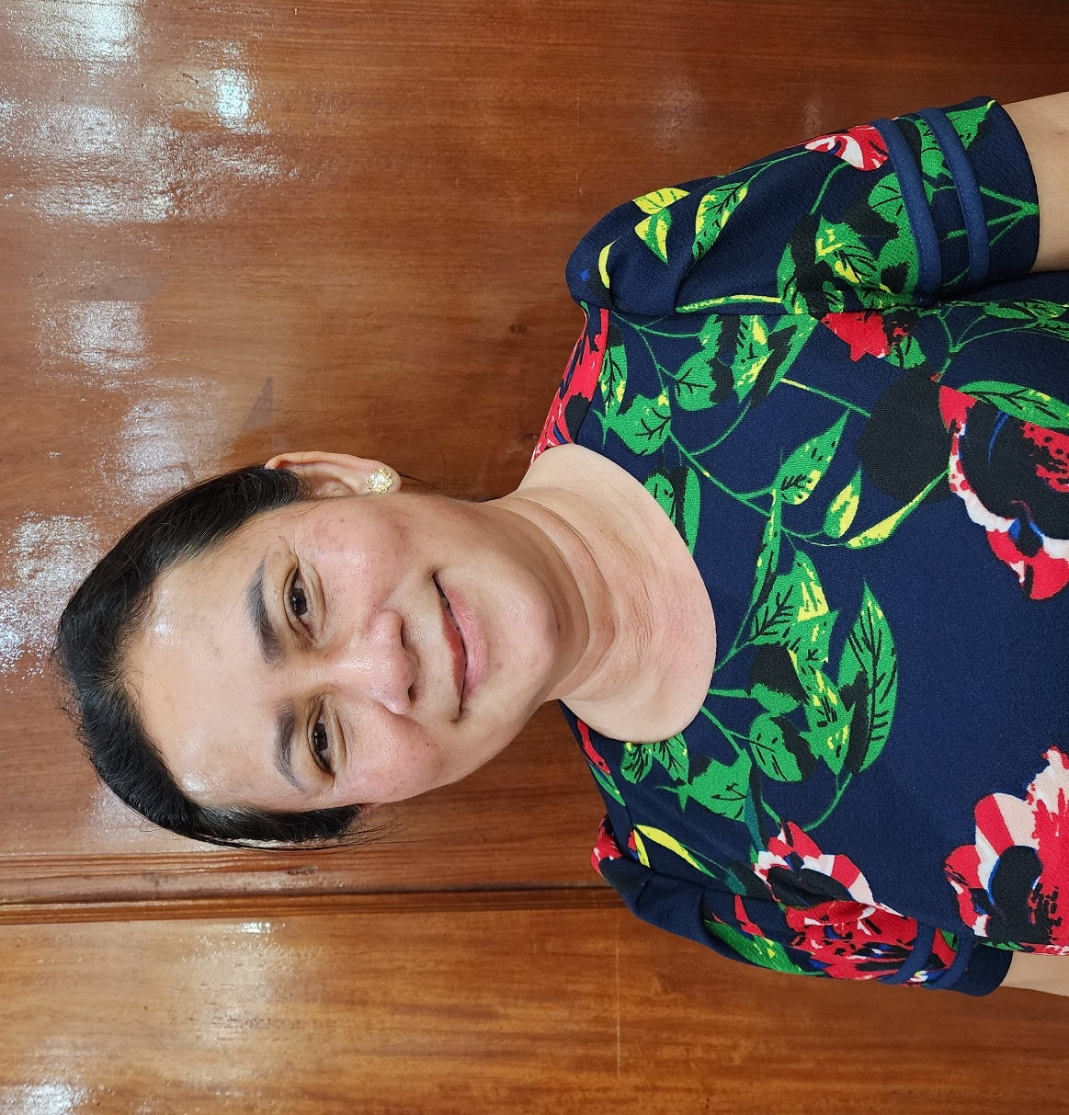
Photo 10: Mrs. Eng Sophea, Deputy Administration Director of Stung Treng Provincial Administration, Senior PCDM member

Mrs. Eng Sophea who is also the designated PCDM Platform for Real-time Impact and Situation Monitoring (PRISM) focal point, is responsible for maintaining the connection between PRISM, the Commune Committee for Disaster Management (CCDM) and the District Disaster Management Committee (DCDM), ensuring that field reports are received, verified and visualised in near real-time. PRISM is a map-based, web-accessible climate-risk monitoring platform that brings together satellite-derived hazard data, early-warning alerts and socio-economic vulnerability information so authorities and responders can prioritise where assistance is needed. This inclusive planning has shortened the information gap between local communities and government authorities by linking commune - and district-level reports with provincial dashboards and community channels (e.g., Telegram), enabling faster situational awareness and two-way communication.
Despite these advances, both PCDMs acknowledge ongoing challenges: limited resources, inconsistent training without routine simulations, and the need for sustained technical support at the commune level.
Yet what’s unfolding is a quiet transformation of both policy and perspective. Inclusive disaster planning is no longer viewed as an “extra” or an “NGO requirement,” it’s integrated into institutional practice. With continued investment, both provinces aim to embed these approaches into long-term policy and budget frameworks.
Sophea sees this as just the beginning. Having witnessed the obstacles faced by women leaders, often unsupportive spouses and lingering cultural biases. She’s working with village authorities and NGOs to shift gender norms. “Strengthening women’s leadership is possible but takes a lot of time. We need to be humble and patient to support these women and not put them at risk,” she explains.
Their journey proves that inclusion is practical, local, and deeply human and when provincial systems truly reflect the needs of their people, resilience becomes not just possible, but sustainable.

Story #7: “Water Is Closer Now”: Solar Power, Young Women's Leadership in Dal Phnom
Location: Dal (Phnom) Village, Andoung Meas District, Ratanakiri Province, Cambodia
Theme: Infrastructure for Resilience – Water Access, Inclusion, and Women’s Leadership
Linked Indicator: Evidence of local authorities with increased resource allocations for DRM and/or CCA in target communities, in particular climate-smart livelihood options

Dal (Phnom) village is tucked away in the forested hills of Andoung Meas District in Ratanakiri. It's a quiet and hard to reach place. This hardship is made worse by history. Years ago, Dal (Phnom)'s villagers were displaced by flooding caused by the Yali Dam in Vietnam. Relocated inland, they rebuilt with little support and poor infrastructure. Water access remained one of the most urgent and unaddressed needs. For years, residents, especially women and girls, faced the burden of water collection. During the dry season, they walked up to three times a day to distant ponds and streams. Though some men helped, deep-rooted gender roles meant that water-fetching was still seen as “women’s work” a reality that placed extra pressure on older women and school-age girls.
As part of Oxfam’s Strengthening Climate Resilience in the Lower Mekong project, implemented by the 3S Rivers Protection Network (3SPN), a solar-powered water pump system was recently installed in the first quarter of 2025. At the request of the Deputy Provincial Governor and the Village Disaster Management Group, the intervention delivered immediate, significant benefits to all 66 Krueng households—243 residents in total, including 107 women and two People with Disability.
To support the new infrastructure, a water management group was formed to help maintain the system and communicate with households. Several women were selected to take part—but their leadership began, quite literally, by chance. One of them, Sal Neab, an 18-year-old woman, shared that it was her grandmother who had been nominated by the village chief to join the group. “But my grandma is very old,” she said. “She cannot manage the system or join meetings. So, I offered to help and do it for her.”
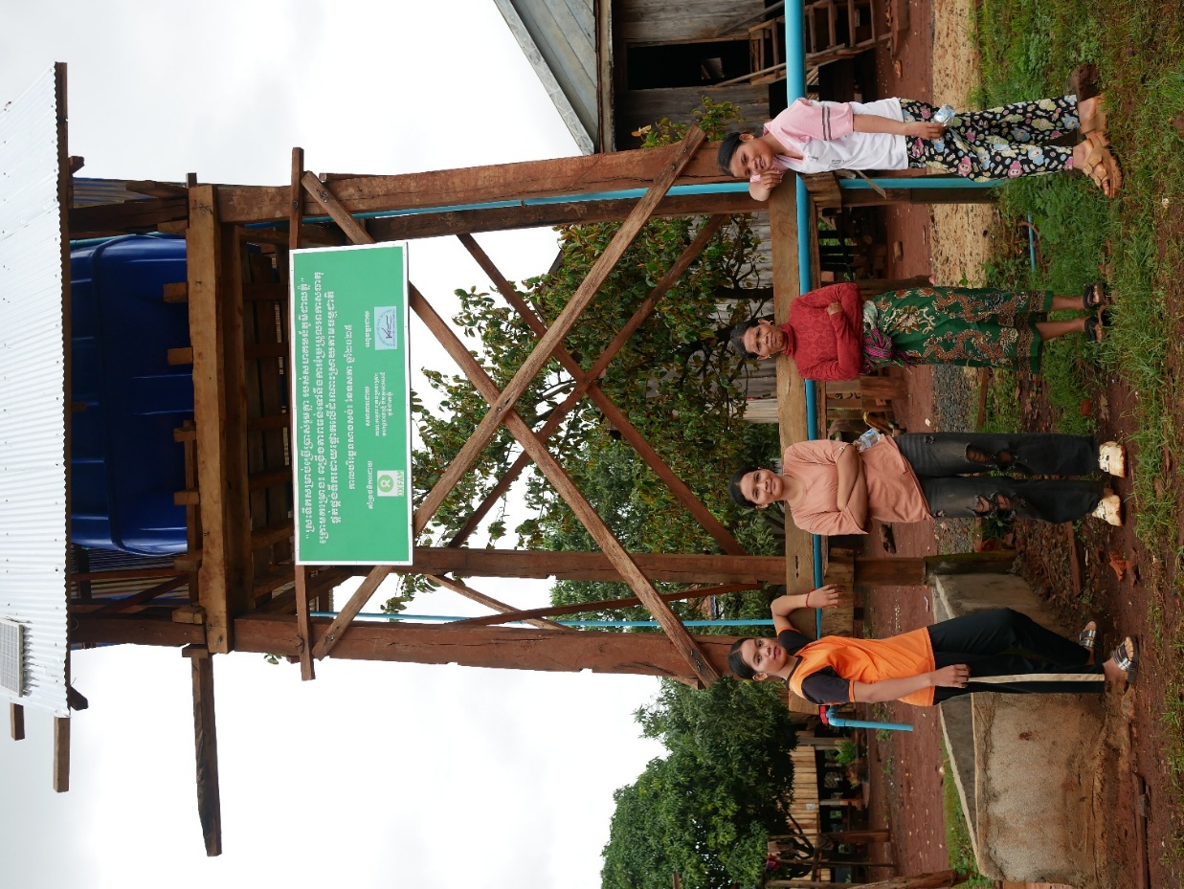
Photo 31: The young woman of water management group
The village chief who nominated her grandmother also agreed and saw that she could make some change in the village as she is an active member of the younger generation.
As a result of the pump installation, women reported having more time for rest, fewer injuries from walking long distances, and increased time for income-generating tasks. The village had a reliable water supply after the water infrastructure was installed. However, there were obstacles, as the heavy rain makes the ponds quite dirty and no water filter is yet installed. The people in the village do not want to use the solar-powered water pump system as it will take the “dirty” water up to the tank. They go back to the original well to fetch water for drinking purposes, and women and girls are the ones responsible for this work.
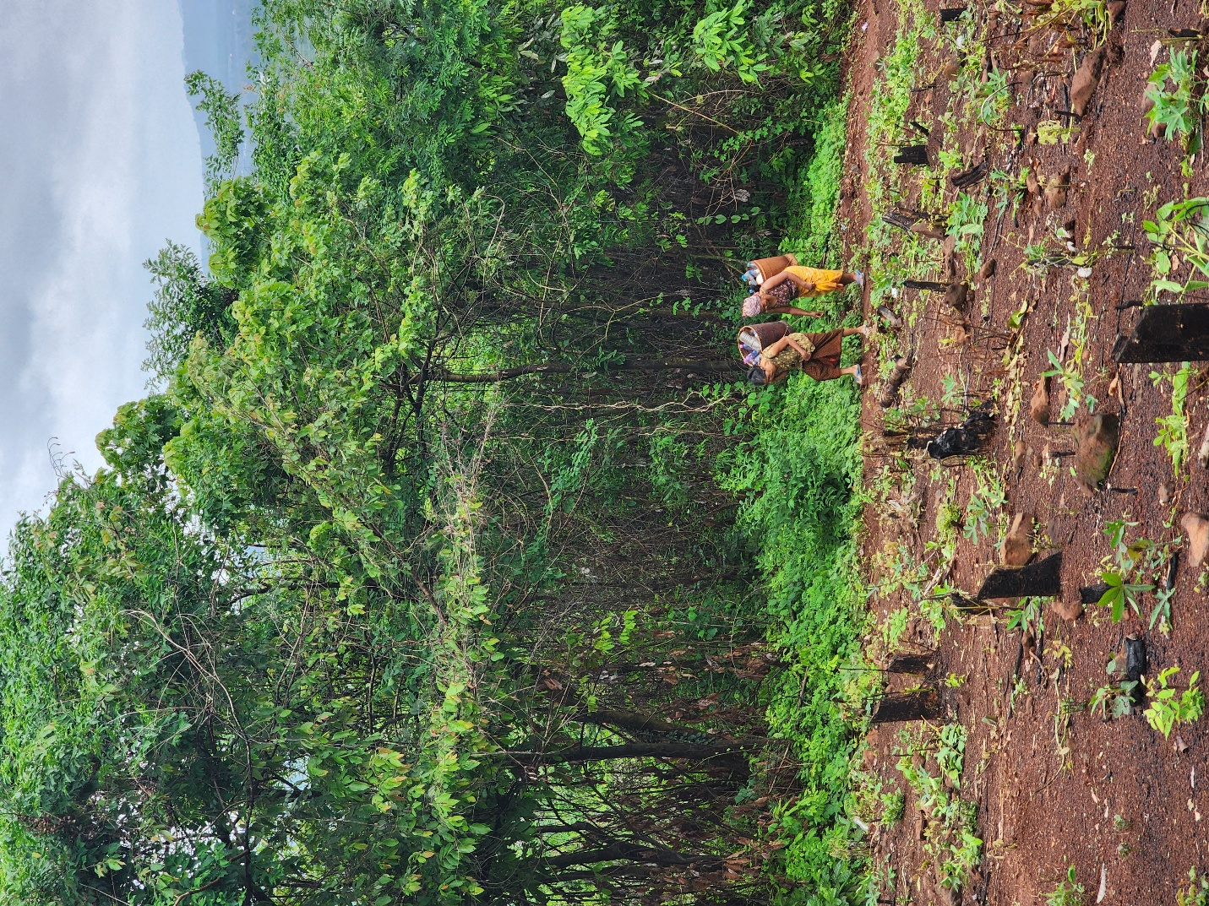
Photo 12: Older women still need to collect water during the rainy season
Infrastructure investments unlock substantial time savings and restore dignity for women, but hardware alone will not secure sustained benefits. Without accompanying behaviour-change interventions, practical water-treatment training, and clear arrangements for filtration upkeep, communities are unlikely to trust or consistently use new supplies and women will continue to shoulder the burden of collecting safe water. The project therefore proposes targeted sessions on household water-treatment methods, user behaviour change, and operation & maintenance, paired with community maintenance plans and follow-up support, so that technological improvements are matched by knowledge and practice and women’s workloads are genuinely reduced.
Leadership in Dal (Phnom) didn’t spring from formal titles but from action. The young woman who stepped in for her grandmother now leads with quiet authority, reminding us that inclusion often begins with simple acts of responsibility.

Summary
No. | Topic | Location (Cambodia) | Interviewee | Type of Interview | Link to outcome
1 | Strengthening GEDSI and Women’s Leadership through NGO Partnerships | Stung Treng and Ratanakiri Provinces | Ms. Sovanthong Sit (MVI)  Ms. Nen Cannvatha (3SPN) | Individual | Evidence of local authorities integrating the perspective of women, People with Disability, and marginalised groups into DRM/CCA policies and programs
2 | Women’s Leadership, Inclusion, and Climate Adaptation through Climate Smart Agriculture (CSA) | Koh Sralao Village, Stung Treng Province | Mrs. Thoeung Lam and Mrs. Duong Pi | Group, individual | Evidence of communities demonstrating new/improved/adapted livelihood strategies that promote resilience to disaster and climate change
3 | Increasing Women’s Leadership in Village Disaster Management and Inclusive Planning | Koh Snaeng, Stung Treng Province | Mrs.Na Ousa; Mrs. Phang Nin, a Kindergarten teacher; and Mrs. Samut Chenda, | Group, individual | Evidence of participation of women, youth, People with Disability, and marginalised groups in the planning of DRM/CCA activities
4 | GEDSI in VDMG – Women and People with Disability meaningful participation | Dal Village, Andoung Meas District, Ratanakiri Province | Mrs. Sav Myan , Mr. Sal Liv , and VDMG members | Group, individual | Evidence of participation of women, youth, People with Disability, and marginalised groups in the planning of DRM/CCA activities
5 | GEDSI in VDMG – Collective Participation and CSA Enabling Women’s Effective Roles | Kaengsan Village, Seda Commune, Lumphat District, Ratanakiri Province | Ms. Savat Savoeun, and VDMG members | Group, individual | Evidence of participation of women, youth, People with Disability, and marginalised groups in the planning of DRM/CCA activities
6 | Strengthening GEDSI Through Government Leadership and Systems Coordination | Stung Treng and Ratanakiri, Cambodia | Mr. Mar Vichet, and Mrs. Eng Sophea | Individual | Evidence of local authorities integrating the perspectives of women, People with Disability, and marginalised groups into DRM/CCA plans
7 | Infrastructure for Resilience – Water Access, Inclusion, and Women’s Leadership | Dal (Phnom) Village, Andoung Meas District, Ratanakiri Province | Ms. Sal Neab | Group, individual | Evidence of local authorities with increased resource allocations for DRM and/or CCA in target communities, in particular climate-smart livelihood options

